PRESS RELEASE
New solder paste printer from ASMPT delivers more flexibility
DEK TQ L: Proven performance and precision for large circuit boards
Suwanee (USA), August 17, 2022 – With its precision, processing speed and floorspace performance, the DEK TQ series from ASMPT is the leading printing platform on the market today. For even more flexibility in the processing of large circuit boards, the SMT leader now presents a new model: the DEK TQ L for boards measuring up to 600 by 510 millimeters. The new solder paste printer also sets more new performance records and delivers many features for ASMPT's Open Automation concept in the Integrated Smart Factory.
With an alignment accuracy of ±12.5 microns @ 2 Cmk and wet printing accuracy of ±17.0 microns @ 2 Cpk, the machines of the DEK TQ platform are some of the most precise paste printers on the market. The new DEK TQ L was also designed in accordance with ASMPT’s motto of “Maximum performance and flexibility in the smallest footprint”. As a special highlight, users can place two machines back-to-back to double their line's productivity without increasing its length.

What's new about the DEK TQ L
The DEK TQ L offers electronics manufacturers new degrees of freedom for printing larger boards with dimensions of up to 600 x 510 millimeters – 90 percent more than the DEK TQ. The printable area, which measures 560 by 510 millimeters, is 78 percent larger. With a three-stage conveyor, the DEK TQ L can process boards that are up to 345 millimeters long (DEK TQ: 250 millimeters).
Despite the increase in board size, the core cycle time maximum is only 6.5 seconds in three-stage operation (DEK TQ: 5 seconds). The machine achieves these values with features such as high-precision linear drives, a new off-belt printing process, innovative clamping systems, an advanced print head, and the unique ASMPT NuMotion controller with fiber-optic cabling. In addition, the efficient high-speed understencil cleaning system (USC) with its own linear drives cleans up to 50 percent faster than traditional systems. Due to the up to more than 90 percent larger PCB surfaces, the USC can be equipped with three different and easily exchangeable fabric roll sizes.
With a length of 1.3 meters and a width of 1.5 meters for a footprint of 1.95 square meters, the new printer is only slightly larger than the DEK TQ. Outstanding floorspace performance is therefore guaranteed.

Zero-line-stop philosophy
The printers of the DEK TQ platform are designed to run for more than eight hours without a user assist, depending on the cleaning requirements. This is made possible, among other things, by their optimized understencil cleaning system with its 22-meter fabric roll and seven-liter cleaning fluid tank. The machines also accommodate 11-meter fabric rolls as well as easily interchangeable vacuum inserts of different widths. To minimize manual assists during the printing process, the DEK TQ printers optionally feature an efficient paste management system with an Automatic Paste Dispenser and integrated Paste Height Control with individually configurable warning and stop thresholds. Another convenience is the optional Dual Access Cover (DAC), which makes it possible to replace paste cartridges without having to stop the printer.

Automation step-by-step
The DEK TQ platform follows ASMPT's Open Automation concept for the step-by-step automation of SMT production, which lets users decide how quickly and extensively they want to automate their lines. The machines’ various expansion options are based on the same principle.
For example, the system can determine on its own where to position support pins that prevent boards from bending during the printing process. It places the pins with diameters of 4-mm or 12-mm automatically and verifies them regarding their position and – as the only machine in the industry – their height. On the DEK TQ L, the magazine for the optional Smart Pin Placement holds up to 60 pins due to the large board sizes, which is twice as many as on the DEK TQ. DEK’s All Purpose Clamping also delivers more flexibility. With its software-driven linear drives, the universal and by far most flexible clamping system from ASMPT automatically adapts to the thickness and shape of each board. As a result, DEK TQ machine can even print in areas very close to the edge reliably and with excellent quality.
If DEK TQ printers are employed in combination with the Process Lens SPI system and the AI-driven WORKS Process Expert software, the entire printing process can be automatically controlled and optimized.

Easy integration via open interfaces
For the best possible horizontal and vertical integration into the user’s line, material or production management system, various open and flexible interfaces and protocols are available. They include IPC-HERMES-9852 for board-related communication within the line as well as IPC-CFX for the transfer of process data. Also available are ASMPT workflow solutions such as offline programming with WORKS Printer Programming as part of the WORKS shop floor management suite, which also offers factory-wide asset and maintenance management along with seamless M2H communication. Also supported is the communication with third-party systems and IT systems such as MES or WMS solutions, along with extensive remote support solutions, and a whole lot more.

More floorspace, more flexibility
“With the DEK TQ L, we offer users even more flexibility for opening up new business areas and expanding their production with the precision, performance and quality they are used to, and all of this with an unprecedented level of floorspace performance,” explains Jens Katschke, Senior Process Solutions Manager at ASMPT. “With their various modules for custom-tailored automation, the new-generation DEK TQ printers are the ideal machines for SMT manufacturers who prefer open, non-proprietary solutions for building their Integrated Smart Factories.”

Illustrations for downloading
The following printable illustrations are available for downloading:
http://www.htcm.de/kk/asm

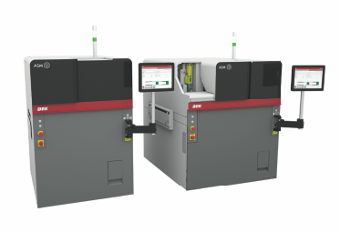
Even more flexibility with the DEK TQ printing platform from ASMPT: The new DEK TQ L (right) processes circuit boards measuring up to 600 by 510 millimeters.

Source: ASMPT

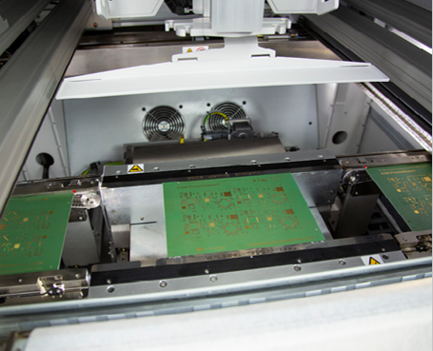
Three-stage conveyor system: While one board is being printed, the previously printed board is moved out of the machine and the next board moved into the machine.

Source: ASMPT

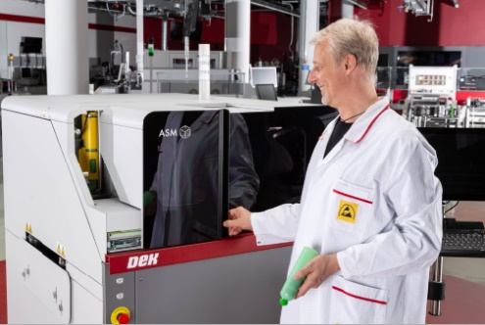
Fewer line stops: The optional Dual Access Cover makes it possible to replace paste cartridges without having to stop the printer.

Source: ASMPT

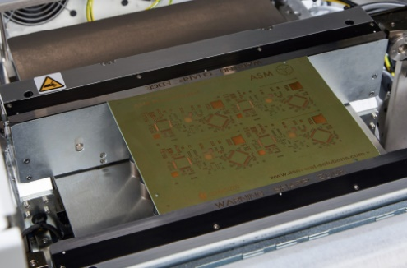
DEK All-Purpose Clamping (APC): The by far most flexible DEK clamping system features job-specific programming, saves time and effort, and offers significantly more capabilities.

Source: ASMPT

About ASMPT Limited (“ASMPT”)
ASMPT (HKEX stock code: 0522) is a leading global supplier of hardware and software solutions for the manufacture of semiconductors and electronics. Headquartered in Singapore, ASMPT’s offerings encompass the semiconductor assembly & packaging, and SMT (surface mount technology) industries, ranging from wafer deposition, to the various solutions that organise, assemble and package delicate electronic components into a vast range of end-user devices, which include electronics, mobile communications, computing, automotive, industrial and LED (displays). ASMPT partners with customers very closely, with continuous investment in R&D helping to provide cost-effective, industry-shaping solutions that achieve higher productivity, greater reliability and enhanced quality.
ASMPT is one of the constituent stocks of the Hang Seng Composite MidCap Index under the Hang Seng Composite Size Indexes, the Hang Seng Composite Information Technology Industry Index under Hang Seng Composite Industry Indexes and the Hang Seng HK 35 Index.
To learn more about ASMPT, please visit us at asmpt.com.

The ASMPT SMT Solutions segment
The mission of the SMT Solutions segment within ASMPT is to implement and support the Integrated Smart Factory at electronics manufacturers worldwide.
ASM solutions support the networking, automation and optimization of central workflows with hardware, software and services that enable electronics manufacturers to transition to the Integrated Smart Factory in stages and enjoy dramatic improvements in productivity, flexibility and quality. With the integrated concept "Open Automation", ASM opens the door for its customers to economically feasible automation, entirely in accordance with their individual requirements - modular, flexible, and vendor-independent.
The product range includes hardware and software such as SIPLACE placement solutions, DEK printing solutions, inspection and storage solutions, and the Smart Shopfloor Management Suite Works. With Works, ASMPT offers electronics manufacturers high-quality software for planning, controlling, analyzing and optimizing all processes on the Shopfloor.
Since maintaining close relationships with customers and partners is a central component of ASMPT’s strategy, the company has established the SMT Smart Network as a global forum for the active exchange of information between and with smart champions.
For more information about ASMPT visit www.smt.asmpt.com.

Media contacts:
AMCAS ASMPT Press Office
SMT Solutions
Mark Ogden
Tel.: +1 (770) 797 3189
E-mail: ogden.mark@asmpt.com
Website: smt.asmpt.com

Global ASMPT Press Office
ASM Assembly Systems GmbH & Co. KG
Susanne Oswald
Rupert-Mayer-Strasse 44
81379 Munich
Germany
Tel: +49 89 20800-26439
E-Mail: susanne.oswald@asmpt.com
Website: smt.asmpt.com

