PRESS RELEASE
Dedicated customer care on site:
Würth Elektronik ICS founds subsidiary in Italy
Niedernhall, Germany, 03 August 2022 – Würth Elektronik ICS, the leading system and component provider for solutions for signal and power distribution, control, display and operation of functions in mobile machinery and commercial vehicles, is expanding its activities in the key market Italy: the new subsidiary Würth Elektronik ICS Italia s.r.l. located in San Giovanni Lupatoto near Verona will offer customers even more comprehensive local support.
Würth Elektronik ICS has been supplying Italian OEMs with electronic and electromechanical solutions for many years. Due to increasing demand and the high number of leading manufacturers of mobile machinery and commercial vehicles, the company has decided to expand its presence in Italy even further. The new company Würth Elektronik Italia s.r.l. was founded in early November 2021 to take over operational support of customers in Italy.
Broad range of tasks
In addition to technical sales and commercial customer support, the tasks of the new Würth Elektronik ICS subsidiary and its presently seven employees include product management and field application engineering in the HMI sector.
Marco Jauchstetter, Sales Manager of the Würth Elektronik ICS Group, is now also in charge of managing the new Italian company. On site, Paolo Bricola handles business development in the HMI sector, and Sabatino Scarpitto is responsible for sales.
Focus on growth market
‘The Italian technology sector is one of our most important growth markets’, explains Bricola. ‘Our high-quality, standardised or customised solutions help powerful local manufacturers and solution providers make their products more competitive with our innovative solutions.’

Available images
The following images are available for download in printable format at:
https://kk.htcm.de/press-releases/wuerth-ics/
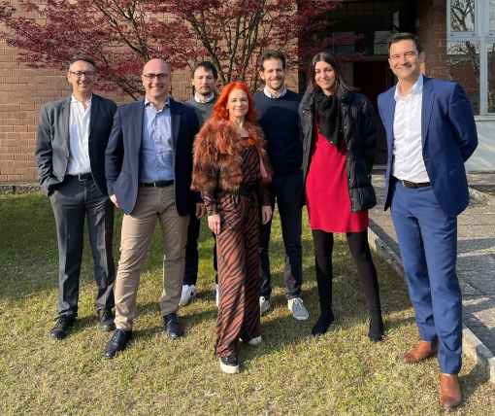
Image source: Würth Elektronik ICS
The Würth Elektronik ICS Italia s.r.l. team

About Würth Elektronik ICS GmbH & Co. KG
Würth Elektronik ICS is a system supplier for electromechanical and electronic solutions for signal and electricity distribution, controlling functions and display and operating solutions. Its main customers include well-known manufacturers of construction and agricultural machinery, as well as commercial vehicles. Sectors such as industrial technology or renewable energies also benefit from products and services provided by ICS. Its company headquarters are located in Niedernhall-Waldzimmern, Germany. There are subsidiaries of the company in France, Italy, the UK, the US and India.
As a member of the Würth Elektronik group of companies, the company belongs to the Würth Group, the world market leader for assembly and fastening technology. In 2021, the 8,000 employees of the Würth Elektronik group of companies generated sales of €1.09 billion.

Würth Elektronik: more than you expect!
You can find more information at www.we-online.de/ics

Further information:  Würth Elektronik ICS GmbH & Co. KG  Sandra Herter  Gewerbepark Waldzimmern  Würthstrasse 1  74676 Niedernhall, Germany  Tel.: (+49-7940) 9810-1503  E-mail: sandra.herter@we-online.de  www.we-online.de/ics | Press contact:  HighTech communications GmbH  Christian Resch  Brunhamstrasse 21  81249 Munich, Germany  Tel.: (+49-89) 5007-7823  Fax: (+49-89) 5007-7877  E-mail: c.resch@htcm.de  www.htcm.de/en/

