PRESS RELEASE
OPEN MIND Presents hyperMILL® MEDICAL Solutions
Optimized toolpaths for medical engineering components
Wessling (Germany), August 3, 2022 – OPEN MIND Technologies AG offers hyperMILL® MEDICAL Solutions for companies that handle demanding machining tasks for the medical industry. Manufacturers of implants and bone plates in various standard sizes benefit in particular from automated CAM programming. Optimized toolpaths protect machines and tools, enable safe and efficient processes, and ensure high surface qualities.
Bone plates made of titanium, intervertebral implants made of PEEK, forged dies for the production of hip stems, knee prosthesis sliding components made of ultra-high molecular weight polyethylene... Despite the diverse range of shapes and materials, what most machining tasks have in common is a high level of complexity. As one of the leading CAM systems for 5-axis machining, hyperMILL® has made a name for itself in programming efficient toolpaths for implants and other medical engineering products. When it comes to producing high-quality surfaces with minimum need for finishing, OPEN MIND offers optimized finishing strategies that ensure, for example, perfect transitions between different sections.
Tools and toolpaths
A key feature of hyperMILL® MEDICAL Solutions is its powerful tool database with interfaces to catalogs from renowned tool manufacturers. Special tools can also be mapped in the tool database. Materials suitable for medical applications – be it titanium, cobalt-chromium alloys, or temperature-sensitive plastics such as UHMWPE – are usually difficult to machine. It is therefore important to select suitable tools and cutting parameters and to account for these when programming the toolpaths with 2.5D, 3D, or 5-axis strategies.
Automated programming
hyperMILL® MEDICAL Solutions shines when it comes to accommodating the need for patient-specific adjustments, the various standard sizes and part families, as well as the associated automation of NC code generation. The hyperMILL® AUTOMATION Center allows users to define and standardize CAD/CAM processes. This includes the specification of steps for data preparation and programming, right up to simulation and NC program generation. Once this has been done, the process is deployed and carried out on new components automatically. This makes it possible to automatically prepare and program machining projects. Automation can be learned by any CAM user with ease, but OPEN MIND also offers support for the automation of CAD/CAM processes. Numerous satisfied customers of automation projects can testify to the solution’s enormous potential for saving time.
Users in medical technology who already use hyperMILL® greatly appreciate the CAD/CAM suite. As Frank Fedtke, a CAM expert at Aesculap AG in south-west Germany, puts it: “Aesculap opted for hyperMILL® in 2008 with the aim of further increasing productivity. We needed to speed up the process of bringing NC programs to the machines as well as making them more reliable. Processing times had to be reduced while maintaining the same level of quality. Thanks to hyperMILL®, we were able to achieve these goals very quickly.”

Available images
The following images are available for download in printable format at:
https://kk.htcm.de/press-releases/open-mind/

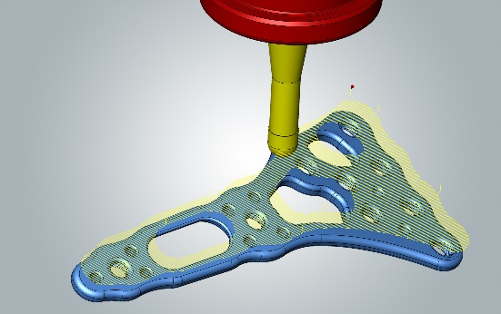  Source: OPEN MIND  hyperMILL® 5-axis strategies for excellent, seamless surfaces | 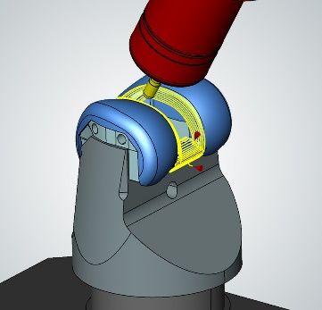  Source: OPEN MIND  Machining of a femoral component: Major time savings can be achieved with barrel cutters.
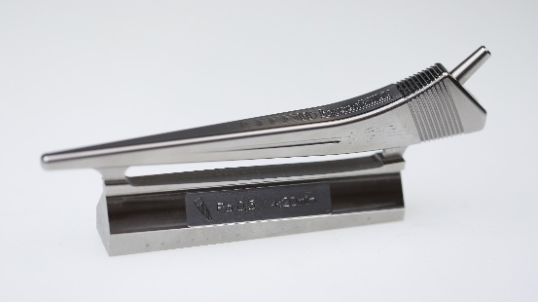
Source: OPEN MIND

Hip shaft made of titanium – hyperMILL® provides innovative strategies for machining materials that are difficult to process.
Available videos
You can find the following videos on our YouTube channel: https://youtu.be/7dR_O7VlZL0
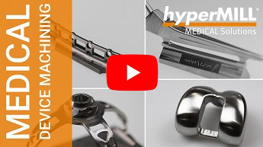
Source: OPEN MIND

hyperMILL® Medical Solutions: Always the right toolpath for any medical engineering product
About OPEN MIND Technologies AG
OPEN MIND is one of the world’s most sought-after developers of powerful CAM solutions for machine and controller-independent programming.
OPEN MIND develops optimized CAM solutions that include a high number of innovative features not available elsewhere to deliver significantly higher performance in both programming and machining. Strategies such as 2.5D, 3D as well as 5-axis milling/mill turning, and machining operations like HSC and HPC are efficiently built into the hyperMILL® CAM system. hyperMILL® provides the maximum possible benefits to customers thanks to its full compatibility with all current CAD solutions and extensive programming automation.
OPEN MIND strives to be the best and most innovative CAD/CAM manufacturer in the world, helping it become one of the top five in the CAM industry according to the “NC Market Analysis Report 2022” compiled by CIMdata. The CAD/CAM solutions of OPEN MIND fulfil the highest demands in the automotive, tool and mold manufacturing, production machining, medical, job shops, energy and aerospace industries. OPEN MIND is represented in all key markets in Asia, Europe and America, and is a Mensch und Maschine company.

You can find more information at www.openmind-tech.com.

OPEN MIND Technologies UK Ltd., Oxford
Unit 3
Bicester Business Park
Telford Road
Bicester
Oxfordshire OX26 4LN
England
Phone: +44 1869 290 003
Fax: +44 1869 369 429
E-mail: Info.UK@openmind-tech.com

OPEN MIND Technologies USA, Inc.
1492 Highland Avenue, Unit 3
Needham MA 02492
USA
Phone: +1 339 225 4557 office
Phone: +1 888 516 1232 x0 toll-free
Fax: +1 270 912 5822
E-mail: Info.Americas@openmind-tech.com

Head office:
OPEN MIND Technologies AG, Argelsrieder Feld 5, 82234 Wessling, Germany
Tel.: (+49-8153) 933-500, Fax: (+49-8153) 933-501
E-mail: Info@openmind-tech.com, website: www.openmind-tech.com

Press contact:
HighTech communications GmbH
Brigitte Basilio
Brunhamstrasse 21
81249 Munich
Germany
Tel.: (+49-89) 500778-20
Fax: (+49-89) 500778-78
E-mail: b.basilio@htcm.de
Website: www.htcm.de

