PRESS RELEASE
RE Thompson has chosen OPEN MIND’s CAM System
Fully Charged with hyperMILL®
Wessling (Germany), July 26, 2022 – The pandemic has undoubtedly changed the way we work, but for OPEN MIND Technologies, undergoing an extensive online tendering and prove-out process against its competitors was an exciting new challenge. RE Thompson has ambitious plans for its manufacturing facility and implementing the correct CAM system was seen as a critical decision requiring due diligence for the subcontract manufacturer.
Founded in 1948, RE Thompson has manufactured aerospace components for more than 60 years, diversifying into the electronics and semiconductor, medical, hydrogen, and electric vehicle (EV) sectors in its more recent history. To undertake this diversification, the company has invested over £7m in the last 10 years; an investment that includes opening a second 20,000sq/ft manufacturing facility, installing advanced fibre connectivity and decarbonising infrastructure and new machine tools.
The next step for the Hampshire company is to increase throughput and automation. Unlike most subcontractors, RE Thompson already has impressive factory floor automation with a remarkable 512 pallets on just nine machining centres. The bottleneck for RE Thompson has been the process flow away from the factory floor – primarily CAM programming.
Commenting upon the existing system, Company Owner Michael Thompson says: “The system was falling down on meeting our requirements. We first put the old system in our factory around 30 years ago and over the years it has failed to keep up with technology.”
After selecting OPEN MIND, Mr Thompson reveals: “We looked at five or six systems. It was a very short review, as we quickly narrowed it down to two packages. hyperMILL® is very well supported in the UK, lots of prestigious companies use it and there is local support. However, local support is now increasingly irrelevant, we have been implementing the system with OPEN MIND over Teams during Covid and have yet to meet them in person. We sometimes have people in 6 to 8 locations working from home, so being able to implement hyperMILL® with everyone involved has been fantastic. We found that hyperMILL® had advanced tool path strategies and the overall support was outstanding.”
“The flexibility of hyperMILL® is second to none and they have really honed in on 3 and 5-axis strategies as well as turning – with its reputation in high-end 5-axis machining, we were very surprised by how good the turning package is.”
Looking at particular components manufactured by RE Thompson, Michael says: “hyperMILL® will help us with very small parts where we want to make multiples through to very large semi-conductor chambers. There was one part in the MPI stage that would save us a staggering four days by using hyperMILL®. This saving will be achieved through automating datum settings. These jobs can take weeks to programme, but just in one area, hyperMILL® will make a huge 4-day saving – that is just phenomenal.”
“When you have a lot of datums and ports on a job, we have to set those all individually and markdown in detail what had been set up. With hyperMILL®, it just does it for you. This saving is just in setting the jobs, it doesn’t even account for the possible savings in overall programming and machining. When it comes to machining cycles and retracts, hyperMILL® will naturally follow the shortest tool path – at present, our system retracts the tool all the way out for each process. This will save a huge amount of time on machining cycles.”
On the factory floor, the company produces everything from 1-offs to runs of hundreds of parts. Turning naturally has higher production volumes, but some milling jobs can be up to 500-off a year. New business is from the semi-conductor, maritime autonomous vehicle, aerospace enclosure, hydrogen, and EV industries – all requiring ever-faster turnaround times.
Off-machine savings
Looking at this evolving mix of work, Michael continues: “Where hyperMILL® will make a difference is during the time from order receipt to first-off production. We expect lead times to be hugely reduced. It means our productivity will at least double as we can do the MPI and produce a lot more in a shorter time. We will be investing in 10 seats of hyperMILL®, but I expect this to double and eventually increase fourfold, as we expect our throughput to more than double with hyperMILL®.”
As Head of Sales, Matthew Shaw adds: “The addition of hyperMILL® will be great for the sales team, as we will have more capacity to sell. hyperMILL® will give us greater speed to market, a faster-quoting process and with improved throughput, our lead-times will improve significantly.”
With regards to being more competitive, Michael says: “Sometimes we weren’t competitive machining propeller blades or impellers, as we couldn’t use barrel tools. So, our sales team had trouble selling that facility. With hyperMILL®, we will be able to utilise all of those tools and strategies. The tool library is also very impressive. Having the facility to build a tool library with comprehensive data on machining parameters excites our team, and OPEN MIND has even more features in the pipeline,” concludes Michael.

Available images
The following images are available for download in printable format at:
https://kk.htcm.de/press-releases/open-mind/
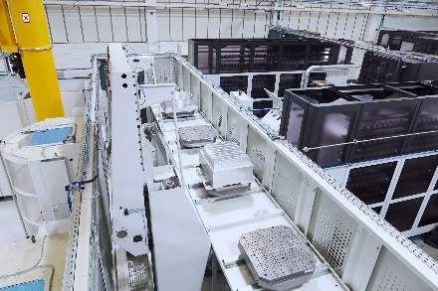  Image source: OPEN MIND  5 axis machining of large parts at RE Thompson | 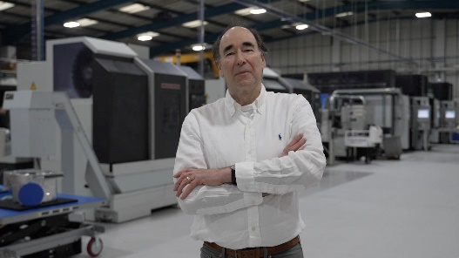  Image source: OPEN MIND  Michael Thompson from RE Thompson
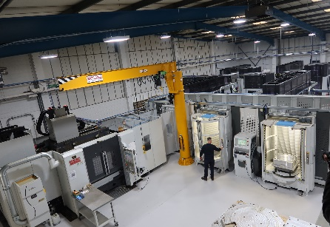
Image source: OPEN MIND

The production floor at RE Thompson with automated cells 1
About OPEN MIND Technologies AG
OPEN MIND is one of the world’s most sought-after developers of powerful CAM solutions for machine and controller-independent programming.
OPEN MIND develops optimized CAM solutions that include a high number of innovative features not available elsewhere to deliver significantly higher performance in both programming and machining. Strategies such as 2.5D, 3D as well as 5-axis milling/mill turning, and machining operations like HSC and HPC are efficiently built into the hyperMILL® CAM system. hyperMILL® provides the maximum possible benefits to customers thanks to its full compatibility with all current CAD solutions and extensive programming automation.
OPEN MIND strives to be the best and most innovative CAD/CAM manufacturer in the world, helping it become one of the top five in the CAM industry according to the “NC Market Analysis Report 2022” compiled by CIMdata. The CAD/CAM solutions of OPEN MIND fulfil the highest demands in the automotive, tool and mold manufacturing, production machining, medical, job shops, energy and aerospace industries. OPEN MIND is represented in all key markets in Asia, Europe and America, and is a Mensch und Maschine company.

You can find more information at www.openmind-tech.com.

OPEN MIND Technologies UK Ltd., Oxford
Unit 3
Bicester Business Park
Telford Road
Bicester
Oxfordshire OX26 4LN
England
Phone: +44 1869 290 003
Fax: +44 1869 369 429
E-mail: Info.UK@openmind-tech.com

OPEN MIND Technologies USA, Inc.
1492 Highland Avenue, Unit 3
Needham MA 02492
USA
Phone: +1 339 225 4557 office
Phone: +1 888 516 1232 x0 toll-free
Fax: +1 270 912 5822
E-mail: Info.Americas@openmind-tech.com

Head office:
OPEN MIND Technologies AG, Argelsrieder Feld 5, 82234 Wessling, Germany
Tel.: (+49-8153) 933-500, Fax: (+49-8153) 933-501
E-mail: Info@openmind-tech.com, website: www.openmind-tech.com

Press contact:
HighTech communications GmbH
Brigitte Basilio
Brunhamstrasse 21
81249 Munich
Germany
Tel.: (+49-89) 500778-20
Fax: (+49-89) 500778-78
E-mail: b.basilio@htcm.de
Website: www.htcm.de

