PRESS RELEASE
OPEN MIND’s CAD/CAM Suite hyperMILL® Successfully Presented at Birmingham Exhibition
Best MACH Ever!
Wessling (Germany), April 27, 2022 – Recognized as the industry’s leading CAM/CAD system for everything from 3-axis to complex 5-axis machining, OPEN MIND Technologies demonstrated exactly why at MACH 2022 with its latest hyperMILL® Version 2022.1. As expected, the crowds on the OPEN MIND stand throughout MACH week far exceeded that of its rivals – and it was no wonder with the level of innovations in the latest version of hyperMILL® highlighting why this CAM system is light years ahead of its competition.
Commenting upon the MACH show, OPEN MIND UK’s Sales Director Ken Baldwin beamed: “We almost received too many leads to deal with! The show was the best MACH we have ever done and out of the hundreds of leads we received, there are upward of 70 companies that want to purchase hyperMILL® straight away. We had six demonstration pods on our stand and the team was extremely busy all week with queues for demonstrations every day.”
“MACH 2022 really was a tipping point for the OPEN MIND brand in the UK. We have been building the brand and the technology has been edging further beyond the realms of our competitors for some years; but at MACH, the visitors were purposely seeking us out. Our visitors were a combination of businesses that had recommendations to buy hyperMILL® from customers, suppliers, colleagues and the machine tool companies that were fellow exhibitors at MACH. With MACH being the first major UK show since the pandemic, visitors came with an intent to buy – and for those companies investing in new machinery, they were subsequently directed to our stand by the machine tool suppliers. This exemplifies not just our relationship with the machine tool vendors, but also the ability of hyperMILL® to help engineers get the most out of their machine tools. Over the next couple of weeks, our team will be collecting orders from stand visitors that were immediately sold on hyperMILL® whilst other manufacturers are keen to step away from existing CAD/CAM suppliers and move to OPEN MIND. MACH 2022 was a resounding success and our team will be busy for months after such a successful show.”
The latest edition of hyperMILL®, Version 2022.1 is packed with an abundance of innovations for enhancing productivity, performance and programming times for components produced on machining centers – but this latest version also incorporates a wealth of new features for its turning cycles. It is for this reason, so many show visitors made a beeline for the OPEN MIND stand at MACH.
In hyperMILL® Version 2022.1, the company presented two new feature types that make turning processes much easier and faster – enhancing its reputation in the field of turned parts. OPEN MIND also showcased its automated program generation potential with the hyperMILL® AUTOMATION Center. The hyperMILL® AUTOMATION Center allows users to automate the job list creation process as well as the selection and positioning of clamping devices.
With something for everyone, OPEN MIND also presented product enhancements for manufacturers utilizing EDM technology. This is a credit to the simple creation and subsequent modification of traverse paths during the EDM process with hyperCAD®-S Electrode. For the additive manufacturing sector, OPEN MIND has further enhanced its hyperMILL® ADDITIVE Manufacturing solution and the latest version opens up an array of flexible options for Directed Energy Deposition processes (DED) and Wire Arc Additive Manufacturing (WAAM) in terms of highly complex 5-axis simultaneous processing. hyperMILL® also allows the potential of additive manufacturing to be truly exploited using Powder Bed Fusion (PBF). With such a remarkable diversity of solutions, it was no wonder that MACH 2022 was such a success.

Available images
The following images are available for download in printable format at:
https://kk.htcm.de/press-releases/open-mind/

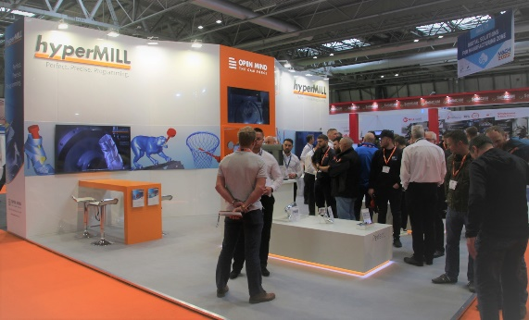  Source: OPEN MIND  The crowds gather on the OPEN MIND Stand at MACH 2022 | 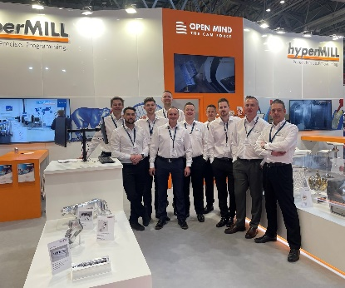  Source: OPEN MIND  The OPEN MIND UK Team at MACH 2022

About OPEN MIND Technologies AG
OPEN MIND is one of the world’s most sought-after developers of powerful CAM solutions for machine and controller-independent programming.
OPEN MIND develops optimized CAM solutions that include a high number of innovative features not available elsewhere to deliver significantly higher performance in both programming and machining. Strategies such as 2.5D, 3D as well as 5-axis milling/mill turning, and machining operations like HSC and HPC are efficiently built into the hyperMILL® CAM system. hyperMILL® provides the maximum possible benefits to customers thanks to its full compatibility with all current CAD solutions and extensive programming automation.
OPEN MIND strives to be the best and most innovative CAD/CAM manufacturer in the world, helping it become one of the top five in the CAM industry according to the “NC Market Analysis Report 2021” compiled by CIMdata. The CAD/CAM solutions of OPEN MIND fulfil the highest demands in the automotive, tool and mold manufacturing, production machining, medical, job shops, energy and aerospace industries. OPEN MIND is represented in all key markets in Asia, Europe and America, and is a Mensch und Maschine company.

You can find more information at www.openmind-tech.com.

OPEN MIND Technologies UK Ltd., Oxford
Unit 3
Bicester Business Park
Telford Road
Bicester
Oxfordshire OX26 4LN
England
Phone: +44 1869 290 003
Fax: +44 1869 369 429
E-mail: Info.UK@openmind-tech.com

OPEN MIND Technologies USA, Inc.
1492 Highland Avenue, Unit 3
Needham MA 02492
USA
Phone: +1 339 225 4557 office
Phone: +1 888 516 1232 x0 toll-free
Fax: +1 270 912 5822
E-mail: Info.Americas@openmind-tech.com

Head office:
OPEN MIND Technologies AG, Argelsrieder Feld 5, 82234 Wessling, Germany
Tel.: (+49-8153) 933-500, Fax: (+49-8153) 933-501
E-mail: Info@openmind-tech.com, website: www.openmind-tech.com

Press contact:
HighTech communications GmbH
Brigitte Basilio
Brunhamstrasse 21
81249 Munich
Germany
Tel.: (+49-89) 500778-20
Fax: (+49-89) 500778-78
E-mail: b.basilio@htcm.de
Website: www.htcm.de

