PRESS RELEASE
Swissbit expands its SD memory card portfolio with S-55 and S-58 series
New product line launched with 3D-TLC SDHC and SDXC memory cards for industrial applications
Bronschhofen, Switzerland. April 26, 2022 – Swissbit is expanding its range of industrial grade SD and microSD memory cards. With "high reliability" at their core, the new S-55 and S-58 series integrate state-of-the-art technologies, making them the first choice for demanding applications. Swissbit accomplishes this by combining leading-edge industrial grade 3D TLC NAND technology with a powerful controller and firmware optimized for maximum reliability. The SD and microSD cards are available in capacities ranging from 16 to 512 GB and support an extended temperature range of -40 to +85 °C. The new S-55 and S-58 series are based on Micron flash chips and complement Swissbit's existing S-50 and S-56 series, which use Kioxia 3D NAND. This provides Swissbit customers with the greatest possible flexibility for the selection of the most suitable cards for specific requirements and applications.
The new SDHC/SDXC S-55 and S-58 series provide all the prerequisites for their intended applications in areas such as data logging, IPCs, HMI units, POS/POI terminals, and medical and surveillance applications. For example, all cards are designed for temperatures ranging from -40 to +85 °C and optimized to tolerate temperature fluctuations between read and write operations across the entire specified temperature range. This reduces servicing intervals and lowers the total cost of ownership (TCO).
Maximum reliability is also ensured by 120bit LDPC error correction, full page fail protection, read disturb management, background data refresh, data recovery following a sudden power loss, and sophisticated static and dynamic wear leveling. A molded SiP package with gold contacts completes the feature set, providing optimal protection against high mechanical stress and environmental influences even in harsh environments.
Capacity and compatibility
The new memory cards are SD-6.1 compliant and support both the common SPI interface mode in embedded systems and the UHS-I interface mode. They reach UHS speed class U3 or respectively speed class 10, as well as application class A2 and video speed class V30.
The S-55 is available in capacities ranging from 64 to 512 GB, with the microSD version S-55u offering between 64 and 256 GB choices.
Swissbit of course continues to offer a 3D pSLC mode option with its S-58 series, which is particularly well-suited for applications requiring extensive recording of small data blocks or constant high workloads. Along with capacities ranging from 16 to 128 GB (S-58) and 16 to 64 GB (S-58u), the pSLC versions provide up to ten times the longevity and up to twice the speed.
Long-term availability and NAND architecture selection
With the release of the S-55 and S-58 series, Swissbit maintains its commitment to supplying memory cards of the highest quality at competitive prices while assuring long-term availability. This is further underlined by the fact that Swissbit now offers NAND flash in its SD card portfolio from its two strategic partners, Kioxia and Micron. In addition to the new series based on Micron’s 3D NAND, Swissbit already offers memory cards from its S-50/S-56 range fitted with Kioxia’s flash chips. While the performance specifications and reliability advantages of both series are almost identical, the S-50/S-56 series is also available in capacities as low as 4 GB. Additionally, this strategic alignment enables customers to fully respond to short-term market fluctuations by ensuring the capacity to deliver at any.
With the broad range of "high reliability" SD and microSD cards, Swissbit provides its customers with the greatest possible choice and planning security – as well as the perfect opportunity to switch from legacy NAND technologies such as 2D MLC or SLC to the latest 3D TLC generation.

Available images
The following images are available for download in printable format at: https://kk.htcm.de/press-releases/swissbit/
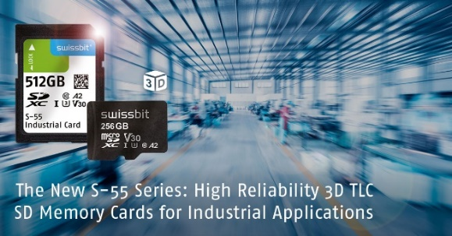  Image Source: Swissbit  Highest reliability and suitability for demanding industrial applications: Swissbit's S-55 and S-58 SD-card series. | 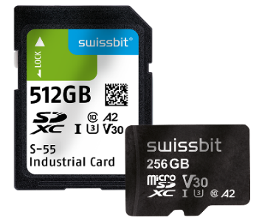  Image Source: Swissbit  SD- and microSD-cards from Swissbit’s new S-55 series.

About Swissbit
Swissbit AG is the leading European manufacturer of storage, security and embedded IoT solutions for demanding applications. Swissbit combines its unique competences in storage and embedded IoT technology with its advanced packaging know how. This expertise allows our customers to reliably store and protect data in industrial, NetCom, automotive, medical and fiscal applications as well as across the Internet of Things (IoT).
Swissbit develops and manufactures industrial-grade storage and security products “Made in Germany” with high reliability, long-term availability, and custom optimization.
Swissbit’s storage range includes SSDs with PCIe and SATA interface such as mSATA, Slim SATA, CFast™, M.2 and 2.5” as well as CompactFlash, USB flash drives, SD Memory Cards, micro SD Memory Cards and managed NAND BGAs like e.MMC. Security products are available in various application specific editions as USB flash drives, SD Memory Cards, and micro SD Memory Cards.
Swissbit was founded in 2001 and has offices in Switzerland, Germany, USA, Japan and Taiwan. Swissbit owns the registered trademarks Swissbit® and Hyperstone®. Since 2020, the independent investment firm Ardian is holding a majority stake in the company to support its growth.
For further information, please visit www.swissbit.com

Regional Headquarters:
Swissbit Germany AG
Bitterfelder Strasse 22
12681 Berlin
Germany
Tel: +49 30 936 954 0
Email: info@swissbit.com
www.swissbit.com
Headquarters:
Swissbit AG
Industriestrasse 4
9552 Bronschhofen
Switzerland
Tel: +41 71 913 03 03
Email: info@swissbit.com
www.swissbit.com

Contact:  Swissbit AG  Marian Weber  Industriestrasse 4  9552 Bronschhofen  Switzerland  Tel: +49 172 854 88 26  Email: marian.weber@swissbit.com  www.swissbit.com | Press Agency:  HighTech communications GmbH  Brigitte Basilio  Brunhamstrasse 21  81249 Munich  Germany  Tel: +49 89 500778-20  Fax: +49 89 500778-77  Email: b.basilio@htcm.de  www.htcm.de

