PRESS RELEASE
A new box complements REDline Power Boxes platform from Würth Elektronik ICS
Sealed solution for primary power distribution
Niedernhall (Germany), April 07, 2022 – Six MIDI fuses in one robust, IP66-compliant housing: The REDline Power Box 6F is the latest development in the family of REDline Power Boxes, the successful power distribution platform from Würth Elektronik ICS, used for installation in battery, engine and chassis areas.
Measuring only 170 x 112 x 48 mm, the compact sealed housing provides space for up to six MIDI fuses in 32 V and 70 V versions. The high IP rating allows OEMs to install the box in chassis, battery and engine areas. The box can operate at temperatures ranging from -40°C to +85°C.
The REDline Power Box 6F can also be used in 48 V on-board electrical networks thanks to its compatibility with 70 V fuses, meaning it can also be used in electromobility projects.
Cost-effective solution with a long service life
OEMs receive a cost-effective solution with a long service life compared to conventional outdoor fuse boxes that are unprotected. Like all boxes in the product family, the REDline Power Box 6F is connectorised so it can be connected quickly to the cable harness in production, and it can be easily and efficiently serviced.
The new box represents a seamless continuation of the proven concept and offers customers benefits such as short time-to-market, high cost efficiency and an impressive service concept.

Available images
The following images can be downloaded from the Internet in printable quality: https://kk.htcm.de/press-releases/wuerth-ics/

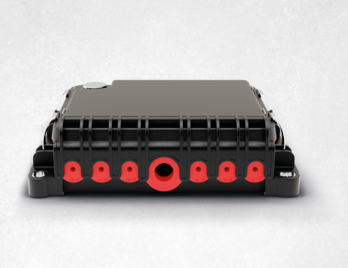
Image source: Würth Elektronik ICS
The REDline Power Box 6F from Würth Elektronik ICS offers space for up to six MIDI fuses in its sealed housing for implementation in harsh environments.

About Würth Elektronik ICS GmbH & Co. KG
Würth Elektronik ICS is a system supplier for electromechanical and electronic solutions for signal and power distribution, control, and display and operating solutions. The company’s key customers include well-known manufacturers of construction and agricultural machinery as well as commercial vehicles. Sectors such as industrial technology or renewable energies also benefit from products and services provided by ICS. The company is headquartered in Niedernhall-Waldzimmern (Germany). Further subsidiaries are located in France, Great Britain, Italy, the USA, and India.
The company is part of the Würth Elektronik Group and therefore belongs to the Würth Group, the global leader for assembly and fastening technology. In 2021, the Würth Elektronik Group generated sales of EUR 1.09 billion with around 8,000 employees.
Würth Elektronik: more than you expect!
Further info at www.we-online.com/ics

More information:  Würth Elektronik ICS GmbH & Co. KG  Sandra Herter  Gewerbepark Waldzimmern  Würthstrasse 1  74676 Niedernhall  Germany  Phone: +49 7940 9810-1503  E-mail: sandra.herter@we-online.de  www.we-online.com/ics | Press contact:  HighTech communications GmbH  Christian Resch  Brunhamstrasse 21  81249 Munich  Germany  Phone: +49 89 500778-23  Telefax: +49 89 500778-77  E-mail: c.resch@htcm.de  www.htcm.de

