PRESS RELEASE

Centrally control transport robots from different manufacturers
sloXis®: cts presents new middleware for heterogeneous AMR/AGV fleets
Burgkirchen (Germany), 04 April 2022 – Administration, control, synchronization, monitoring and communication - the management of autonomous transport systems holds pitfalls. The automation specialist cts GmbH offers with sloXis® a middleware in constant further development, with which AMR fleets of different manufacturers can be harmonized. The web-based, custom-fit and modular solution supports native interfaces and the open VDA5050 standard, includes smart functions and thus enables the seamless integration of transport robots from a wide range of manufacturers. This includes communication with higher-level company systems, machines as well as production lines. sloXis® can be easily integrated into existing infrastructures.

AMR fleets are increasingly taking over important tasks in the internal material flow process. However, the systems of the various manufacturers of transport robots are rarely compatible with each other. This applies primarily to the fleet management and the control software. With the middleware sloXis®, cts has introduced a solution that provides various native interfaces for the integration of heterogeneous AMR systems: in addition to platforms from omron, MIR and Magazino, sloXis® also supports the core functions of the open VDA5050 standard and thus a large number of manufacturers. The integration of conventional floor conveyors as well as the communication with PLC controls of production machines and lines, fire alarm systems, building technology such as automatic doors or elevators and peripheral devices is also possible with it. sloXis® takes over the control, management, coordination and synchronization of all connected systems.
Heart of smart intralogistics
"Our guiding principle 'More.than.Automation' is especially true for the new middleware sloXis®, Smart Logistics Orchestration & Integration Service," comments Philipp Eberherr, Head of Smart Logistics at cts about the completely revised and improved successor of the middleware AIV Framework. "But sloXis® is not simply an interface for connecting autonomous mobile transport robots or industrial robots with enterprise systems. Rather, our brand new middleware enables seamless integration of homogeneous and heterogeneous fleets into existing system landscapes across a wide range of industries and industry segments." Eberherr continues, "What is unique here is the holistic linking of hardware and software in intralogistics."
Intuitive operation
The operation of sloXis® is completely web-based. All tasks can be controlled and executed intuitively and independent of location from computers, tablets, smartphones or other smart devices. In addition, intuitive modules such as the Universal Map ensure simple and efficient operation: Similar to Google Maps, the map of the production environment not only transmits the current location of all AMR, it also provides an overview of all relevant data on machines and plants with a click - and in real time. Users also have the possibility to create workflows for driving jobs: They can be automatically transferred from higher-level systems, created and transmitted using corresponding templates from the SmartSignalManager module, or individually designed using graphical overviews.
Modular conception creates future security
sloXis® brings everything companies need to manage their transport robot fleets. By means of a completely modular design, sloXis® can be further adapted to individual needs in an optimal way: from the automatic generation of transport orders to role-based configurations, tracking solutions and extensions of communication options to comprehensive door and elevator control and the connection to fire alarm systems. sloXis® grows with the company's requirements and adapts to changes in an optimal way without major effort.
AIV Framework becomes sloXis®
With a wide range of AMR solutions and top modules and the proven middleware AIV Framework, cts has been one of the leading solution providers for automated intralogistics for quite some time. Now a new era starts: sloXis®: Orchestration. Integration. Automation - the motto is program: It has never been more uncomplicated for users to centrally administer and manage all AMR and machines, regardless of manufacturer, and to design the automated material flow optimally and efficiently - including comprehensive monitoring, tracing and reporting.
More information is available at www.sloxis.com

Available images
The following image material is available for download in printable form on the Internet: https://kk.htcm.de/press-releases/cts/

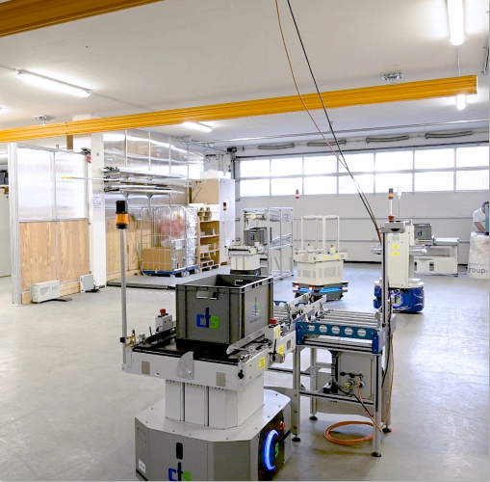
Source: cts GmbH
Fleets consisting of many different AMR can only be managed in a complicated way - the cts middleware sloXis® fully solves the problem.

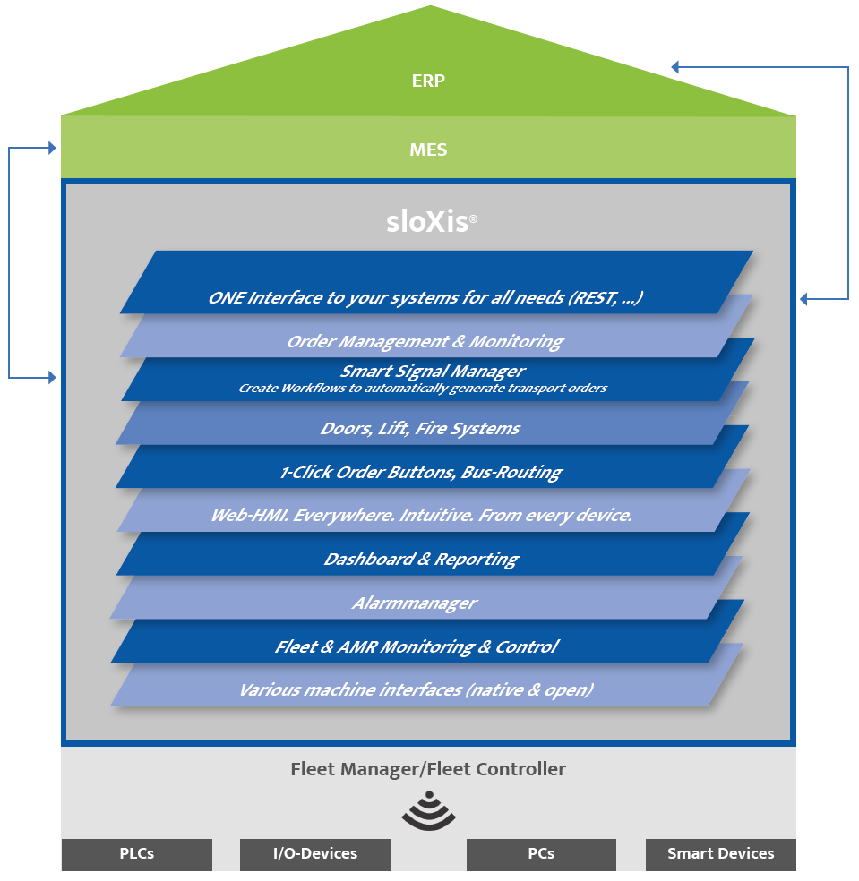
Source: cts GmbH
Orchestration. Integration. Automation. - sloXis® turns AMR from different manufacturers into a centrally controllable overall fleet including management of horizontal and vertical communication.

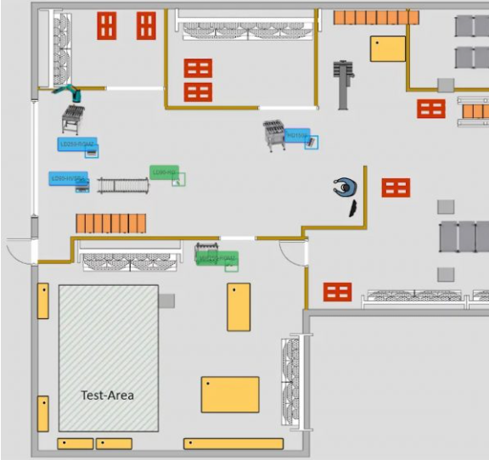
Source: cts GmbH
The Universal Map gives an overview of all AMR as well as machines and equipment in use - the operation is as simple as from Google Maps.

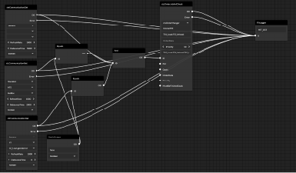
Quelle: cts GmbH
SmartSignalManager enables the user to create complex workflows for driving jobs easily and down to the smallest details.

About cts GmbH
"cts - more than automation": Burgkirchen-based cts GmbH, founded in 2006, offers customers a complete range of services for process and factory automation. More than 350 employees develop innovative solutions at several locations in Germany, Austria, the Czech Republic and Slovenia. They range from the construction of a single control cabinet to the automation of complete production plants, including information management. The comprehensive range of services offered by the established system integrator from southern Bavaria includes feasibility studies, conceptual design, planning, implementation, maintenance and servicing of running systems and plants.
cts installs stationary and mobile robots in plant and machine building for high-tech industries such as automotive, electronics, radiopharmaceuticals and the semiconductor industry. As one of the leading companies for the integration and operation of heterogeneous fleets of autonomous mobile robots (AMR/AIV/AGV/FTS), cts also sets standards in automated material supply. Here, cts solutions are often used in combination with production-related or centralized automated storage systems.
In highly sensitive industry segments such as chemicals and petrochemicals, life sciences or pharmaceuticals, cts supports its customers in the context of plant automation from planning to qualification. The Robotics business area of cts includes the programming, installation and optimization of welding and production robots as well as fully automated packaging systems. The extensive portfolio of the specialist for process and factory automation is complemented by software solutions for data acquisition, evaluation, visualization and optimization of machines as well as plants and a suitable service and support offer.
Further information is available at www.group-cts.de/en

Kontakt:  cts GmbH  Susanne Meidl  Fuhrmannstraße 10  84508 Burgkirchen  Deutschland  Mobil: +49 163 3054 186  E-Mail: Susanne.Meidl@group-cts.de  www.group-cts.de | Presseagentur:  HighTech communications GmbH  Christian Resch  Brunhamstraße 21  81249 München  Deutschland  Telefon: +49 89 500778-23  E-Mail: c.resch@htcm.de  www.htcm.de

