PRESS RELEASE
Würth Elektronik publishes an addition to the automotive catalog
Additional AEC-Q200 qualified components
Waldenburg (Germany), 30 March 2022—Automotive electronics are subjected to special requirements. This has resulted in industry-typical standards such as AEC-Q200 qualification or IATF-16949-certified production. In this context, Würth Elektronik has supplemented its extensive catalog for automotive components. The extension can be downloaded here.
Highlights among the new additions include WE-CAR-TEC and WE-CNSA. The WE-CAR-TEC series is a folding ferrite with a core material made of NiZn. WE-CAR-TEC allows the suppression of electromagnetic interference in the frequency range from 1 MHz to 1 GHz. Thanks to a patented closing mechanism, the ferrite is reusable and therefore also ideal for test and measurement purposes in EMC laboratories.
WE-CNSA is a current compensated data line filter. It offers high common mode noise rejection at high frequencies and a low RDC design. This makes the filter suitable for automotive infotainment, FlexRay and high-speed data line applications.

Available images
The following images can be downloaded from the Internet in printable quality: https://kk.htcm.de/press-releases/wuerth/
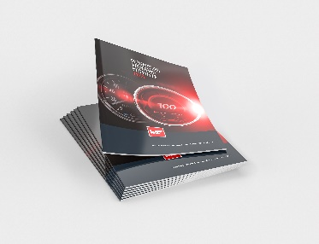
Würth Elektronik has added to its catalog for automotive components.
Image source: Würth Elektronik

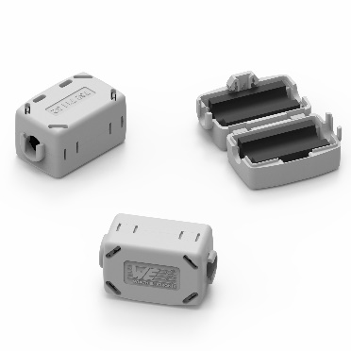
WE-CAR-TEC Snap Ferrite
Image source: Würth Elektronik

About the Würth Elektronik eiSos Group
Würth Elektronik eiSos Group is a manufacturer of electronic and electromechanical components for the electronics industry and a technology company that spearheads pioneering electronic solutions. Würth Elektronik eiSos is one of the largest European manufacturers of passive components and is active in 50 countries. Production sites in Europe, Asia and North America supply a growing number of customers worldwide.
The product range includes EMC components, inductors, transformers, RF components, varistors, capacitors, resistors, quartz crystals, oscillators, power modules, Wireless Power Transfer, LEDs, sensors, connectors, power supply elements, switches, push-buttons, connection technology, fuse holders and solutions for wireless data transmission.
The unrivaled service orientation of the company is characterized by the availability of all catalog components from stock without minimum order quantity, free samples and extensive support through technical sales staff and selection tools.
Würth Elektronik is part of the Würth Group, the world market leader for assembly and fastening technology. The company employs 8,000 staff and generated sales of 1.09 Billion Euro in 2021.
Würth Elektronik: more than you expect!
Further information at www.we-online.com

Further information:  Würth Elektronik eiSos GmbH & Co. KG  Sarah Hurst  Max-Eyth-Strasse 1  74638 Waldenburg  Germany  Phone: +49 7942 945-5186  E-mail: sarah.hurst@we-online.de  www.we-online.com | Press contact:  HighTech communications GmbH  Brigitte Basilio  Brunhamstrasse 21  81249 Munich  Germany  Phone: +49 89 500778-20  Telefax: +49 89 500778-77  E-mail: b.basilio@htcm.de  www.htcm.de

