PRESS RELEASE
Würth Elektronik, Analog Devices, Harting and Mouser jointly promote Single Pair Ethernet
Single is More
Waldenburg (Germany), March 24, 2022—Harting, Analog Devices and Würth Elektronik have joined forces to promote Single Pair Ethernet. Under the motto "Single is More" and in cooperation with Mouser, a joint landing page was created: https://eng.info.mouser.com/adi-wurth-harting-single-pair-ethernet In order to further strengthen the industrial use of the Ethernet variant, which was originally introduced in the automotive industry, the four companies summarize their matching products here. In addition, they provide white papers, videos and other useful information on the topic of 10BASE-T1L.
Würth Elektronik is committed to the use of SPE in industrial applications as a member of the Single Pair Ethernet Industrial Partner Network initiative. Information on circuit design and components can be found on the official WE website: www.we-online.com/spe.

Available images
The following images can be downloaded from the Internet in printable quality: https://kk.htcm.de/press-releases/wuerth/
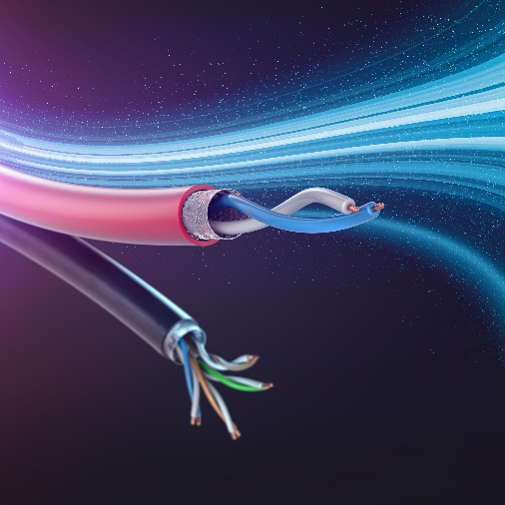
A contribution from Würth Elektronik to the promotion of SPE: Filter design for single-pair Ethernet interface
Image source: Würth Elektronik

About the Würth Elektronik eiSos Group
Würth Elektronik eiSos Group is a manufacturer of electronic and electromechanical components for the electronics industry and a technology company that spearheads pioneering electronic solutions. Würth Elektronik eiSos is one of the largest European manufacturers of passive components and is active in 50 countries. Production sites in Europe, Asia and North America supply a growing number of customers worldwide.
The product range includes EMC components, inductors, transformers, RF components, varistors, capacitors, resistors, quartz crystals, oscillators, power modules, Wireless Power Transfer, LEDs, sensors, connectors, power supply elements, switches, push-buttons, connection technology, fuse holders and solutions for wireless data transmission.
The unrivaled service orientation of the company is characterized by the availability of all catalog components from stock without minimum order quantity, free samples and extensive support through technical sales staff and selection tools.
Würth Elektronik is part of the Würth Group, the world market leader for assembly and fastening technology. The company employs 8,000 staff and generated sales of 1.09 Billion Euro in 2021.
Würth Elektronik: more than you expect!
Further information at www.we-online.com

Further information:  Würth Elektronik eiSos GmbH & Co. KG  Sarah Hurst  Max-Eyth-Strasse 1  74638 Waldenburg  Germany  Phone: +49 7942 945-5186  E-mail: sarah.hurst@we-online.de  www.we-online.com | Press contact:  HighTech communications GmbH  Brigitte Basilio  Brunhamstrasse 21  81249 Munich  Germany  Phone: +49 89 500778-20  Telefax: +49 89 500778-77  E-mail: b.basilio@htcm.de  www.htcm.de

