Press release
Schröder Group at the DM i Skills performance comparison
Best sheet metal working machines for the next generation of Danish craftsmen
Wessobrunn-Forst (Germany), 16 March 2022 – Schröder machines in use for SkillsDenmark: Schröder sales partner Muncholm is one of the suppliers to the DM i Skills vocational competition. Muncholm is providing the PowerBend Universal sheet metal folding machine and the PDC NC motorized shear for the preliminary round of the international WorldSkills. The competition will be held in Høng, Kalundborg, Denmark, from April 28 to 30, 2022.
Muncholm, a leading wholesaler of sheet metal and sheet metal working machinery in Denmark and distributor of the Schröder Group, supports the major annual Danish championship for young people in vocational training. Around 300 young people take part in the competition in various subjects. In addition, schoolchildren here learn more about apprenticeship occupations. Two machines from the Schröder Group are also exhibited. While the young craftsmen will be proving themselves on the machines, master craftsmen and trainers will be able to find out more about what the Schröder partner has to offer.
For the competition of the young craftsmen
The Schröder folding machine PowerBend Universal can be seen at the Skills event in a working length of 3200 mm. This machine is able to bend up to 3 mm thick sheets very precisely and without damaging the surface. The POS 2000 Professional graphic control is used to enter the folding programs - an industrial solution that enhances the craft machine just as much as the options used. The exhibition machine is equipped with a motorized folding beam adjustment, hydraulic tool clamping of the clamping beam, motorized central crowning and a motorized back gauge.
PDC NC is a motorized shear with NC positioning gauge for up to 3 mm thick sheets at a working length of 3200 mm. The shear can cut in series at a stroke rate of 34 per minute. The material thickness can be selected on the control, and the blade gap then adjusts automatically. The PDC NC at the Skills competition has a closed sheet support table, support plates with ball rollers and is equipped with extended angle gauges and LED cutting edge illumination.

Available images
The following images are available for download in printable format at:
https://kk.htcm.de/press-releases/schroeder/
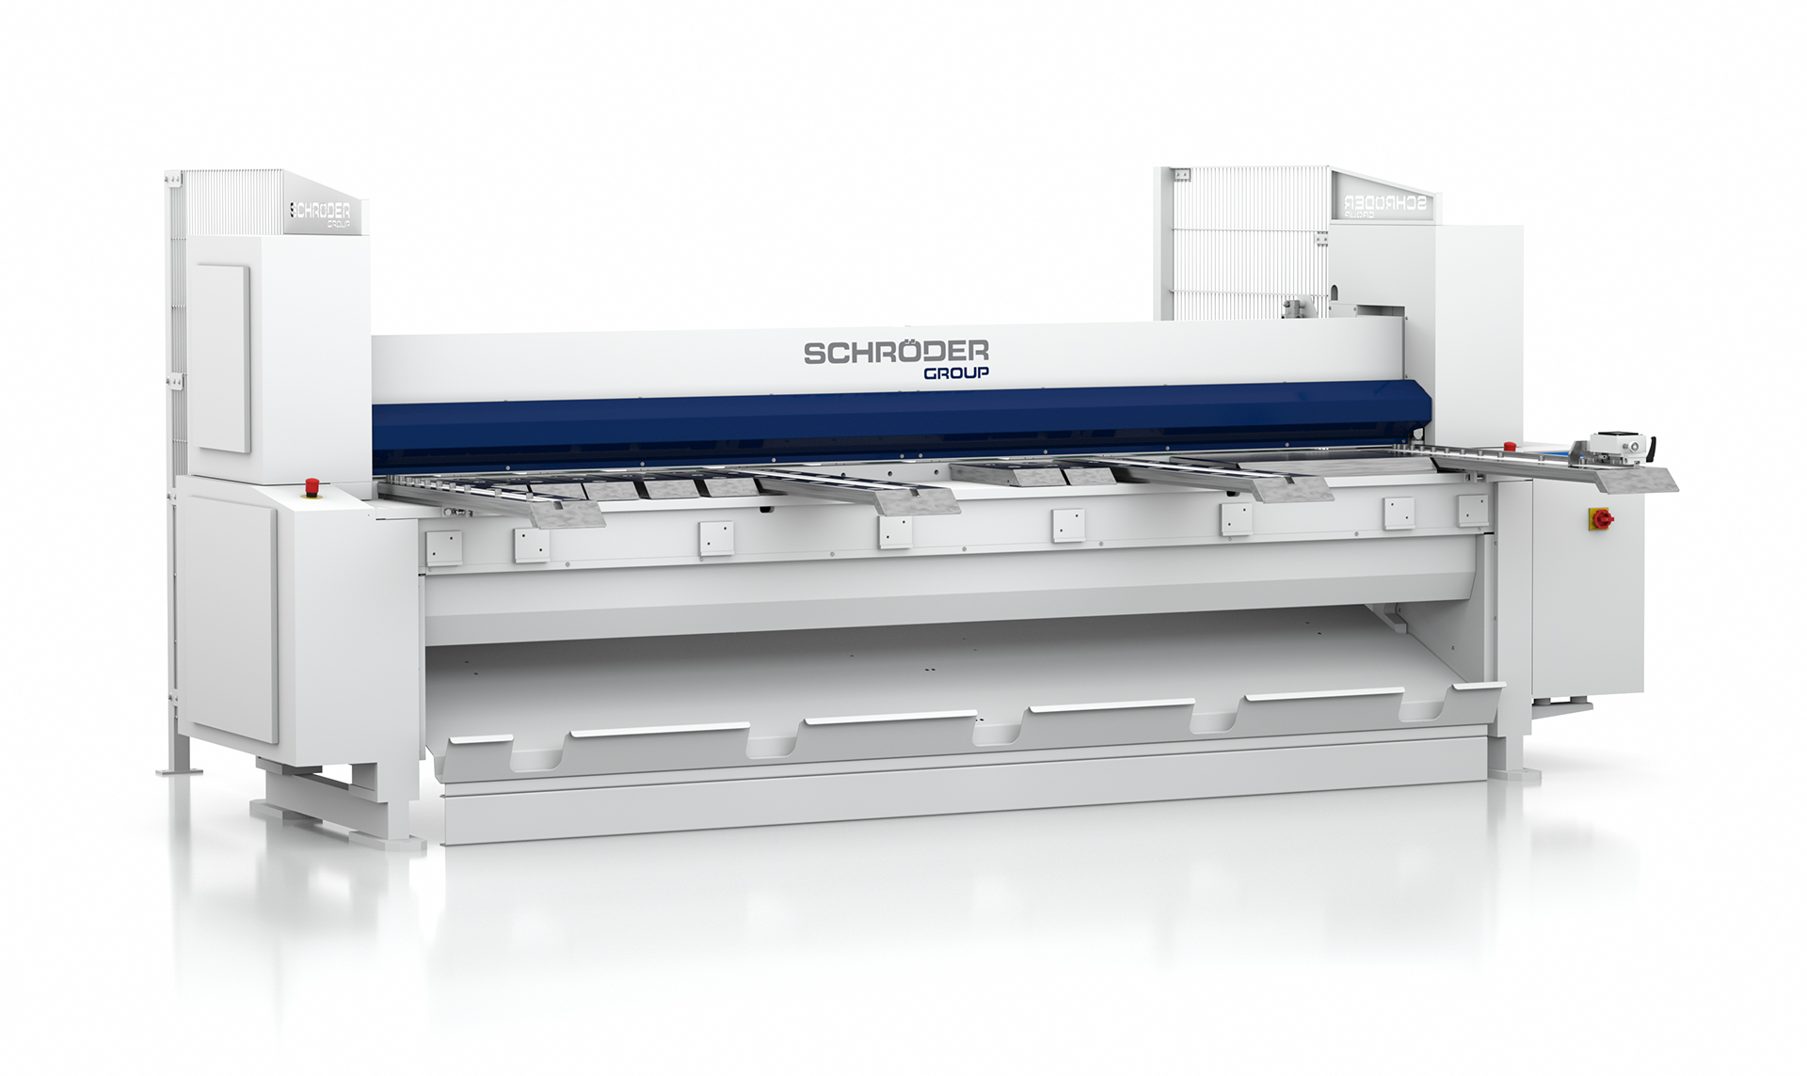  Image source: Schröder Group  Motorized shear PDC NC | 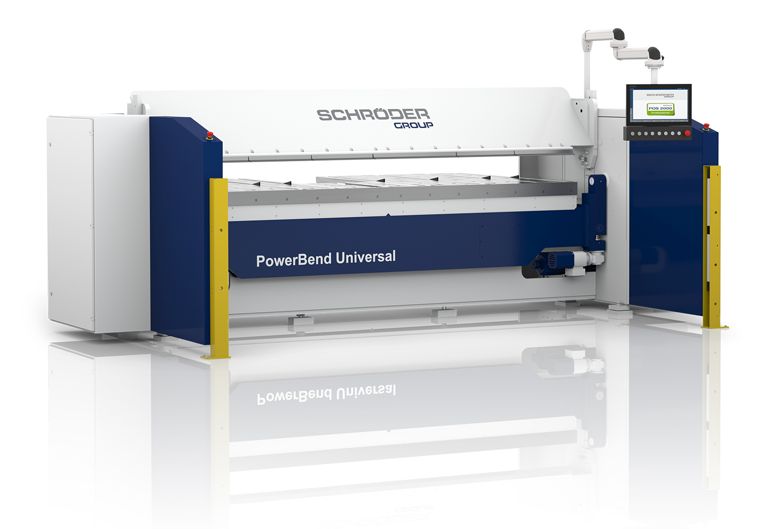  Image source: Schröder Group  Folding machine PowerBend Universal

About Schröder Group
The Schröder Group consists of Hans Schröder Maschinenbau GmbH, which is located in Wessobrunn-Forst, Germany, SCHRÖDER-FASTI Technologie GmbH, located in Wermelskirchen, Germany and the SMU GmbH, located in Leinburg-Weißenbrunn.
Founded in 1949, Hans Schröder Maschinenbau GmbH unifies traditional and modern approaches in machine building: Successfully managed as a quality and customer-oriented, family-owned company, Hans Schröder Maschinenbau is specialized in the development of modern machine concepts for bending and cutting sheet metal.
The successful integration of the Fasti Company in 2006 and its worldwide presence make the Schröder Group one of today‘s leading providers of machines for bending, cutting, beading, flanging, and circular bending all types of sheet metal. The company‘s precision machines range from proven solutions for craftsmen to innovative, high-performance machines for automatic industrial production processes. 2021 the Schröder Group was expanded by the tool manufacturer SMU GmbH. Overall, the Schröder Group currently employs more than 300 people at various locations at home and abroad.
Further information is available at www.schroedergroup.eu/en.

Press contact:
Schröder Group
Hans Schröder Maschinenbau GmbH
Janina Biró
Feuchten 2
82405 Wessobrunn-Forst
Germany
T: +49 8809 9220-68
E-mail: jj@schroedergroup.eu
Website: www.schroedergroup.eu

HighTech communications GmbH
Brigitte Basilio
Brunhamstraße 21
81249 München
Germany
T: +49 89 500778-20
E-mail: b.basilio@htcm.de
Website: www.htcm.de

