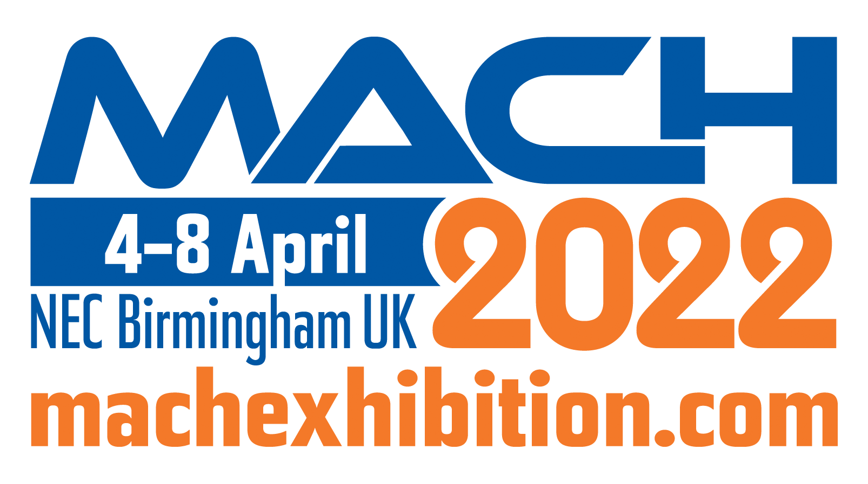PRESS RELEASE
OPEN MIND at MACH 2022
Demonstration of Full CAM Capabilities
Wessling (Germany), March 7, 2022 – Recognised as the industry’s leading CAM/CAD system for everything from 3-axis to complex 5-axis machining, OPEN MIND Technologies will be showcasing why its latest hyperMILL® Version 2022.1 offers so much more at MACH 2022. On Stand 440 in Hall 17, the experts from OPEN MIND will be discussing why hyperMILL® is the complete solution for all your machine shop requirements.
Hall 17, Stand 440

Whilst there will be an abundance of innovations for enhancing productivity, performance and programming times for components produced on machining centres, OPEN MIND has also added new features for its turning cycles. hyperMILL® Version 2022.1 will present two new feature types at MACH 2022 that will make programming turning processes much easier and faster. Component areas for turning or plunging are reliably recognised, structured and displayed. During this process, hyperMILL® automatically divides the recognised features into several areas that can be turned, faced, groove machined or machined with a combination of these technologies. This saves users considerable time in contour selection and programming while giving them full access to all recognised contours.
The latest version of hyperMILL® that will be showcased at the Birmingham NEC in April also offers convenient programming for production on turning centres with a main and counter spindle. The machining jobs are simply programmed under the ‘Main Spindle’ and ‘Counter Spindle’ containers, which assigns them to the respective machining side. The component or bar material, with or without parting, is transferred with the new transfer job. NC output from the main and opposite sides and component transfer is realised in one end-to-end NC program with a machine model and a post-processor. DMG MORI CTX machines with a Siemens control are supported with this function in release 2022.1 and more manufacturers and machine types will follow imminently.
With automation being a buzzword in manufacturing, OPEN MIND will also be showcasing its automated program generation at MACH 2022 with the hyperMILL® AUTOMATION Center. The hyperMILL® AUTOMATION Center allows users to automate the job list creation process as well as the selection and positioning of clamping devices. Furthermore, a uniform process can be defined for all programmers.
The AUTOMATION Center solution primarily focuses on the individual elements of a CAD model and makes it possible to define and standardise complex processes. The steps for data preparation and programming, right up to simulation and NC program generation, can all be defined. Once a manufacturing process has been defined, it can be applied to any new component and executed automatically. If any decisions cannot be made with complete certainty within the automated process, the user is prompted to make the relevant choices during the program run. The user is interactively guided through the individual process steps, making it possible to program the job in a very short time.
The hyperMILL® AUTOMATION Center has opened-up CAM automation to companies that are not permitted to use external programming services due to strict internal design protection requirements. Companies across all industries that manufacture their products can now be well prepared for CAM automation if they already work with design rules.
For manufacturers utilising EDM technology, there are also product enhancements. Now, users no longer need to program on the controller. This is a credit to the simple creation and subsequent modification of traverse paths during the EDM process with hyperCAD®-S Electrode. Three new modes are available to users for creating the traverse paths.
With additive manufacturing technology evolving at pace with an ever greater uptake among industry, OPEN MIND has further enhanced its industry-leading hyperMILL® ADDITIVE Manufacturing solution. The latest version opens up an array of flexible options for Directed Energy Deposition processes (DED) and Wire Arc Additive Manufacturing (WAAM) in terms of highly complex 5-axis simultaneous processing. Both laser-based powder nozzle machine heads and wire arc additive manufacturing can be controlled using the software from OPEN MIND for selective material deposition, as well as conveniently programmed and automatically simulated for collision avoidance.
hyperMILL® also allows the potential of additive manufacturing to be truly exploited using Powder Bed Fusion (PBF). If 3D-printed parts do not offer the desired precision, or support structures have to be removed, the parts can be completed through 5-axis machining. Even hard-to-reach areas can be machined in a secure manner using hyperMILL®. As an integral part of the process chain, the CAD/CAM system from OPEN MIND supports reworking of this nature whereby the printed components are analysed, machined to size and examined. OPEN MIND is indeed driving forward the implementation of integrated process chains. Additive and subtractive manufacturing are combined in one single machine tool for hybrid manufacturing. hyperMILL® now enables users to perfectly program the cladding and the milling together. True-to-detail application and removal simulation as well as stock tracking between the individual machining steps guarantee the greatest possible process reliability. If you would like to know more about the world of possibilities available from OPEN MIND Technologies, please visit our stand at MACH 2022 and speak to our expert engineers on Stand 440 in Hall 17.

Available images
The following images are available for download in printable format at:
https://kk.htcm.de/press-releases/open-mind/
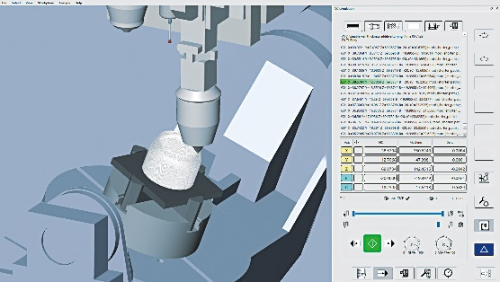  Source: OPEN MIND  hyperMILL® VIRTUAL Machining: NC code simulation of additive toolpaths | 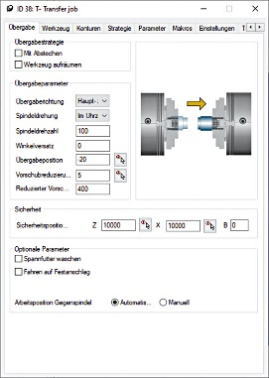  Source: OPEN MIND  Straightforward programming of main and counter spindle machining

About OPEN MIND Technologies AG
OPEN MIND is one of the world’s most sought-after developers of powerful CAM solutions for machine and controller-independent programming.
OPEN MIND develops optimized CAM solutions that include a high number of innovative features not available elsewhere to deliver significantly higher performance in both programming and machining. Strategies such as 2.5D, 3D as well as 5-axis milling/mill turning, and machining operations like HSC and HPC are efficiently built into the hyperMILL® CAM system. hyperMILL® provides the maximum possible benefits to customers thanks to its full compatibility with all current CAD solutions and extensive programming automation.
OPEN MIND strives to be the best and most innovative CAD/CAM manufacturer in the world, helping it become one of the top five in the CAM industry according to the “NC Market Analysis Report 2021” compiled by CIMdata. The CAD/ CAM solutions of OPEN MIND fulfil the highest demands in the automotive, tool and mold manufacturing, production machining, medical, job shops, energy and aerospace industries. OPEN MIND is represented in all key markets in Asia, Europe and America, and is a Mensch und Maschine company.

You can find more information at www.openmind-tech.com.

OPEN MIND Technologies UK Ltd., Oxford
Unit 3
Bicester Business Park
Telford Road
Bicester
Oxfordshire OX26 4LN
England
Phone: +44 1869 290 003
Fax: +44 1869 369 429
E-mail: Info.UK@openmind-tech.com

OPEN MIND Technologies USA, Inc.
1492 Highland Avenue, Unit 3
Needham MA 02492
USA
Phone: +1 339 225 4557 office
Phone: +1 888 516 1232 x0 toll-free
Fax: +1 270 912 5822
E-mail: Info.Americas@openmind-tech.com

Head office:
OPEN MIND Technologies AG, Argelsrieder Feld 5, 82234 Wessling, Germany
Tel.: (+49-8153) 933-500, Fax: (+49-8153) 933-501
E-mail: Info@openmind-tech.com, website: www.openmind-tech.com

Press contact:
HighTech communications GmbH
Brigitte Basilio
Brunhamstrasse 21
81249 Munich
Germany
Tel.: (+49-89) 500778-20
Fax: (+49-89) 500778-78
E-mail: b.basilio@htcm.de
Website: www.htcm.de

