PRESS RELEASE
New subsidiary in Sweden:
OPEN MIND Increases Awareness of hyperMILL® CAD/CAM Suite in Scandinavia
Wessling, Gothenburg (Sweden), February 28, 2022 – One of the world’s leading providers of CAD/CAM solutions strengthens its presence in Scandinavia by establishing OPEN MIND Technologies Scandinavia AB in Gothenburg. OPEN MIND took over direct sales of the hyperMILL® software suite in 2019. In the preceding years, the solution had been distributed via dealers on the Scandinavian market, primarily in Sweden and Norway.
“hyperMILL® is well known and firmly established in the Scandinavian industrial landscape. Our new office allows us to serve customers in these markets even better and further expand our activities in the region,” says Claudio Jorio, Sales Director DACH and Executive Board Member OPEN MIND Technologies Scandinavia AB. He is supported by Mikael Martensson. The application engineer is well connected to the existing customers that are optimizing their machining operations with hyperMILL®. “In many industries, companies are facing challenges for which we have the right solutions. This includes state-of-the-art automation technologies for process optimization or solutions for additive manufacturing,” says Martensson. “hyperMILL® empowers our customers to exhaust the possibilities offered by CNC machines and tools. The Gothenburg office consolidates our presence in the market and demonstrates our lasting commitment to customers and prospects alike.”

Available images
The following images are available for download in printable format at:
https://kk.htcm.de/press-releases/open-mind/

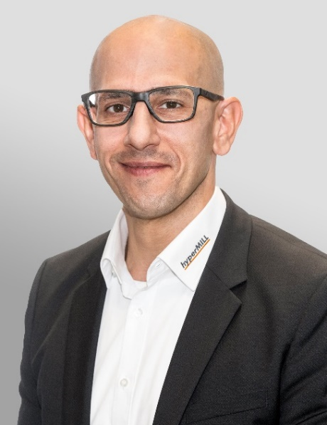  Source: OPEN MIND  Claudio Jorio, Sales Director DACH (Germany, Austria, and Switzerland) and Executive Board Member at OPEN MIND Technologies Scandinavia AB |   Source: OPEN MIND  Mikael Martensson, Application Engineer at OPEN MIND Technologies Scandinavia AB

About OPEN MIND Technologies AG
OPEN MIND is one of the world’s most sought-after developers of powerful CAM solutions for machine and controller-independent programming.
OPEN MIND develops optimized CAM solutions that include a high number of innovative features not available elsewhere to deliver significantly higher performance in both programming and machining. Strategies such as 2.5D, 3D as well as 5-axis milling/mill turning, and machining operations like HSC and HPC are efficiently built into the hyperMILL® CAM system. hyperMILL® provides the maximum possible benefits to customers thanks to its full compatibility with all current CAD solutions and extensive programming automation.
OPEN MIND strives to be the best and most innovative CAD/CAM manufacturer in the world, helping it become one of the top five in the CAM industry according to the “NC Market Analysis Report 2021” compiled by CIMdata. The CAD/ CAM solutions of OPEN MIND fulfil the highest demands in the automotive, tool and mold manufacturing, production machining, medical, job shops, energy and aerospace industries. OPEN MIND is represented in all key markets in Asia, Europe and America, and is a Mensch und Maschine company.

You can find more information at www.openmind-tech.com.

OPEN MIND Technologies UK Ltd., Oxford
Unit 3
Bicester Business Park
Telford Road
Bicester
Oxfordshire OX26 4LN
England
Phone: +44 1869 290 003
Fax: +44 1869 369 429
E-mail: Info.UK@openmind-tech.com

OPEN MIND Technologies USA, Inc.
1492 Highland Avenue, Unit 3
Needham MA 02492
USA
Phone: +1 339 225 4557 office
Phone: +1 888 516 1232 x0 toll-free
Fax: +1 270 912 5822
E-mail: Info.Americas@openmind-tech.com

Head office:
OPEN MIND Technologies AG, Argelsrieder Feld 5, 82234 Wessling, Germany
Tel.: (+49-8153) 933-500, Fax: (+49-8153) 933-501
E-mail: Info@openmind-tech.com, website: www.openmind-tech.com

Press contact:
HighTech communications GmbH
Brigitte Basilio
Brunhamstrasse 21
81249 Munich
Germany
Tel.: (+49-89) 500778-20
Fax: (+49-89) 500778-78
E-mail: b.basilio@htcm.de
Website: www.htcm.de

