PRESS RELEASE
Würth Elektronik: CTO Alexander Gerfer at the Start-up Night Talk evening
EXPO DUBAI 2022: Young companies make a strong case for sustainability
Waldenburg (Germany), Dubai (UAE), February 21, 2022 - Sustainability significantly determines the direction in politics and business. At this year's EXPO DUBAI, an evening with start-ups from Berlin and the United Arab Emirates (UAE) was filled with ideas about how innovations can contribute to sustainability. The topic of smart farming received special attention. New concepts in agriculture, such as LED horticulture, raise hopes of securing food for billions of people, while at the same time, being able to use limited resources
Alexander Gerfer, CTO of the Würth Elektronik eiSos Group, focused on the topic of smart farming in his presentation. Gerfer explained how intelligent solutions for agriculture help to address the huge challenges of feeding the world's population, while conserving resources such as soil, energy, and water. Gerfer used current figures to underline the importance of commitment in this context to feeding the world's population, saying "Today, 7.7 billion people live on our planet; by 2050, this figure will rise to almost ten billion. That's why we are working intensively on new concepts for agriculture."
LED Horticulture: Optimize plant growth
This includes LED Horticulture, an innovative technology that has emerged from collaboration between Würth Elektronik and biologists and agricultural experts. LED Horticulture takes advantage of the fact that the growth of plants and the composition of their nutrients relevant to humans can be specifically optimized by the controllable light of LEDs, and sustainably so; the LEDs save around 70 percent energy, minimize CO2 emissions by up to 90 percent, limit the use of pesticides and fertilizers, and minimize water and land consumption by around 98 percent compared to conventional cultivation methods. In addition, Gerfer says LED horticulture allows plants to be grown close to consumers in cities and urban centers to shorten transportation distances. Würth Elektronik also lives up to its responsibility for the environment and society because its horticulture know-how is shared with lighting solution providers and developers specializing in agricultural solutions.
Anna-Franziska Michel, founder and CEO of YOONA Technology, was among the other representatives of the 15 or so start-ups in the Berlin delegation at EXPO DUBAI 2022. She impressively illustrated how new technologies such as Artificial Intelligence (AI) are impacting sustainability at the international fashion startup. A speaker from the UAE's Ministry of Climate Change & Environment, in turn, spoke about the importance of sustainability for international companies in the Arab country and what companies and startups are currently working on there.

Available images
The following images can be downloaded from the Internet in printable quality: https://kk.htcm.de/press-releases/wuerth/
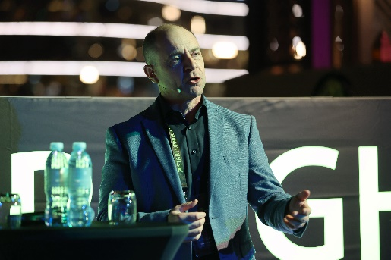Image source: Zander & Partner GmbH  Alexander Gerfer, CTO of the Würth Elektronik eiSos Group, at the Start-up Night Talk evening: Fighting global famine with smart farming | 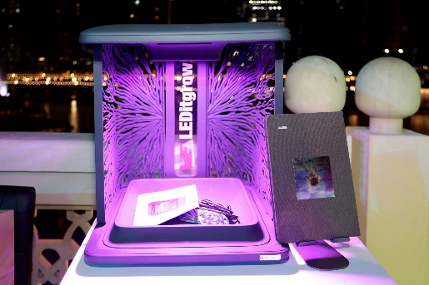  Image source: Zander & Partner GmbH  LEDitgrow: Agricultural experts assign LED lighting solutions a key role for agriculture
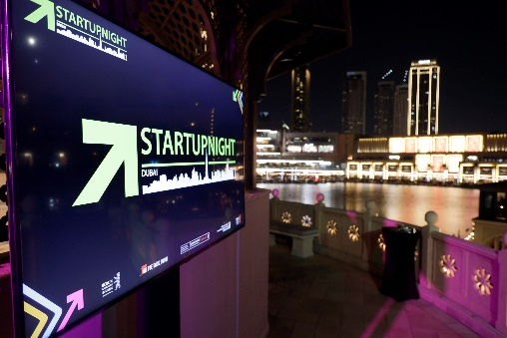  Image source: Zander & Partner GmbH  The Start-up Night Talk was all about sustainability | 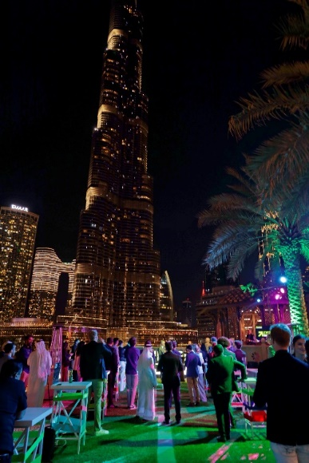  Image source: Zander & Partner GmbH  Representatives of the Berlin delegation and the UAE at an informal exchange

About the Würth Elektronik eiSos Group
Würth Elektronik eiSos Group is a manufacturer of electronic and electromechanical components for the electronics industry and a technology company that spearheads pioneering electronic solutions. Würth Elektronik eiSos is one of the largest European manufacturers of passive components and is active in 50 countries. Production sites in Europe, Asia and North America supply a growing number of customers worldwide.
The product range includes EMC components, inductors, transformers, RF components, varistors, capacitors, resistors, quartz crystals, oscillators, power modules, Wireless Power Transfer, LEDs, sensors, connectors, power supply elements, switches, push-buttons, connection technology, fuse holders and solutions for wireless data transmission.
The unrivaled service orientation of the company is characterized by the availability of all catalog components from stock without minimum order quantity, free samples and extensive support through technical sales staff and selection tools.
Würth Elektronik is part of the Würth Group, the world market leader for assembly and fastening technology. The company employs 8,000 staff and generated sales of 1.09 Billion Euro in 2021.
Würth Elektronik: more than you expect!
Further information at www.we-online.com

Further information:  Würth Elektronik eiSos GmbH & Co. KG  Sarah Hurst  Max-Eyth-Strasse 1  74638 Waldenburg  Germany  Phone: +49 7942 945-5186  E-mail: sarah.hurst@we-online.de  www.we-online.com | Press contact:  HighTech communications GmbH  Brigitte Basilio  Brunhamstrasse 21  81249 Munich  Germany  Phone: +49 89 500778-20  Telefax: +49 89 500778-77  E-mail: b.basilio@htcm.de  www.htcm.de

