

NEWS RELEASE

For Release: IMMEDIATELY With Art: Two Digital Images

Editorial Michael McCue OPEN MIND Alan Levine
Contact: McCue & Associates LLC Contact: OPEN MIND Technologies USA, Inc.
978-733-1353 339-225-4557 mmccue@mccueassociates.com alan.levine@openmind-tech.com

OPEN MIND Introduces New, Powerful Functionality in
hyperMILL® 2022.1 CAD/CAM Software Suite

New Capabilities, Enhancements Offered for Toolpath Optimization, Tool Management,
Virtual Machining, Additive Manufacturing, EDM, Mill-Turn and More

NEEDHAM, MA U.S.A. (December 15, 2021) – OPEN MIND Technologies AG, a leading developer of CAD/CAM software solutions worldwide, has introduced its latest hyperMILL® 2022.1 CAD/CAM software suite which offers users new and enhanced features for even more powerful NC programming in applications ranging from 2.5D to 5-axis. “Continually improving programming efficiency and providing ways to save preferred routines is critical for enriching and streamlining the operator experience,” said Mr. Alan Levine, Managing Director of OPEN MIND Technologies USA, Inc. “The latest features and enhancements in hyperMILL® give users increased convenience and faster programming tools.”

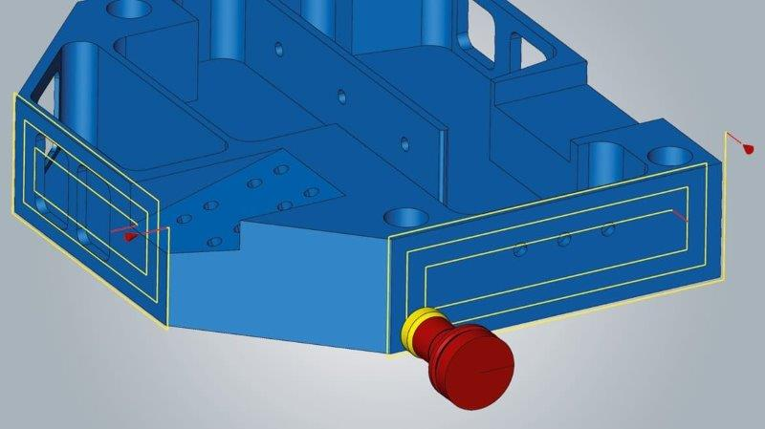
2D, 3D Strategies and Tool, Job Efficiencies
Highlights in hyperMILL® 2022.1 include a new break-edge function for contour milling, combined pocket milling together with a finish path allowing cutter compensation, and increased efficiency for 3D plane machining. The new automated 3D plane machining strategy improves machining quality by searching for suitable, high performance path layouts according to parameters including when adaptive pockets are present.
Fully automated hyperMILL® 3D Plane Machining searches for suitable, high performance path layouts.

For improved tool data reliability and time savings, tool data such as length, radius, corner radius, and tool number and name, can be transferred directly from hyperMILL® to a Heidenhain TNC640 control using the hyperMILL® CONNECTED Machining module. Now it is possible to import calibrated tools from a tool management system into hyperMILL® to create programs, and then transfer the tool list or individual tool data to the machine.

- more -

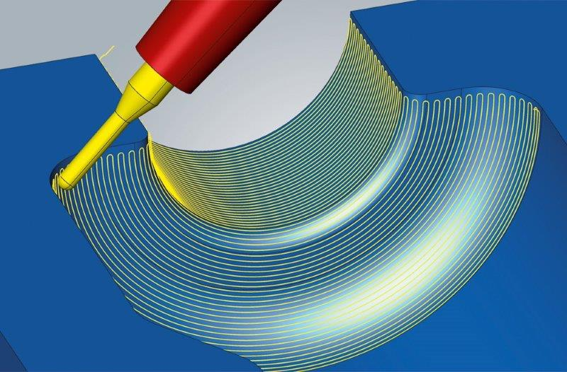
Blow Molding & Tube Machining Developments
Five-axis radial machining strategy for blow molds has been enhanced to better handle steep areas and undercut regions, and to adapt to 3-axis machines as required. For
5-axis Tube Finishing, there have been several enhancements to improve machining quality and simplify programming.
New hyperMILL® infeed strategy delivers top surface qualities for
5-axis radial machining (blow molds).
Expanded Virtual Machining Capabilities
Improved linking logic in hyperMILL® VIRTUAL Machining Optimizer for 5-axis table-table machines is now offered. The VIRTUAL Machining Optimizer module links individual part programs with smooth and safe connections. An “Optimized Table-Table Logic” option allows users to select a distance value and the Optimizer automatically calculates the safety distances using the raw part, component and clamps selected in the job list. The defined distance is maintained between all components, and movement sequences are automatically optimized.

Virtual Meets Additive
A new VIRTUAL Machining capability for Additive Manufacturing processes, where machines often have limited axis ranges, is available in hyperMILL® 2022.1. Now hyperMILL® VIRTUAL Machining Optimizer can be used during NC code generation to simulate additive tool paths to optimize them for the machining.

Time Savings in EDM
Enhancements to CAD functions and the integrated hyperCAD®-S Electrode module allow users to control the traverse path during the EDM eroding process and eliminate the need to program on the controller. Movement sequences can be simulated with the hyperMILL® SIMULATION Center and checked for collisions.

Mill-Turn Enhancements
New extensions to the hyperMILL® MILL-TURN capability include more streamlined programming and simulation processing and management for machines with main and counter spindle configurations. The jobs are simply programmed in one job list under the “main spindle” and “counter spindle” containers, which assigns them to the respective machining side. The component or bar material, with or without parting, is easily transferred with the new transfer job. NC output from the main side, opposite side, and component transfer are realized in one end-to-end NC program with one machine model and post-processor. This process is initially available for DMG Mori CTX machines with a Siemens control. Also, component areas for turning or grooving are reliably recognized, structured and displayed as programming features. hyperMILL® automatically divides the recognized features into several areas that can be turned, faced, groove machined, or machined with a combination of these technologies, saving significant time while giving users full access to all recognized contours.

More Information about hyperMILL® 2022.1
- more -

About OPEN MIND Technologies AG
Headquartered in Wessling, Germany, OPEN MIND is one of the world's leading developers of powerful CAM solutions for machine and controller-independent programming. The company develops optimized CAM solutions that include many innovative features unavailable elsewhere, to deliver significantly higher performance in both programming and machining. Strategies such as 2.5D, 3D, as well as 5-axis milling, mill/ turning, and machining operations like HSC and HPC, are efficiently designed into the hyperMILL® CAM system, providing maximum user benefit and compatibility with all current CAD solutions and extensive programming automation. OPEN MIND strives to be the best, most innovative CAD/ CAM developer in the world, and has earned the top five ranking in the CAD/ CAM industry according to the 2021 NC Market Analysis Report by CIMdata. OPEN MIND CAD/ CAM solutions meet and exceed the requirements of the most demanding industries such as automotive, tool and mold manufacturing, production machining, medical, job shops, energy and aerospace industries, and is represented in all key markets of Asia, Europe and the Americas. OPEN MIND is a Mensch und Maschine Company. http://www.mum.de/ For more information visit https://www.openmind-tech.com/en.html.

# # # # #

