PRESS RELEASE
Würth Elektronik introduces its optocoupler product series
High-quality Optoelectronics for Safe Circuit Isolation
Waldenburg (Germany), January 20, 2022—The manufacturer Würth Elektronik has expanded its optoelectronic portfolio with optocouplers in all common packages and CTR (Current Transfer Ratio) values. This includes the WL-OCPT series of phototransistor optocouplers in DIP-4, SOP-4 and LSOP-4 packages. The WL-OCDA Darlington optocoupler series is available as DIP-4 and SOP-4. These different packages are also available in a range of lead frame varieties. The CTR values of the components—classified according to binning type—range from 20 to 15,000 percent. In addition, the DIN EN 60747-5-5 certified components can be used in the operating temperature range from -55 to +110°C.
Galvanic isolation of low power control circuits from high power circuits is an important safety aspect in many applications. Optocouplers protect against interference and overvoltage in power supplies, chargers, computers, microprocessors, sequence controllers, programmable logic controllers, measuring devices and other applications. In designing the optocouplers, Würth Elektronik has chosen the coplanar package with a constant isolation gap. This guarantees perfect isolation up to 5000 V. High quality silicone and polymer materials provide for 100% internal reflection and ensure a stable CTR over the entire temperature range. Würth Elektronik optocouplers feature fast switching times and high DC transmission ratios even in low current operation. The copper lead frames ensure optimal solderability and reliable assembly in the application.
Würth Elektronik optocouplers are available from stock in all package designs and CTR binnings. Free samples are available. Further information on service life and design recommendations for extending the service life of Würth Elektronik optocouplers can be found in Application Note ANO006.

Available images
The following images can be downloaded from the Internet in printable quality: https://kk.htcm.de/press-releases/wuerth/

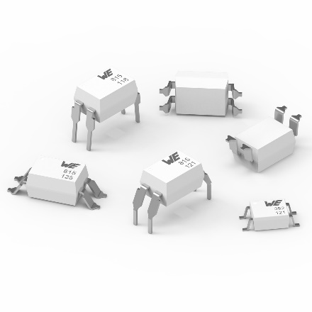
Image source: Würth Elektronik
High-quality Würth Elektronik optocouplers for signal transmission between galvanically isolated circuits

About the Würth Elektronik eiSos Group
Würth Elektronik eiSos Group is a manufacturer of electronic and electromechanical components for the electronics industry and a technology company that spearheads pioneering electronic solutions. Würth Elektronik eiSos is one of the largest European manufacturers of passive components and is active in 50 countries. Production sites in Europe, Asia and North America supply a growing number of customers worldwide.
The product range includes EMC components, inductors, transformers, RF components, varistors, capacitors, resistors, quartz crystals, oscillators, power modules, Wireless Power Transfer, LEDs, sensors, connectors, power supply elements, switches, push-buttons, connection technology, fuse holders and solutions for wireless data transmission.
The unrivaled service orientation of the company is characterized by the availability of all catalog components from stock without minimum order quantity, free samples and extensive support through technical sales staff and selection tools.
Würth Elektronik is part of the Würth Group, the world market leader for assembly and fastening technology. The company employs 7,300 staff and generated sales of 823 million euros in 2020.
Würth Elektronik: more than you expect!
Further information at www.we-online.com

Further information:  Würth Elektronik eiSos GmbH & Co. KG  Sarah Hurst  Max-Eyth-Strasse 1  74638 Waldenburg  Germany  Phone: +49 7942 945-5186  E-mail: sarah.hurst@we-online.de  www.we-online.com | Press contact:  HighTech communications GmbH  Brigitte Basilio  Brunhamstrasse 21  81249 Munich  Germany  Phone: +49 89 500778-20  Telefax: +49 89 500778-77  E-mail: b.basilio@htcm.de  www.htcm.de

