PRESS RELEASE
The inventor of Powerelements expands its portfolio of lead-free High Current Contacts
Plug instead of screw – completely lead-free
Niedernhall (Germany), 6 December 2021 – The LF PowerBasket SMD series from Würth Elektronik ICS offers lead-free Powerelements for pluggable contacting on printed circuit boards. A new bushing variant with a diameter of 6 mm has recently been added to the company’s portfolio.
PowerBasket SMD High Current Contacts are the result of the progress has been made in consistently developing our pluggable LF PowerBasket products in line with market requirements. The Powerelements of this product series are designed to reduce the effort required to assemble components. The LF PowerBasket SMD Power Supply Terminals are multi-pluggable and are ideal for use in wire-to-board and board-to-board connections. Compared to conventional systems, the special design of the contact blades significantly reduces the insertion and extraction forces. Due to the high position tolerance of up to 0.6 mm, several contacts can be plugged in at the same time. This offers a considerable advantage for three-phase connections, for example.
The Powerelements feature a high current carrying capacity of up to 160 A at 20 °C. A special alloy makes it possible to use them at higher ambient temperatures. Depending on the design, the operating temperature range can be up to 150 °C and even up to 170 °C for short periods.
LF PowerBasket Powerelements can be processed in conventional SMT lines and are soldered in a convection oven or via a vapour phase system. They are supplied on a reel in ESD blister packaging, optionally with Kapton sticker. This enables fast and cost-effective assembly.
The LF PowerBasket SMD High Current Contacts are produced using a punching and bending process and can therefore be manufactured without any lead additive. They are totally lead-free and RoHS compliant - and thus completely unaffected by the possibly soon expiring exemption 6c of the RoHS Directive, which allows four percent lead in copper alloys for electrical and electronic equipment. To ensure a greater degree of planning reliability, manufacturers should monitor their project development times and product life cycles that stretch over several years and switch to lead-free solutions in time. Würth Elektronik ICS is one of the first companies on the market to also offer its High Current Contact portfolio as a lead-free variant (LF Powerelements). Customers and interested parties can find all the information they need on the subject ‘lead-free’ on the online platform LF-Powerelements.com.

Available images
The following images can be downloaded from the Internet in printable quality: https://kk.htcm.de/press-releases/wuerth-ics/
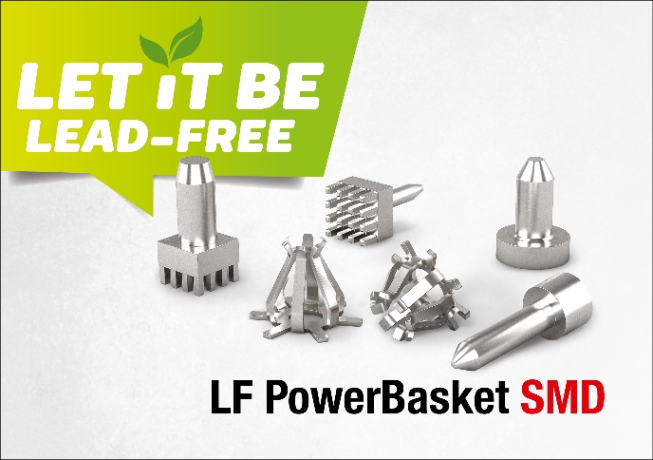Image source: Würth Elektronik ICS
Lead-free LF PowerBasket Powerelements series for pluggable contacting on printed circuit boards in SMD 3 mm and SMD 6 mm versions

About Würth Elektronik ICS GmbH & Co. KG
Würth Elektronik ICS is a system supplier for electromechanical and electronic solutions for signal and power distribution, control, and display and operating solutions. ICS has been on the market as a member of the Würth Elektronik Group since 1984, and currently has about 400 employees, who generate an annual turnover of over €75 million. Its company headquarters are located in Niedernhall, Germany. There are subsidiaries of the company in France, the U.S., and India. Its main customers include well-known manufacturers of construction and agricultural machinery, as well as commercial vehicles. Sectors such as industrial technology or renewable energies also benefit from products and services provided by ICS.
Würth Elektronik: more than you expect!
Further info at www.we-online.com/ics

More information:  Würth Elektronik ICS GmbH & Co. KG  Sandra Herter  Gewerbepark Waldzimmern  Würthstrasse 1  74676 Niedernhall  Germany  Phone: +49 7940 9810-1503  E-mail: sandra.herter@we-online.de  www.we-online.com/ics | Press contact:  HighTech communications GmbH  Brigitte Basilio  Brunhamstrasse 21  81249 Munich  Germany  Phone: +49 89 500778-20  Telefax: +49 89 500778-77  E-mail: b.basilio@htcm.de  www.htcm.de

