PRESS RELEASE

cts automates wafer packaging
Process reliability in the preparation of wafers for shipment
Burgkirchen (Germany), 9 November 2021 – The airtight packaging of so-called "Front Opening Shipping Boxes" (FOSB) for the transport of wafers to a semiconductor plant is complex and time-consuming – and until now mostly a manual process. cts GmbH now offers an automation solution for the correct packaging of FOSBs for the transport of wafers to a semiconductor fab. Automatically tested and documented, this ensures that the wafers for chip production are not contaminated on their way from cleanroom to cleanroom.
The manual handling of the FOSB transport containers with stacks of 25 wafers with a diameter of 300 millimeters as well as the airtight double sealing in special foils are time-consuming. As one of the few remaining manual activities in an otherwise largely automated industry, the preparation of wafer delivery also represents a process risk. cts has now developed compact automatic machine for FOSB loading that take up as little expensive clean room space as possible. The solution can be delivered in different degrees of automation - up to the use of AMRs (Autonomous Mobile Robots) adapted to cleanroom requirements from the cts Smart Logistics portfolio. In this way, a fully autonomous, automated transport process follows on from automatic packaging and leak testing without the need for costly conversion work.
"Based on a single solution for a customer, cts has now developed a standardized modular overall solution that fully automates the entire process of FOSB packaging on request," explains Stefan Schmiedlechner, Head of Factory Automation at automation specialist cts. „Wafer producers thus achieve comprehensive process reliability in three expansion stages, relieve their employees, free them up for more important value-adding activities and eliminate possible sources of error. With a possible utilization of up to 10,000 FOSBs per quarter, which corresponds to 250,000 wafers, the solution is suitable for both medium-sized megafabs and smaller gigafabs with up to six digit production volumes per month. The semi-automatic 'Manual Bagging' model and the fully automatic 'Auto Bagging' version are among the most compact solutions on the market and take up as little valuable cleanroom space as possible."

Available images
The following image material is available for download in printable form on the Internet: https://kk.htcm.de/press-releases/cts/
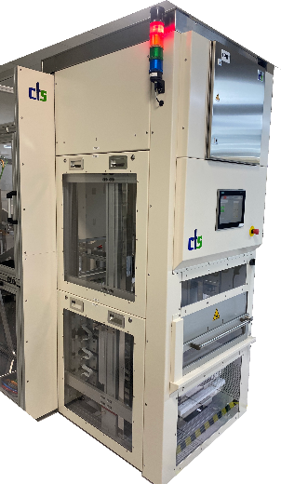
Image source: cts
Depending on the level of automation, the cts GmbH solution handles the FOSB packaging process with the help of operators or fully automatically with the use of industrial robots.

About cts GmbH
Founded in 2006, cts GmbH offers a complete range of services for process and factory automation. At twelve international locations, the employees work on the implementation of innovative, modern solutions for different industrial sectors. The company has already been awarded the coveted Top 100 prize for particularly innovative companies in the German SME sector twice (2016 and 2018).
The cts portfolio ranges from the construction of a single control cabinet to the automation of complete production plants including in-house information management. With its 15 years of experience as a system integrator, cts offers its customers comprehensive support from conceptual design and feasibility studies, planning and implementation to maintenance and servicing of the running systems and plants. For Factory Automation, cts develops customized total solutions that combine highest efficiency and productivity with optimal investment and future security. In the area of material supply, cts is today considered one of the leading companies for the integration of heterogeneously designed fleets of autonomous, intelligent mobile robots (AMR/AIV/AGV) in combination with production-related automated storage systems such as the Smart Warehouse.
In other business areas, cts offers a comprehensive portfolio for visualization, control and monitoring of refinery, petrochemical and pharmaceutical plants. Special attention is paid to the Robotics business area. The range of services here extends from programming and installation to the optimization of welding and production robots or even fully automated packaging systems.
For more information visit www.group-cts.de/en

Contact:  cts GmbH  Mirela Mesanovic  Münchener Strasse 14  93326 Abensberg  Germany  Mobile: +49 151 16213759  E-Mail: Mirela.Mesanovic@cts-gmbh.de  www.group-cts.de | Press agency:  HighTech communications GmbH  Brigitte Basilio  Brunhamstraße 21  81249 München  Germany  Phone: +49 89 500778-20  E-Mail: b.basilio@htcm.de  www.htcm.de

