Press release
Schröder Group improves motorized shear PDC-NC
Series cut for all types of sheet materials
Wessobrunn-Forst (Germany), 7 October 2021 – The PDC-NC is a robust motorized shear with NC positioning gauge and a pneumatically controlled sheet support. Hans Schröder Maschinenbau has now equipped the proven Duo-Cut shear with a new control system and the back gauge with precise servo motors. The manual blade gap adjustment for material thickness adjustments is now optionally available with a motor. One simply selects the desired material thickness on the touch display of the Schröder Cut Control and the blade gap is automatically adjusted.
The most important functional extension of the PDC-NC is the serial cutting that allows to preset up to 99 different or repeating gauge dimensions. This means that several gauge dimensions can be processed one after the other, or repetitions can be specified for individual dimensions. The PDC-NC is suitable for up to 3 mm thick steel sheets (version with 3200 mm working length) or 2.5 mm (on 4000 mm), but is also often used for other materials. For very soft materials, it is now possible to deactivate the pneumatic hold-down device. The sheet support, which is also responsible for depositing the sheet either at the front or at the rear after the cut, can now also be set via the touch display.

Available images
The following images are available for download in printable format at:
https://kk.htcm.de/press-releases/schroeder/
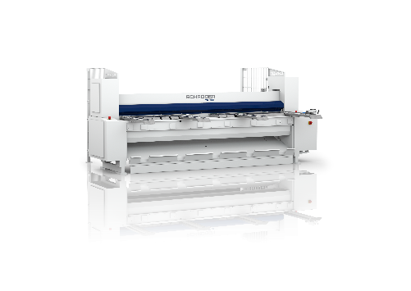Image source: Schröder Group
Motorized shear PDC-NC

About Schröder Group
The Schröder Group consists of Hans Schröder Maschinenbau GmbH, which is located in Wessobrunn-Forst, Germany, SCHRÖDER-FASTI Technologie GmbH, located in Wermelskirchen, Germany and the SMU GmbH, located in Leinburg-Weißenbrunn.
Founded in 1949, Hans Schröder Maschinenbau GmbH unifies traditional and modern approaches in machine building: Successfully managed as a quality and customer-oriented, family-owned company, Hans Schröder Maschinenbau is specialized in the development of modern machine concepts for bending and cutting sheet metal.
The successful integration of the Fasti Company in 2006 and its worldwide presence make the Schröder Group one of today‘s leading providers of machines for bending, cutting, beading, flanging, and circular bending all types of sheet metal. The company‘s precision machines range from proven solutions for craftsmen to innovative, high-performance machines for automatic industrial production processes. 2021 the Schröder Group was expanded by the tool manufacturer SMU GmbH. Overall, the Schröder Group currently employs more than 300 people at various locations at home and abroad.
Further information is available at www.schroedergroup.eu/en.

Press contact:
Schröder Group
Hans Schröder Maschinenbau GmbH
Janina Biró
Feuchten 2
82405 Wessobrunn-Forst
Germany
T: +49 8809 9220-68
E-mail: jj@schroedergroup.eu
Website: www.schroedergroup.eu

HighTech communications GmbH
Brigitte Basilio
Brunhamstraße 21
81249 München
Germany
T: +49 89 500778-20
E-mail: b.basilio@htcm.de
Website: www.htcm.de

