PRESS RELEASE
Würth Elektronik: virtual EMC conference WE meet @ EMC digital days 2021
Four days packed with EMC expertise
Waldenburg (Germany), October 5, 2021 - Würth Elektronik is holding its virtual conference for the third time. This time with a focus on electromagnetic compatibility under the title WE meet @ EMC digital days. This EMC conference will be held free of charge and in English from October 25 to 28. A comprehensive program with workshops by Würth Elektronik specialists and external partners is offered. During the workshops, participants will be able to ask their questions via chat function and will have the opportunity to deepen their knowledge in interactive question and answer sessions. The division of the conference days follows the four steps to market maturity of EMC solutions: Education, design, certification and production. All information about the program and registration is available at www.we-online.de/emc-digital-days.
"The great success of our four-day virtual conference WE meet @ digital days 2021 in April 2021 spurs Würth Elektronik to offer a similar format just on the topic of 'electromagnetic compatibility' (EMC). Our portfolio in the EMC area is constantly growing and we offer everything required for successful development and component manufacturing from just one source. As a proven specialist in all aspects of EMC, we want to share our decades of expertise with participants via technically detailed workshops," explains Alexander Gerfer, CTO of the Würth Elektronik eiSos Group, who will also deliver the event's introductory keynote speech on October 25.

Nine workshops with extensive program
WE meet @ EMC digital days offers a total of nine workshops with lengths ranging from 45 to 90 minutes. Not only will proven Würth Elektronik specialists be on hand, but representatives from partner companies will also be on board, such as the University of Valencia, TU Graz, Silent Solutions LLC and the University of Zaragoza. The spectrum of topics covered by the workshops ranges from electromagnetic interference, signal filters, shielding and conformity testing to the field behavior of passive components. The program of the four days informs the participants about the current state of the technologies as well as about future developments. However, the conference is not only for passive listening and watching: Questions can be asked during the workshop and afterwards there will be an extensive Q&A session in each case. Many practical tips, background information and application examples round off the offer.

Information on demand
Würth Elektronik has set up its own website for WE meet @ EMC digital days, where all information about the program is available. In addition, the complete information material of the workshops will be made available there for download "on demand" after the event. The event will be held in English. Participation is free of charge and requires registration at www.we-online.de/emc-digital-days.

Available images
The following images can be downloaded from the Internet in printable quality: https://kk.htcm.de/press-releases/wuerth/
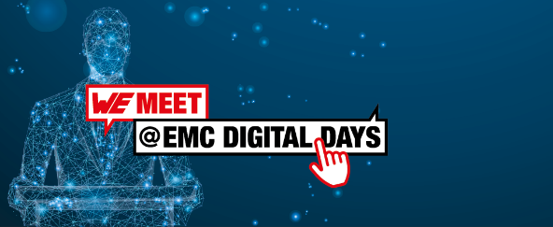Image source: Würth Elektronik  With WE meet @ EMC digital days 2021, EMC specialist Würth Elektronik offers a virtual conference with concentrated know-how on all topics related to electromagnetic compatibility. The event will be held in English. | 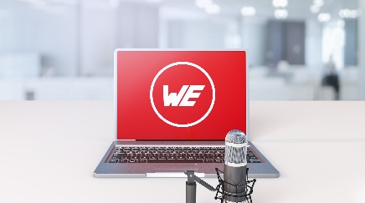Image source: Würth Elektronik  Proven Würth Elektronik specialists and experts from partner companies will be available to answer participants' questions via chat function and Q&A sessions.

About the Würth Elektronik eiSos Group
Würth Elektronik eiSos Group is a manufacturer of electronic and electromechanical components for the electronics industry and a technology company that spearheads pioneering electronic solutions. Würth Elektronik eiSos is one of the largest European manufacturers of passive components and is active in 50 countries. Production sites in Europe, Asia and North America supply a growing number of customers worldwide.
The product range includes EMC components, inductors, transformers, RF components, varistors, capacitors, resistors, quartz crystals, oscillators, power modules, Wireless Power Transfer, LEDs, sensors, connectors, power supply elements, switches, push-buttons, connection technology, fuse holders and solutions for wireless data transmission.

The unrivaled service orientation of the company is characterized by the availability of all catalog components from stock without minimum order quantity, free samples and extensive support through technical sales staff and selection tools.
Würth Elektronik is part of the Würth Group, the world market leader for assembly and fastening technology. The company employs 7,300 staff and generated sales of 823 million euros in 2020.
Würth Elektronik: more than you expect!
Further information at www.we-online.com
Further information:  Würth Elektronik eiSos GmbH & Co. KG  Sarah Hurst  Max-Eyth-Strasse 1  74638 Waldenburg  Germany  Phone: +49 7942 945-5186  E-mail: sarah.hurst@we-online.de  www.we-online.com | Press contact:  HighTech communications GmbH  Brigitte Basilio  Brunhamstrasse 21  81249 Munich  Germany  Phone: +49 89 500778-20  Telefax: +49 89 500778-77  E-mail: b.basilio@htcm.de  www.htcm.de

