PRESS RELEASE
OPEN MIND helps contractor manufacturer BAM automate its processes
Slash Programming Times in hyperMILL® by up to 80 Percent
Wessling (Germany), September 27, 2021 – BAM GmbH, based in Weiden, Bavaria, is going all in with digital processes in an effort to further reduce costs and project times in contract manufacturing. With the support of OPEN MIND Technologies AG, BAM has used hyperMILL® AUTOMATION Center to streamline and markedly speed up CAM programming, which represents the final digital step in the transition from the customer design to the finished workpiece. Automation has helped reduce CAM programming times in hyperMILL® by 70 to 80 percent.
“Thanks to the powerful 2.5D, 3D and 5-axis cycles of hyperMILL®, we have succeeded in reducing setup and programming times at the machining centers, resulting in increased efficiency and higher capacity utilization,” states Stefan Bauer, Head of Manufacturing at BAM GmbH. “With its feature technology, macro databases and associated process, hyperMILL® also provides a solid basis to automate programming and significantly reduce time expenditure by reusing pre-existing programming know-how.”
hyperMILL® AUTOMATION Center is built on feature and macro technology, allowing any user to standardize machining steps and automatically apply them to new workpieces. OPEN MIND honed and optimized the process for use at BAM. To handle a wide variety of orders and workpieces, the CAD/CAM manufacturer integrated an interactive user guide which uses a few parameters to control automated programming.
Support from the CAM Developer
Marco Bauer, Managing Director of BAM GmbH, is extremely satisfied with the support provided by the team of hyperMILL® experts: “The competent OPEN MIND staff always provide us with expert support, even when dealing with highly complex applications and exotic projects. One of the key factors for us was that OPEN MIND develops their software in-house. As a result, we were able to obtain customized functions for our automation projects very rapidly, which has helped us improve leaps and bounds.”

Available images
The following images are available for download in printable format at:
https://kk.htcm.de/press-releases/open-mind/
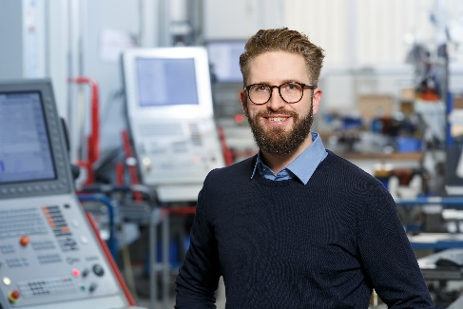  Source: BAM  Marco Bauer, Founder and Managing Director of BAM GmbH | 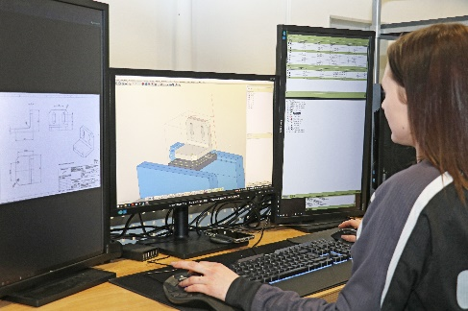  Source: OPEN MIND  The CAM office is an essential place. Using the hyperMILL® high-end CAM system from OPEN MIND, employees create NC programs based on 3D design data; in some cases, the programs are even generated fully automatically.
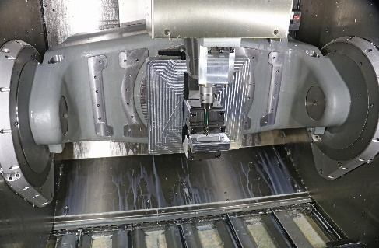
Source: OPEN MIND
Modern machining relies on 5-axis technology. BAM uses the hyperMILL® CAM system to generate suitable NC programs – in some cases even fully automatically.

Available videos
You can find the following videos on our YouTube channel:
https://youtu.be/p7bd2BOIYNI
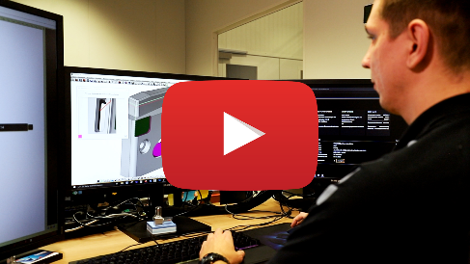
Source: OPEN MIND

Standardize, automate, optimize – BAM uses hyperMILL® Automation Center to improve process times

About BAM GmbH
BAM GmbH offers precision manufacturing, special-purpose machine construction, and digital services. Founded in 2011 in the German town of Weiden, the company has developed from a traditional contract manufacturer to a digital manufacturer whose high-quality machinery operates based on automation and smart material flow concepts. BAM produces laser cut-outs and manufactures metal and plastic components using machining as well as erosive, additive, and forming processes. The high-quality products adhere to stringent tolerances. Customers include leading companies from the medical technology, measurement technology, mechanical and plant engineering, biotechnology, and electronics industries. At BAM, business and private customers can also configure and order required plastic and metal components online.
www.bam.group

About OPEN MIND Technologies AG
OPEN MIND is one of the world’s most sought-after developers of powerful CAM solutions for machine and controller-independent programming.
OPEN MIND develops optimized CAM solutions that include a high number of innovative features not available elsewhere to deliver significantly higher performance in both programming and machining. Strategies such as 2.5D, 3D as well as 5-axis milling/mill turning, and machining operations like HSC and HPC are efficiently built into the hyperMILL® CAM system. hyperMILL® provides the maximum possible benefits to customers thanks to its full compatibility with all current CAD solutions and extensive programming automation.
OPEN MIND strives to be the best and most innovative CAD/CAM manufacturer in the world, helping it become one of the top five in the CAM industry according to the “NC Market Analysis Report 2021” compiled by CIMdata. The CAD/ CAM solutions of OPEN MIND fulfil the highest demands in the automotive, tool and mold manufacturing, production machining, medical, job shops, energy and aerospace industries. OPEN MIND is represented in all key markets in Asia, Europe and America, and is a Mensch und Maschine company.

You can find more information at www.openmind-tech.com.

OPEN MIND Technologies UK Ltd., Oxford
Unit 3
Bicester Business Park
Telford Road
Bicester
Oxfordshire OX26 4LN
England
Fon: +44 1869 290 003
Fax: +44 1869 369 429
E-mail: Info.UK@openmind-tech.com

OPEN MIND Technologies USA, Inc.
1492 Highland Avenue, Unit 3
Needham MA 02492
USA
Phone: +1 339 225 4557 office
Phone: +1 888 516 1232 x0 toll-free
Fax: +1 270 912 5822
E-mail: Info.Americas@openmind-tech.com

Head office:
OPEN MIND Technologies AG, Argelsrieder Feld 5, 82234 Wessling, Germany
Tel.: (+49-8153) 933-500, Fax: (+49-8153) 933-501
E-mail: Info@openmind-tech.com, website: www.openmind-tech.com

Press contact:
HighTech communications GmbH
Brigitte Basilio
Brunhamstrasse 21
81249 Munich
Germany
Tel.: (+49-89) 500778-20
Fax: (+49-89) 500778-78
E-mail: b.basilio@htcm.de
Website: www.htcm.de

