PRESS RELEASE

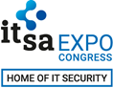
Hardware-based security for the IoT and more
it-sa 2021: Swissbit presents security solutions for the protection of data and devices
October 12-14, 2021
Hall 7, Booth 312
Bronschhofen (Switzerland), Nuremberg (Germany), 22 September 2021 – Firmly established as the “Home of IT Security”, it-sa 2021 will once again be opening its doors at the Nuremberg Exhibition Centre from 12 October as a live, in-person event. Swissbit AG will use this opportunity at Europe's largest IT security trade fair to present its latest hardware-based security solutions. At the Bundesverband IT-Sicherheit e. V. (TeleTrusT) booth 312 in hall 7, Swissbit will present its entire security portfolio ranges, including upgrades for existing products as well as selected best practices. With its solutions based on industrial storage media, Swissbit addresses a wide range of applications across the Internet of Things (IoT). At it-sa, highlights will include solutions for securing sensitive video data, a universal secure boot solution for the Raspberry Pi, and a use case about IP and license protection.
“The increasing networking of devices in the IoT brings with it numerous new security requirements and poses challenges for developers and manufacturers alike,” explains Silvio Muschter, CEO of Swissbit AG. “Our hardware-based security solutions help to reliably protect data and devices, and can be used in a wide range of applications thanks to their modularity and standard interfaces. In addition, they can also be integrated into existing systems or further developed as needed.”
iShield Camera: Plug & Play Security
The latest addition to Swissbit’s security solutions is iShield Camera. The microSD card was specially developed for the encryption and access-protection of video recordings and is host-independent, making it compatible with a wide range of camera types. Thanks to its plug & play approach, iShield Camera can be easily integrated into existing systems. This allows manufacturers and users of drones, body cameras or dashcams to add an additional security feature to their models that specifically prevents unauthorized access to recorded data stored in the camera. Among other things, this can ensure compliance with legal requirements, such as the DSGVO (Datenschutz-Grundverordnung: General Data Protection Regulation).
Secure Boot for Raspberry Pi: Update for more application possibilities
There is an update for the Raspberry Pi’s Secure Boot solution, which is now also available for the CM3+ and 4 versions. The easy-to-implement security solution consists of the ‘Raspberry Edition’ PS-45u-DP microSD card and a software development kit. This enables the effective securing of the Raspberry Pi bootloader, thereby encrypting or write-protecting boot and application code, proprietary know-how and intellectual property. There are three different methods to implement security policies: by PIN entry, via the PU-50n USB stick as an authentication dongle, or via a NET Policy Server.
Best Practice: IP and License Protection
How secure storage media solutions contribute to the protection of software licenses is demonstrated by Swissbit in a project with one of the leading manufacturers in industrial automation. This company was looking for a way to distribute and roll-out software licenses securely for its new control platform. The solution: the Swissbit PS-46 SD memory card, Data Protection Edition. It functions as a secure license container that uniquely links the relevant license file with the memory card through a two-stage process. In this way, the license and SD card are firmly linked and protected without losing the benefits of portability. For machine builders and system integrators, this flexible license protection solution results in a considerable time advantage during roll-out and commissioning.
Swissbit TSEs for legally compliant conversion of cash registers
A further highlight at it-sa 2021 will be Swissbit’s certified range of TSEs (Technical Security Equipment) for tamper-proof recording of cash register data. In addition to the solutions for individual devices and networked cash register systems (LAN), Swissbit’s cloud option is now available for even more installation environments. In total, the Cloud TSE supports 26 different operating systems and variants. Furthermore, Swissbit will soon integrate a solution for Android-based cash registers into its portfolio. As the market leader in the field of TSE – and the first manufacturer to receive TSE certification for storage solutions from the BSI (German Federal Office for Information Security) – Swissbit offers the industry’s greatest variety and security for the legally compliant conversion of cash register systems, which has already been mandatory in Germany since January 1, 2020.

Available images
The following images are available for download in printable format at: https://kk.htcm.de/press-releases/swissbit/
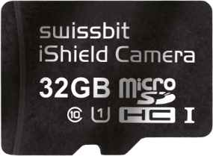  Image Source: Swissbit  Plug & play security: the Swissbit iShield Camera microSD card. | 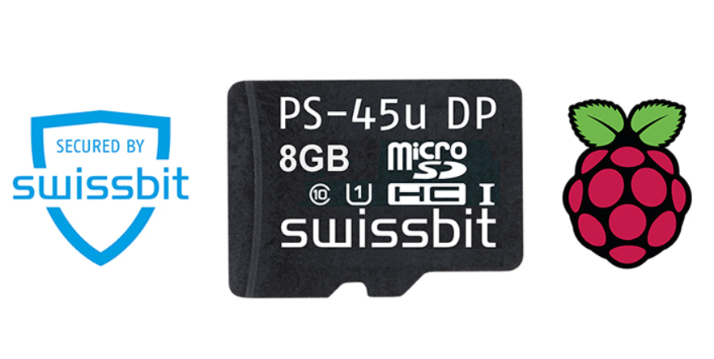  Image Source: Swissbit  The Swissbit Secure Boot Solution for Raspberry Pi: now also available for versions CM3+ and 4.
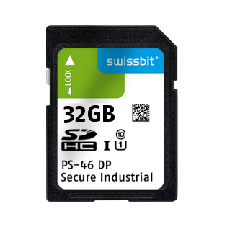  Image Source: Swissbit  Use Case: The Swissbit PS-46 DP memory card acts as a secure license container for software applications. | 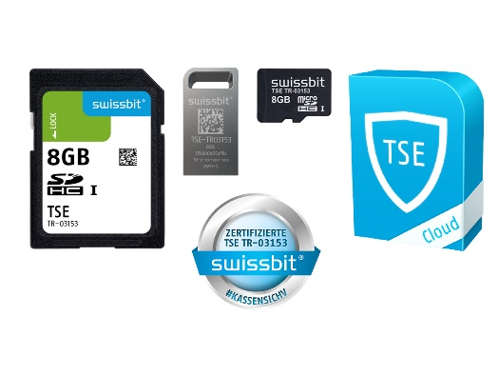  Image Source: Swissbit  The Swissbit TSE portfolio for the legally compliant conversion of cash registers and POS systems.
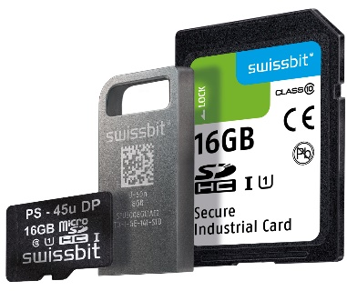
Image Source: Swissbit
Swissbit at it-sa 2021: hardware-based security solutions in SD card, USB and microSD formats.

About Swissbit
Swissbit AG is the leading European manufacturer of storage, security and embedded IoT solutions for demanding applications. Swissbit combines its unique competences in storage and embedded IoT technology with its advanced packaging know how. This expertise allows our customers to reliably store and protect data in industrial, NetCom, automotive, medical and fiscal applications as well as across the Internet of Things (IoT).
Swissbit develops and manufactures industrial-grade storage and security products “Made in Germany” with high reliability, long-term availability, and custom optimization.
Swissbit’s storage range includes SSDs with PCIe and SATA interface such as mSATA, Slim SATA, CFast™, M.2 and 2.5” as well as CompactFlash, USB flash drives, SD Memory Cards, micro SD Memory Cards and managed NAND BGAs like e.MMC. Security products are available in various application specific editions as USB flash drives, SD Memory Cards, and micro SD Memory Cards.
Swissbit was founded in 2001 and has offices in Switzerland, Germany, USA, Japan and Taiwan. Swissbit owns the registered trademarks Swissbit® and Hyperstone®. Since 2020, the independent investment firm Ardian is holding a majority stake in the company to support its growth.
For further information, please visit www.swissbit.com

Regional Headquarters:  Swissbit Germany AG  Bitterfelder Strasse 22  12681 Berlin  Germany  Tel: +49 30 936 954 0  Email: info@swissbit.com  www.swissbit.com | Headquarters:  Swissbit AG  Industriestrasse 4  9552 Bronschhofen  Switzerland  Tel: +41 71 913 03 03  Email: info@swissbit.com  www.swissbit.com
Contact:  Swissbit AG  Marian Weber  Industriestrasse 4  9552 Bronschhofen  Switzerland  Tel: +49 172 854 88 26  Email: marian.weber@swissbit.com  www.swissbit.com | Press Agency:  HighTech communications GmbH  Brigitte Basilio  Brunhamstrasse 21  81249 Munich  Germany  Tel: +49 89 500778-20  Email: b.basilio@htcm.de  www.htcm.de

