Medieninformation
Schröder Group sets standards with EVO Heavy Duty
Most powerful folding machine in the world
Wessobrunn-Forst (Germany), 16 September 2021 – Bending sheet steel with a thickness of up to 16 mm over a working length of 3240 mm - this is possible for the first time with the Schröder EVO Heavy Duty in the swivel folding process. The EVO Heavy Duty, which is equipped with innovative hydraulic compact drives, takes over tasks that previously required press brakes and also performs them much more precisely. For flexible use, Schröder has equipped the machine with state-of-the-art control software - including the option of offline programming - to maximize machine availability and productivity.
With the EVO Heavy Duty, the Schröder Group sets new standards in industrial folding and combines highest precision with the greatest possible folding performance. Compared to press braking, swivel folding increases productivity due to the easier handling of the workpieces and allows for greater accuracies. Innovative hydraulic compact drives enable a clamping force of 200 t. The main drive has an output of 37 kW. The clamping and folding beam drives on both sides ensure extremely fast closing of the clamping beam and swiveling of the folding beam. The clamping beam stroke of 500 mm offers plenty of space for workpieces. 16 mm thick sheet steel can be formed up to a bending angle of 180°, which means that pre-bent sheets can also be closed.
Power and control
The EVO Heavy Duty is operated with the POS2000 Professional or optional POS3000 Professional control. The folding programs of the ergonomic and user-friendly machine can also be prepared offline, i.e. away from and without loading the machine, in the SCHRÖDER Unfold CAD/CAM solution.
"We are pleased to be able to offer this extremely robust machine with an optimum flow of forces during bending. It pushes previously valid limits and achieves a completely new precision in the processing of thick sheets. The advantages of ergonomic, precisely controlled folding are now available in an area that previously had to work with presses“, explains Guido Blissenbach, Head of Design at Hans Schröder Maschinenbau. „EVO Heavy Duty is an economical and reliable folding machine that now offers sheet metal processing companies the added flexibility, speed, dimensional accuracy and repeatability in production associated with our folding technology, even with heavy sheets.“
For the first time, the EVO Heavy Duty was on display at Fabtech in Chicago from September 13 to 16 at the booth of Schröder's partner Metalforming Inc.

Available images
The following images are available for download in printable format at:
https://kk.htcm.de/press-releases/schroeder/
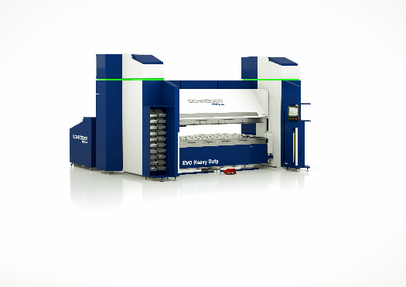Image source: Schröder Group
Folding machine EVO Heavy Duty

About Schröder Group
The Schröder Group consists of Hans Schröder Maschinenbau GmbH, which is located in Wessobrunn-Forst, Germany, SCHRÖDER-FASTI Technologie GmbH, located in Wermelskirchen, Germany and the SMU GmbH, located in Leinburg-Weißenbrunn.
Founded in 1949, Hans Schröder Maschinenbau GmbH unifies traditional and modern approaches in machine building: Successfully managed as a quality and customer-oriented, family-owned company, Hans Schröder Maschinenbau is specialized in the development of modern machine concepts for bending and cutting sheet metal.
The successful integration of the Fasti Company in 2006 and its worldwide presence make the Schröder Group one of today‘s leading providers of machines for bending, cutting, beading, flanging, and circular bending all types of sheet metal. The company‘s precision machines range from proven solutions for craftsmen to innovative, high-performance machines for automatic industrial production processes. 2021 the Schröder Group was expanded by the tool manufacturer SMU GmbH. Overall, the Schröder Group currently employs more than 300 people at various locations at home and abroad.
Further information is available at www.schroedergroup.eu/en.

Press contact:
Schröder Group
Hans Schröder Maschinenbau GmbH
Janina Biró
Feuchten 2
82405 Wessobrunn-Forst
Germany
T: +49 8809 9220-68
E-mail: jj@schroedergroup.eu
Website: www.schroedergroup.eu

HighTech communications GmbH
Brigitte Basilio
Brunhamstraße 21
81249 München
Germany
T: +49 89 500778-20
E-mail: b.basilio@htcm.de
Website: www.htcm.de

