PRESS RELEASE
Würth Elektronik extends its MagI³C-FDSM-36-V family with a 12 V output voltage version
Power Modules Replace L78x Linear Regulators
Waldenburg (Germany), 15 September 2021—The range of MagI³C-FDSM power modules with 36 V input voltage has been expanded to include a version with 12 V output voltage. The power module in a SIP-3 package represents a cost-effective solution to meet the requirements for the real-world voltage transients of a 24 V industrial power architecture. The new module operates from 16 to 36 V_{IN} and generates a fixed output voltage of 12 V with current up to 1 A.
The FDSM series MagI³C power modules are fully integrated DC/DC voltage converters with a fixed output voltage. The modules incorporate all of the components needed, like the controller, inductor and input/output capacitors, with the added benefit of thermal overload and short circuit protection. Since there are no external components required for operation, there is essentially no circuit design needed. This reduces development costs and makes it possible to get to market quickly with new applications. This power module has around 95% efficiency while the linear regulator will have an efficiency of 50%. The standard THT housing for easy mounting is pin-compatible with L78x linear controllers.
Pre-compliance testing has shown both the radiated and conducted emissions on an evaluation board are below the limits of EMC standards EN55032/CISPR32 Class B.

Available images
The following images can be downloaded from the Internet in printable quality: https://kk.htcm.de/press-releases/wuerth/

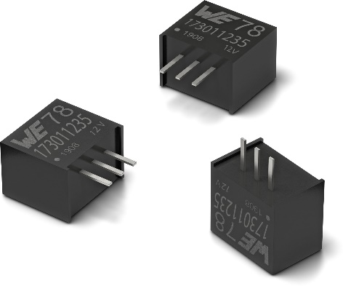Image source: Würth Elektronik
MagI³C FDSM step-down converter with fixed output voltage

About the Würth Elektronik eiSos Group
Würth Elektronik eiSos Group is a manufacturer of electronic and electromechanical components for the electronics industry and a technology company that spearheads pioneering electronic solutions. Würth Elektronik eiSos is one of the largest European manufacturers of passive components and is active in 50 countries. Production sites in Europe, Asia and North America supply a growing number of customers worldwide.
The product range includes EMC components, inductors, transformers, RF components, varistors, capacitors, resistors, quartz crystals, oscillators, power modules, Wireless Power Transfer, LEDs, sensors, connectors, power supply elements, switches, push-buttons, connection technology, fuse holders and solutions for wireless data transmission.
The unrivaled service orientation of the company is characterized by the availability of all catalog components from stock without minimum order quantity, free samples and extensive support through technical sales staff and selection tools.
Würth Elektronik is part of the Würth Group, the world market leader for assembly and fastening technology. The company employs 7,300 staff and generated sales of 823 million euros in 2020.
Würth Elektronik: more than you expect!
Further information at www.we-online.com

Further information:  Würth Elektronik eiSos GmbH & Co. KG  Sarah Hurst  Max-Eyth-Strasse 1  74638 Waldenburg  Germany  Phone: +49 7942 945-5186  E-mail: sarah.hurst@we-online.de  www.we-online.com | Press contact:  HighTech communications GmbH  Brigitte Basilio  Brunhamstrasse 21  81249 Munich  Germany  Phone: +49 89 500778-20  Telefax: +49 89 500778-77  E-mail: b.basilio@htcm.de  www.htcm.de

