PRESS RELEASE

New cts Tops for transport robots
Innovative stacking/destacking design for fewer trips and higher efficiency
Burgkirchen (Germany), 7 September 2021 – With the new HVSRG-SES system, cts GmbH is expanding its portfolio of smart Tops for Autonomous Mobile Robots or Autonomous Intelligent Vehicles (AMR/AIV). The innovative solution for AMR platforms from currently two different manufacturers includes an integrated stacking/destacking function for small payloads up to 25 kilograms and offers maximum flexibility for the transport of small load carriers (KLT) and trays. The cts solution expands the application possibilities of AMR platforms and makes material flow processes in the electronics, pharmaceutical, food or raw materials industries significantly more efficient.
KLT and trays in a wide range of sizes, in different stacking heights, with an ergonomic transfer height of 800 millimeters as well as the complete integration into the fleet control middleware cts-AIV-Framework allow a universal use of the new stacking/destacking AMR/AIV HVSRG-SES. The cts solution picks up several containers from different pick-up points within one transport and can deliver them separated to different or stacked to one transfer point. This significantly reduces the number of transports and greatly increases efficiency when using AMR/AIV fleets. Focused on collaboration, the HVSRG-SES complies with the safety standards ISO 3691-4, JIS D6802 and ANSI B56.5. LIDAR systems, safety lasers or even 3D cameras detect obstacles and avoid collisions.
At launch, the HVSRG-SES will be offered for low-payload transports up to 25 kilograms based on the Omron LD-90 and MIR250. A version for the basic Omron LD-250 and MIR250 systems for the medium-payload segment will follow later on. ESD-compliant variants are available for the electronics industry.
Complete Integration
Like all AMR/AIV solutions from cts, the HVSRG-SES integrates seamlessly into cts' own middleware AIV Framework. The modular software controls and manages fleets of up to 100 autonomous transport systems, even if they are heterogeneously composed of different models and types from different manufacturers. Via a multitude of interfaces, data and control of the mobile transport systems can be easily integrated into existing production environments and into MES/ERP systems. The browser-based design allows access to the data independent of location and device. Users always have an overview of their fleets via various dashboards. A reporting module offers a variety of statistical evaluations.
Perfect addition to the cts portfolio
"The HVSRG-SES complements our portfolio of low-payload AMRs/AIVs. With it, even more flexible applications such as collective transport and a resulting reduction in individual trasnports are now possible. This expands the possible applications of our customers' AMR/AIV fleets and accelerates the payback of projects in the area of material flow automation," explains Philipp Eberherr, Smart Logistics department manager at cts GmbH. "In addition to standard setups such as the HVSRG-SES, we can also make customer-specific adaptations - on AMR platforms from a wide range of manufacturers."
Flexible financing models
In order to provide customers with the greatest possible flexibility for setting up and expanding their AMR/AIV fleets, cts now also offers the option of leasing individual systems or even entire fleets. "Our specialists develop individually tailored leasing packages for each customer," explains Philipp Eberherr. "This makes our service package even more interesting from an economic point of view, and our customers can drive digitization and automation forward more decisively and quickly."
Autonomous transport systems for almost any task
In addition to the new HVSRG-SES, cts offers a wide range of Tops for a variety of transport tasks for KLT, trays and other transport containers. These include, for example, front and back roller loaders with one (RG, RGMZ) or two levels (RG-TLA, RG-TLM), side loaders (RG2S) or trolley movers (TT). Transfer heights can be fixed or variable with lift solutions (HVSRG) depending on type between about 550 and 1500 millimeters. Even the transport of Euro pool pallets with dimensions of 1200 × 800 millimeters can be implemented via optional size extensions.

Available images
The following image material is available for download in printable form on the Internet: https://kk.htcm.de/press-releases/cts/
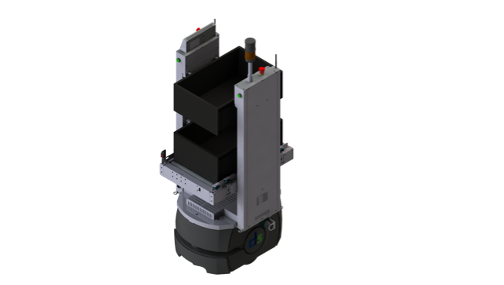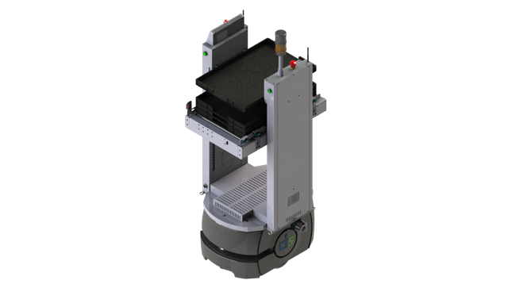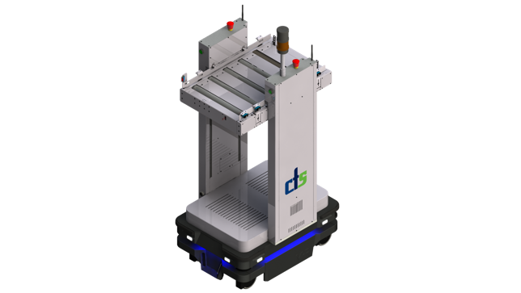
Image source: cts
The HVSRG-SES can run on different platforms and integrates seamlessly with cts' own middleware AIV framework.

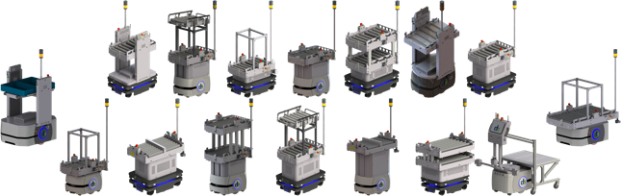
Image source: cts
With the large number of standardized Tops available on a wide variety of base vehicles, cts offers ready-made solutions for a wealth of use cases. Customized special designs can also be realized at any time.

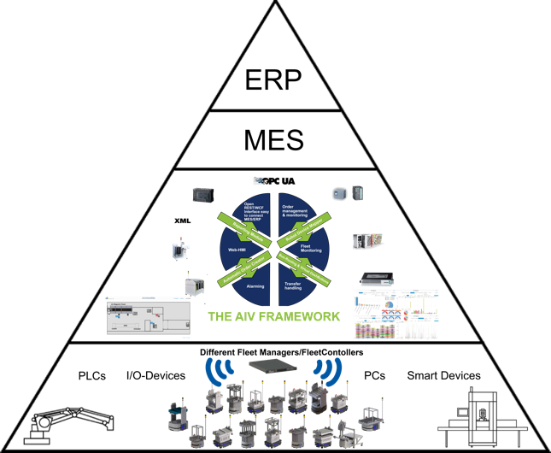
Image source: cts
The cts Middleware AIV-Framework allows the setup and management of even highly heterogeneous or diverse AMR/AIV fleets with up to 100 vehicles and robots. AIV-Framework also enables the integration of AMRs/AIVs into enterprise systems such as MES or ERP.

About cts GmbH
Founded in 2006, cts GmbH offers a complete range of services for process and factory automation. At twelve international locations, the employees work on the implementation of innovative, modern solutions for different industrial sectors. The company has already been awarded the coveted Top 100 prize for particularly innovative companies in the German SME sector twice (2016 and 2018).
For industry, the Factory Automation division offers comprehensive, cross-manufacturer AMR/AIV solutions from a single source - from conception, customizing of AMRs/AIVs and system integration to maintenance of AMR/AIV fleets and the setup of line-oriented, automated warehouse systems. The central open connectivity component is the modular middleware cts AIV framework, which provides important interfaces and central functions for AMR/AIV-supported material logistics and sets up end-to-end data communication between AMRs/AIVs and MES/ERP systems via REST.

In other business areas, cts offers a comprehensive portfolio for visualization, control and monitoring of refinery, petrochemical and pharmaceutical plants. Special attention is paid to the Robotics business area. The range of services here extends from programming and installation to the optimization of welding and production robots or even fully automated packaging systems.
For more information visit www.group-cts.de

Contact:  cts GmbH  Mirela Mesanovic  Münchener Strasse 14  93326 Abensberg  Germany  Mobile: +49 151 16213759  E-Mail: Mirela.Mesanovic@cts-gmbh.de  www.group-cts.de | Press agency:  HighTech communications GmbH  Brigitte Basilio  Brunhamstraße 21  81249 München  Germany  Phone: +49 89 500778-20  E-Mail: b.basilio@htcm.de  www.htcm.de

