**Teaming up for a Hockey Project: HAIMER and Open Mind prove machining excellence on sleek Panther Figure**

*approx. word count = 1,000*

***EMBARGO Text, Images, Video until September 6th, 2021 – thank you!***

When HAIMER, headquartered in Igenhausen, Germany, was inspired to take on the challenge of 5-axis machining a panther out of aluminum to support their partnership and allegiance to German Hockey League’s Augsburger Panther Professional Hockey Team, the right tooling as well as powerful CAD/ CAM software was needed to master the project.

As a market leader that designs, manufactures and sells high-precision products including tool presetting machines, solid carbide cutting tools, toolholders and more to metalworking manufacturers in a wide range of industries, HAIMER had the tooling aspect well covered. Dedicated to using the most advanced high-end technology, HAIMER contacted their longtime CAD/CAM software partner, OPEN MIND Technologies (Wessling, Germany) for its *hyper*MILL® software suite and programming expertise. Providing a leading worldwide CAM solutions, OPEN MIND was the perfect match for programming complete freely shaped contours required on the panther.

OPEN MIND Manager of Global Engineering Services Christian Neuner explained, “A model such as this one was a great opportunity to put the versatility and flexibility of our software to the test. *hyper*MILL® has a wide range of functions that allow CAM users to truly optimize a machine’s capabilities to achieve the desired goal, including making intricate, challenging parts.”

That’s why Jakob Nordmann, Application Engineer at OPEN MIND, setup camp at HAIMER for a few weeks, where he teamed up with HAIMER Applications Engineer Daniel Swoboda to develop the ideal programming and machining infrastructure. For the milling machine, they chose the linear, 5-axis DMG MORI HSC70 machining center located in the HAIMER Application Center, which is well suited for precise aluminum machining and excellent surface finish.

**Tool Solutions Meet Machining Challenges**

Machining the panther’s head proved especially challenging, in particular the extremely detailed mouth and incisors. The long and thin shape of the filigree tail section was equally difficult to master, as it was extremely sensitive to vibration. What’s more, access to many of the parts was extremely difficult, so two setups were done using a LANG macro grip 5-axis clamp fixture.

The limited accessibility also impacted the type of tools selected. Although the shortest possible tools were already being utilized, the application specialists still required tool lengths up to 10.9" (278 mm). This led Swoboda to choose the modular HAIMER Duo-Lock™ tools for the roughing applications. This system consists of carbide tool heads that are connected to different extensions via an extremely stable interface. A four-flute cutter with a corner radius from the Duo-Lock™ HAIMER MILL Alu series was selected for the job. These fine balanced tools feature superior length repeatability, and offer a degree of sharpness with a precise balance of abrasiveness and resistance. “We clamped the coated, cylindrical extensions of the Duo-Lock tools using the HAIMER Power Shrink Chucks,” said Swoboda. “This resulted in significantly more rigid clamping with less vibration, compared with standard tool holders. In turn, a greater depth of cut and a higher metal removal rate was able to be achieved.”

For the finishing process, the applications team selected a full radius version of the solid carbide end mill from the HAIMER MILL Alu series because of its micro-geometrical properties, which are designed for smoothness and top surface quality. The very limited space conditions were factored in when clamping with the extra slim and low-vibration HAIMER Power Mini Shrink holders.

Nordmann added, “What I found most helpful was that all the HAIMER holders and cutting tools were also available in the form of DXF and STP files. The models are available on the HAIMER website homepage for easy download. It takes just three clicks in the *hyper*MILL® Toolbuilder to enter the models into the database, making them immediately available for programming and simulation.”

**The Role of CAD for CAM and Simulation**

Creating a visually appealing panther model demanded careful, well-executed programming. The first core challenge was due to the panther being presented as an STL data model. Nordmann explained, “Since conversion into a surface model would have taken too long, we decided to mill on the STL network, but with line-by-line milling of 0.039" (1mm) to ensure that the faceted structure was not visible.”

“For especially detailed areas, such as the mouth and tail section or with the creases of the joints, we generated additional surfaces that can be combined with the STL network in *hyper*MILL®, said Nordmann. For this, *hyper*CAD®-S, the ‘CAD for CAM’ system specially designed by OPEN MIND to help meet all the needs of programmers, was used.

Since the limited space required different tilts of the tool, the focus was on maintaining the exact line spacing and a seamless transition without any visible gaps. “I used the ‘edit toolpath’ command for this,” said Jakob. “This allowed me to determine the entire toolpath and divide it into sections, which then made it possible to edit in various tilts using different tools, saving a significant amount of time.”

Equally imperative for milling the panther was the *hyper*MILL® VIRTUAL Machining Center, a process-safe NC simulation solution where virtual machine movements fully mimic real movements and ensure reliable collision detection. The VIRTUAL Machining Center pre-emptively recognized that the component could not be processed in a basic orientation due to X-axis limited and automatically generated a solution for a workable position.

It took the team approximately three intensive weeks to complete the first free-standing panther. Once the machining parameters were in place and optimized, the approximately 20" (500 mm) long panther was machined in just under 13 hours. In addition to being proudly showcased by the Augsburger Panther hockey team, the panther model will be on display at HAIMER and OPEN MIND trade show booths at future events.

# # # # # #

**Images & Video (thumbnails and link found on the following four pages) are Courtesy of OPEN MIND Technologies and HAMIER**

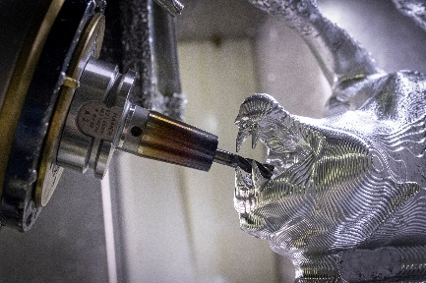

B01_Haimer_OM_2034_bea

HAIMER and OPEN MIND’s panther model demonstrates the results of efficiently manufacturing challenging, free-form components.

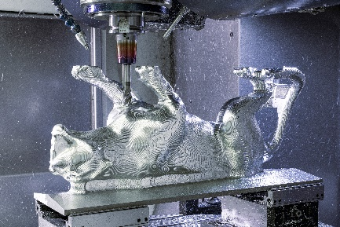

B02_Haimer_OM__1814

The designers used the modular Haimer Duo-Lock™ tool system for roughing. This system consists of carbide tool heads that are connected to different extensions via an extremely stable interface.

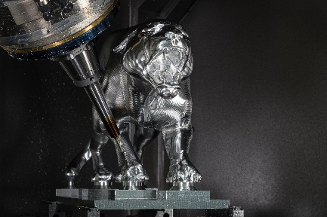

B03_Haimer_OM_Panther_10

The finish was done using the full radius version of solid carbide end mills from the HAIMER MILL Alu series, which were clamped in the extra slim, low-vibration HAIMER Power Mini Shrink holders.

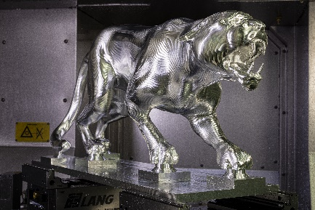

B04_Haimer_OM_Panther_5

The panther, which is approximately 20" (500 mm) in length, was machined from an aluminum block in just under 13 hours.

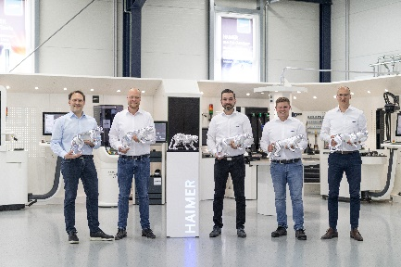

B05_Haimer_OM_3039_bea

The face of winners: (from left to right) Christian Neuner and Jakob Nordmann from OPEN MIND, with Head of the HAIMER Application Center Konstantin Brodowski, Daniel Swoboda and Director of Marketing Tobias Völker from HAIMER are thrilled with their successful teamwork.

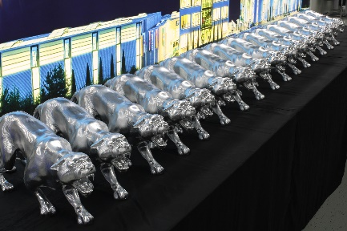

B06_Haimer_OM__2754

The panthers are eagerly awaiting their shining opportunity to be seen. They’ll soon be a fixture to be admired at HAIMER, OPEN MIND and the stadium of the Augsburger Panther.

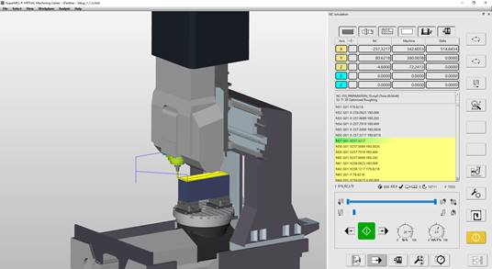

B07_HAIMER_OM_

The Optimizer module in *hyper*MILL® VIRTUAL Machining Center was particularly helpful in the programming process. It pre-emptively recognized that the component could not be processed in the basic orientation due to X-axis limits and automatically provided a solution for a position that worked.

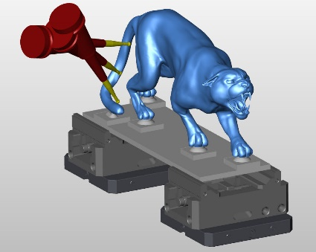

B08_HAIMER_OM_Screenshot

Machining challenge: The long and thin shape of the filigree tail section was extremely sensitive to vibration.

Ein Bild, das Strichzeichnung enthält.
Ein Bild, das Reptil, Schildkröte enthält.

B09_HAIMER-OM_Foto

Powerful and dynamic. The panther came about as the result of the perfect synergy between high-tech HAIMER products and advanced *hyper*MILL® CAD/CAM solutions.

[Ein Bild, das Text enthält.
](https://youtu.be/aN-JP2qKRNE)

**Haimer_OM_Panther-Video**: <https://youtu.be/aN-JP2qKRNE>

**About OPEN MIND Technologies**[(openmind-tech.com)](https://www.openmind-tech.com/en.html)

OPEN MIND Technologies is one of the world’s most sought-after developers of powerful CAM solutions for machine and controller-independent programming. OPEN MIND designs optimized CAM solutions that include a large number of innovative features not available elsewhere in order to deliver significantly higher performance in both programming and machining. Strategies such as 2.5D, 3D and 5axis mill turning as well as machining operations like HSC and HPC are firmly integrated into the *hyper*MILL® CAM system. *hyper*MILL provides the maximum possible benefits to customers thanks to its full compatibility with all current CAD solutions and its extensive programming automation.

OPEN MIND ranks globally among the top five CAM/CAD manufacturers according to the 2021 CIMdata NC Market Analysis Report. The CAM/CAD systems from OPEN MIND meet the strictest requirements in the tool and mold manufacturing and production machining industries as well as in the automotive, aerospace and medical engineering industries. OPEN MIND is active in all of the vital markets in Asia, Europe, and America, and is a member of the Mensch und Maschine Group.

**About HAIMER (**[www.haimer.com](http://www.haimer.com))

HAIMER is a family run, medium size company located in Igenhausen, Bavaria near Augsburg, Germany. The company designs, produces and sells innovative, high precision products for metal cutting in industries including automotive, aerospace, energy, rail and general machining.

In addition to the large offering of toolholders in all popular interfaces and lengths, including shrinking and balancing machines, HAIMER also offers 3-D Sensors, solid carbide cutting tools, and tool presetting machines.

With its 800 employees HAIMER is a true global player with 16 subsidiaries worldwide.   
HAIMER USA was the first one to be established in 2002 and is since then headquartered in Villa Park, IL covering the US and Canada as well as Mexico.

With 500 people at the main production facility in Igenhausen, Germany using the most modern machines and a high level of automation. At the second HAIMER production site in Bielefeld with approximately 50 employees, HAIMER Microset presetting machines are manufactured. Experienced, dynamic and highly skilled employees guarantee the well-known and highest quality “made by HAIMER.” As an active apprenticeship company with almost 50 interns, HAIMER has a high acquisition/ hiring rate, fulfilling its contribution to educate young adults, and fortify the future of its German manufacturing location.

HAIMER is the European market leader for toolholding technology, producing approximately 4,000 toolholders each day. Having a technological edge is key to HAIMER, and the company invests between 8 and 10% of its revenue in research and development to support its corporate philosophy: Quality Wins.