PRESS RELEASE
Würth Elektronik technology partnership with Audi Sport ABT Schaeffler comes to an end
Races Won and Experience Gained Together in Formula E
Waldenburg (Germany), August 17, 2021—Würth Elektronik looks back on seven years of successful partnership with the Audi Sport ABT Schaeffler racing team. At the final race on August 14 and 15, 2021 in Berlin, Lucas di Grassi finished in 7th place and René Rast in 13th place. With a team score of 4th place, Team Audi Sport ABT Schaeffler bows out of Formula E. Würth Elektronik has been involved as a technology partner since the first season. For the manufacturer of electronic and electromechanical components, a period of successful commitment to the most dynamic form of e-mobility draws to a close.
"Together with Audi Sport ABT Schaeffler, we have experienced many exciting races and emotional moments and take pleasure in the very successful partnership that has evolved over the years," said Alexander Gerfer, CTO of the Würth Elektronik eisos Group. "With the developments in the field of e-mobility, we have provided impetus to accentuate the need for a change of mindset and to respond to climate change with new technologies. Our aspiration is to achieve the best results for our components and to discover where we can further improve their performance in order to bring our own expertise and innovations into series production. At the same time, the challenges of our partners and customers drive us forward, however. And that's how it was in Formula E too.”
Electronics for ultra heavy-duty use
The more individual the racing cars were allowed to become over the course of the race series, the more intense the cooperation became. One last highlight of the 2019/20 season: With its WE-AGDT “Auxiliary gate Drive Transformer” and reference design, Würth Elektronik provides a highly compact and efficient solution for driving state-of-the-art silicon carbide MOSFETs and IGBTs. It is part of the innovative MGU05 powertrain from the Audi e-tron F07, which has now seen its last Formula E race. Besides joint developments and the use of components like the REDcube high-current contacts in vibration-resistant press-fit technology, Würth Elektronik also provided spontaneous assistance: It was only in the electronics manufacturer's lab that the fault could be found, which had led to vehicle failures at the start of the fourth season. A spectacular catch-up chase then ensued, which ended with winning the Team Championship title.
"In 2014, as the only German team to compete in the newly founded FIA Formula E World Championship, Würth Elektronik was our partner back then and has remained so until today. The collaboration was excellent and together we advanced e-mobility as a racing sport. I say thank you," says Hans-Jürgen Abt, Managing Director of ABT Sportsline GmbH.
"We look back with pleasure on seven years together full of goose bump moments, mutual trust, deep bonding and a shared passion for eMotorsport,” Harry Unflath, Head of Sports Marketing at ABT Sportsline GmbH adds.
Oliver Opitz, Vice President of Wireless Connectivity & Sensors and initiator of Würth Elektronik's commitment with ABT Sportsline in Formula E, had the right connection to ABT: "From the very beginning, it was important for us to promote and help shape an innovative project for the future. We shared Hans-Jürgen Abt’s pioneering spirit, and we were immediately impressed by his willingness to take risks, his courage and curiosity to embark on something groundbreaking. That's why ABT Sportsline became an important and valuable technology partner for us back in 2014, enabling us to accelerate technical developments and to grow with the FIA Formula E race series. Thank you very much for the strong partnership that has grown between us."

Available images
The following images can be downloaded from the Internet in printable quality: https://kk.htcm.de/press-releases/wuerth/
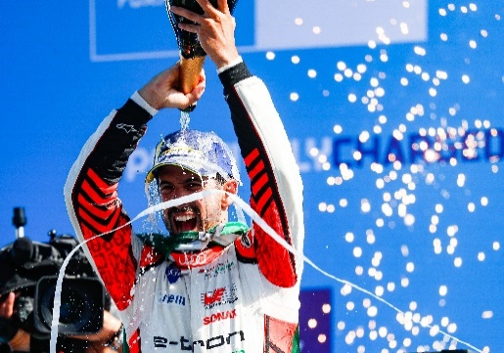Image source: Audi Media Center  Lucas di Grassi finished 7th overall at the race in Berlin on August 14 and 15, 2021. | 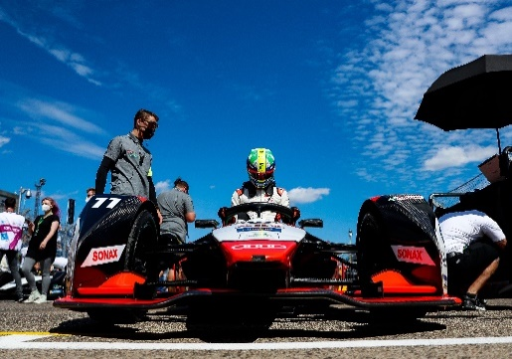Image source: Audi Media Center  Racing driver Lucas di Grassi in the Audi e-tron F07

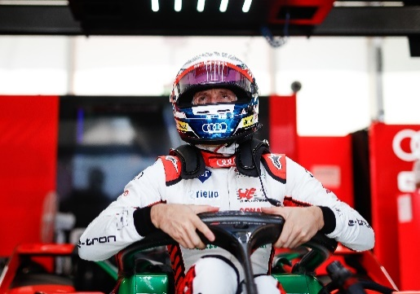Image source: Audi Media Center
Driver René Rast from the Audi Sport ABT Schaeffler racing team

About the Würth Elektronik eiSos Group
Würth Elektronik eiSos Group is a manufacturer of electronic and electromechanical components for the electronics industry and a technology company that spearheads pioneering electronic solutions. Würth Elektronik eiSos is one of the largest European manufacturers of passive components and is active in 50 countries. Production sites in Europe, Asia and North America supply a growing number of customers worldwide.
The product range includes EMC components, inductors, transformers, RF components, varistors, capacitors, resistors, quartz crystals, oscillators, power modules, Wireless Power Transfer, LEDs, sensors, connectors, power supply elements, switches, push-buttons, connection technology, fuse holders and solutions for wireless data transmission.
The unrivaled service orientation of the company is characterized by the availability of all catalog components from stock without minimum order quantity, free samples and extensive support through technical sales staff and selection tools.
Through its technology partnership with the Audi Sport ABT Schaeffler Formula E Team and its support for the Formula Student racing series, the company demonstrates its innovative strength in eMobility
(www.we-speed-up-the-future.com).
Würth Elektronik is part of the Würth Group, the world market leader for assembly and fastening technology. The company employs 7,300 staff and generated sales of 823 million euros in 2020.
Würth Elektronik: more than you expect!
Further information at www.we-online.com

Further information:  Würth Elektronik eiSos GmbH & Co. KG  Sarah Hurst  Max-Eyth-Strasse 1  74638 Waldenburg  Germany  Phone: +49 7942 945-5186  E-mail: sarah.hurst@we-online.de  www.we-online.com | Press contact:  HighTech communications GmbH  Brigitte Basilio  Brunhamstrasse 21  81249 Munich  Germany  Phone: +49 89 500778-20  Telefax: +49 89 500778-77  E-mail: b.basilio@htcm.de  www.htcm.de

