PRESS RELEASE

Würth Elektronik supplies transformer and reference design for powertrain of Audi e-tron FE07
WE-AGDT: Highest efficiency transformer proves itself in Formula E
Waldenburg (Germany), August 6, 2021 – Würth Elektronik has been a technology partner of the Audi Sport ABT Schaeffler team since the beginning of Formula E. Now, with the WE-AGDT transformer and the RD001 reference design, an important part of the power inverter gate driver system in the innovative Audi MGU05 electric powertrain of the Audi e-tron FE07 Formula E race car has been co-designed. Launched last December, the WE-AGDT transformer and power supply solution developed by Würth Elektronik for the demanding gate driving of SiC MOSFETs was inspired by the technology partnership with the Formula E team. The solution is proving itself on the race tracks for the first time this season. WE-AGDT has already received AEC-Q200 qualification; other automotive certifications such as PPAP level 3 and IATF-16949 qualifications are underway.
"We wanted to provide an optimized isolated power supply solution that delivers the optimal gate drive voltages for silicon carbide MOSFETs and IGBTs, such as those used in electric vehicle powertrains. With the WE-AGDT, we have achieved a solution that is smaller, lighter, more efficient and more powerful than comparable power modules on the market," says Eleazar Falco, Applications Engineer and Product Management at Würth Elektronik eiSos.
The innovative WE-AGDT (Auxiliary Gate Drive Transformer) is a compact transformer in an EP7 package that features a wide input voltage range of 9 to 36 V and a high saturation current of 4.5 A, as well as very low leakage inductance and, at 6.8 pF, also very low capacitance between the windings.
Wide range of applications for the race-proven component
"The gate drive transformer is a critical part of the electric drive system in the vehicle of the Formula E team we support, Audi Sport ABT Schaeffler," says Emil Nierges, Product Manager Power Isolated, Product Marketing and Development at Würth Elektronik eiSos. "This innovation, inspired by racing, has now successfully become a standard Würth Elektronik component after a few laps on the track. There are numerous applications in which these transformers can be used. These include, for example, charging stations for e-mobility, inverters used in the conversion of renewable energies such as solar or wind power, and industrial motors that drive production lines in factories."
WE-AGDT can be ordered in various designs from stock -- including as a free sample. Würth Elektronik's reference design for a compact, galvanically isolated DC/DC converter for SiC MOSFET gate drivers is available at www.we-online.com/RD001.

Available images
The following images can be downloaded from the Internet in printable quality: https://kk.htcm.de/press-releases/wuerth/
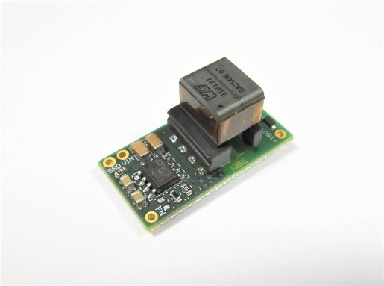Image source: Würth Elektronik  Reference design RD001 from Würth Elektronik for the Audi e-tron FE07 | 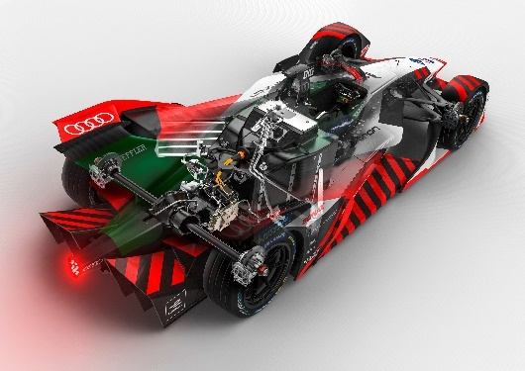Image source: Audi Sport  The power supply solution from Würth Elektronik was developed for the powertrain, specifically for gate driving SiC MOSFETs, in the Audi e-tron FE07.

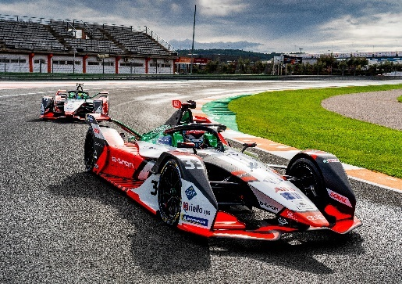Image source: Audi Sport  Formula E race car e-tron FE07. With race driver René Rast, #33 (front) and Lucas di Grassi, #11. | 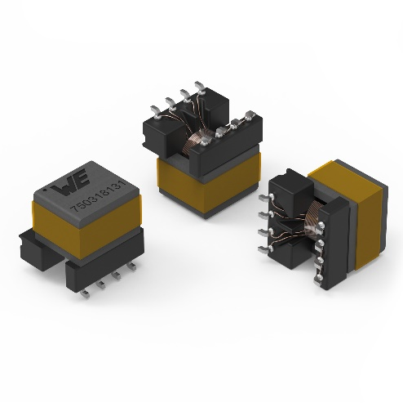  Image source: Würth Elektronik  Transformer WE-AGDT from Würth Elektronik for the Audi e-tron FE07

About the Würth Elektronik eiSos Group
Würth Elektronik eiSos Group is a manufacturer of electronic and electromechanical components for the electronics industry and a technology company that spearheads pioneering electronic solutions. Würth Elektronik eiSos is one of the largest European manufacturers of passive components and is active in 50 countries. Production sites in Europe, Asia and North America supply a growing number of customers worldwide.
The product range includes EMC components, inductors, transformers, RF components, varistors, capacitors, resistors, quartz crystals, oscillators, power modules, Wireless Power Transfer, LEDs, sensors, connectors, power supply elements, switches, push-buttons, connection technology, fuse holders and solutions for wireless data transmission.
The unrivaled service orientation of the company is characterized by the availability of all catalog components from stock without minimum order quantity, free samples and extensive support through technical sales staff and selection tools.
Through its technology partnership with the Audi Sport ABT Schaeffler Formula E Team and its support for the Formula Student racing series, the company demonstrates its innovative strength in eMobility
(www.we-speed-up-the-future.com).
Würth Elektronik is part of the Würth Group, the world market leader for assembly and fastening technology. The company employs 7,300 staff and generated sales of 823 million euros in 2020.
Würth Elektronik: more than you expect!
Further information at www.we-online.com

Further information:  Würth Elektronik eiSos GmbH & Co. KG  Sarah Hurst  Max-Eyth-Strasse 1  74638 Waldenburg  Germany  Phone: +49 7942 945-5186  E-mail: sarah.hurst@we-online.de  www.we-online.com | Press contact:  HighTech communications GmbH  Brigitte Basilio  Brunhamstrasse 21  81249 Munich  Germany  Phone: +49 89 500778-20  Telefax: +49 89 500778-77  E-mail: b.basilio@htcm.de  www.htcm.de

