PRESS RELEASE

Mouser Best-in-Class Award for Würth Elektronik
One of the top 10 manufacturers of passive components
Waldenburg (Germany), August 5, 2021 – As one of the leading manufacturers of electronic components, Würth Elektronik is a valued manufacturer partner of Mouser Electronics. Mouser, a global authorized distributor, is enthusiastic not only about the products, but also about the cooperation. For the second year in a row, Joe Haukos, Distribution Manager Americas at Würth Elektronik eiSos, was honored with the Mouser Best-in-Class Award.
Each year, the electronics distributor honors individuals in the industry with its Best-in-Class Award, recognizing those who maintain a strategic partnership with the Mouser team, promote product lines and new product introductions, find creative solutions to mutually expand market share, maximize Mouser's value proposition, and champion Mouser within their own companies. The presentation of the award to Joe Haukos by Jeff Newell, Senior Vice President at Mouser Electronics, capped off a thoroughly enjoyable quarterly meeting.
“We aspire to provide more than electronic components…we want to provide an experience which fosters loyalty with customers and business partners. Through exceptional collaboration and dedication within the greater Mouser organization, we’re able to do just that.” Said a pleased Joe Haukos.
Commented Newell, “We are pleased to present Joe with this award in recognition of his outstanding relationship with Mouser. Joe and the Würth team have proved dedicated to fostering collaboration, increasing annual revenues, and furthering our successful partnership.”

Available images
The following images can be downloaded from the Internet in printable quality: https://kk.htcm.de/press-releases/wuerth/

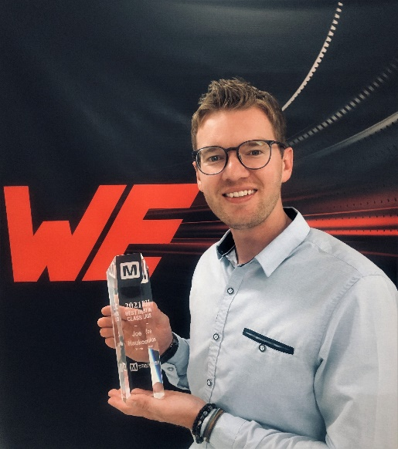Image source: Würth Elektronik
Joe Haukos, Distribution Manager Americas at Würth Elektronik eiSos, received the Mouser Best-in-Class Award for the second year in a row.

About the Würth Elektronik eiSos Group
Würth Elektronik eiSos Group is a manufacturer of electronic and electromechanical components for the electronics industry and a technology company that spearheads pioneering electronic solutions. Würth Elektronik eiSos is one of the largest European manufacturers of passive components and is active in 50 countries. Production sites in Europe, Asia and North America supply a growing number of customers worldwide.
The product range includes EMC components, inductors, transformers, RF components, varistors, capacitors, resistors, quartz crystals, oscillators, power modules, Wireless Power Transfer, LEDs, sensors, connectors, power supply elements, switches, push-buttons, connection technology, fuse holders and solutions for wireless data transmission.
The unrivaled service orientation of the company is characterized by the availability of all catalog components from stock without minimum order quantity, free samples and extensive support through technical sales staff and selection tools.
Through its technology partnership with the Audi Sport ABT Schaeffler Formula E Team and its support for the Formula Student racing series, the company demonstrates its innovative strength in eMobility
(www.we-speed-up-the-future.com).
Würth Elektronik is part of the Würth Group, the world market leader for assembly and fastening technology. The company employs 7,300 staff and generated sales of 823 million euros in 2020.
Würth Elektronik: more than you expect!
Further information at www.we-online.com

Further information:  Würth Elektronik eiSos GmbH & Co. KG  Sarah Hurst  Max-Eyth-Strasse 1  74638 Waldenburg  Germany  Phone: +49 7942 945-5186  E-mail: sarah.hurst@we-online.de  www.we-online.com | Press contact:  HighTech communications GmbH  Brigitte Basilio  Brunhamstrasse 21  81249 Munich  Germany  Phone: +49 89 500778-20  Telefax: +49 89 500778-77  E-mail: b.basilio@htcm.de  www.htcm.de

