PRESS RELEASE
Würth Elektronik as partner of the European Hyperloop Week
CTO Alexander Gerfer Addresses the Hyperloop Teams
Waldenburg (Germany), July 28, 2021—A keynote by Alexander Gerfer, CTO at Würth Elektronik eiSos Group, on July 20 opened the first European Hyperloop Week Conference Week in Valencia.
Alongside the Hyperloop Pod Competition, Würth Elektronik participated in numerous roundtable discussions with development teams and leaders from the Hyperloop scene throughout the week.
Hyperloop Week came to Europe for the first time this year. In 2014, the concept of the Hyperloop mobility was unveiled by Elon Musk and showcased at the SpaceX site in Los Angeles County, U.S.A. Four Hyperloop teams, HYPED from the University of Edinburgh, Swissloop ETH Zurich, Hyperloop UPV Valencia, and Delft Hyperloop, were the organizers behind the first European Hyperloop Week.
With the assistance of components and technical backing, Würth Elektronik has supported three of these teams for a long time. Another team recently joining is Centro Superior de Innovación y Desarollo CHF, Madrid. Würth Elektronik also supported the European Hyperloop Week as a Gold Partner.
“How to make your idea happen – even small challenges can become a show stopper for your idea. Learn how to make sure of your success," states Alexander Gerfer, CTO at Würth Elektronik eiSos Group, as he began his keynote and opened the assembly dedicated to electronics and mechanics on July 20.
Partner for future technologies
"We invest in the development of future technologies, also as a partner of the first European Hyperloop Week. We have been supporting three teams for years by providing components, EMC tests and expertise. We want to encourage young talents and enable them to realize their ideas and make them ready for market," says Gerfer.
Würth Elektronik participated in the roundtable discussions on "Future transportation in Spain" and "Problems facing future transportation / future of Hyperloop". Jorge Victoria, Senior Product Manager EMC Shielding & Thermal Materials, Product Management at Würth Elektronik eiSos, in collaboration with the Fundación Cátedra, conducted EMC testing and analysis, containment, and heat loss reduction tests for the Hyperloop pods from the organizing teams in the joint laboratories at the Universidad Politècnica de València.

Competition and awards in various categories
On Saturday, July 24, 2021, 34 student teams from around the world competed for the best performance in various disciplines on specially built transport tracks at the Circuito Ricardo Tormo de Valencia racetrack. The overall winner with the best "pod" was Team Swissloop from ETH Zurich.
At the gala dinner at the end of the week, awards were presented in various categories. Würth Elektronik sponsored the award for best thermal management design. Jorge Victoria and Josep Balcells Orona, Country Manager Würth Elektronik Spain, presented this award to Team Swissloop from ETH Zurich. On Sunday, July 25, the public had the opportunity to look at the pods and find out more about Hyperloop. A team from Würth Elektronik was on site as a point of contact in the "La Marina" port zone in Valencia and answered questions from interested visitors.

Available images
The following images can be downloaded from the Internet in printable quality: https://kk.htcm.de/press-releases/wuerth/
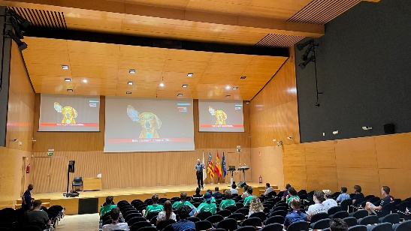 Image source: Würth Elektronik  Alexander Gerfer, CTO at Würth Elektronik eiSos Group, opened the European Hyperloop Week Conference Week in Valencia. | 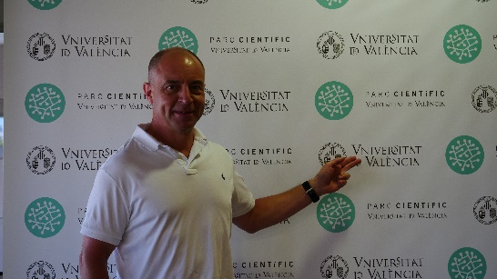  Image source: Würth Elektronik  Alexander Gerfer, CTO at Würth Elektronik eiSos Group

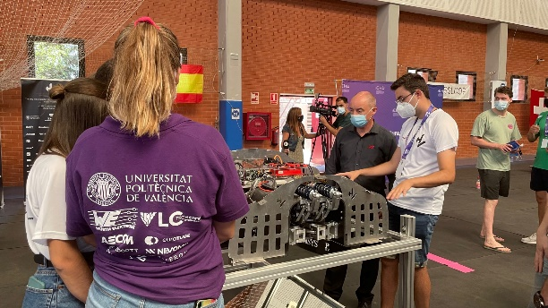 Image source: Würth Elektronik  Technical insights into the construction of the pods | 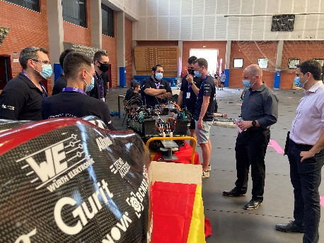 Image source: Würth Elektronik  The Hyperloop Team from the Centro Superior de Innovación y Desarollo CHF, Madrid together with Alexander Gerfer (2nd from right), CTO at Würth Elektronik eiSos Group

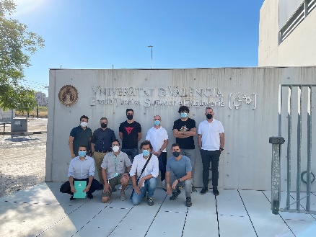 Image source: Würth Elektronik
Partnership with the Fundación Cátedra at the University of Valencia

About the Würth Elektronik eiSos Group
Würth Elektronik eiSos Group is a manufacturer of electronic and electromechanical components for the electronics industry and a technology company that spearheads pioneering electronic solutions. Würth Elektronik eiSos is one of the largest European manufacturers of passive components and is active in 50 countries. Production sites in Europe, Asia and North America supply a growing number of customers worldwide.

The product range includes EMC components, inductors, transformers, RF components, varistors, capacitors, resistors, quartz crystals, oscillators, power modules, Wireless Power Transfer, LEDs, sensors, connectors, power supply elements, switches, push-buttons, connection technology, fuse holders and solutions for wireless data transmission.
The unrivaled service orientation of the company is characterized by the availability of all catalog components from stock without minimum order quantity, free samples and extensive support through technical sales staff and selection tools.
Through its technology partnership with the Audi Sport ABT Schaeffler Formula E Team and its support for the Formula Student racing series, the company demonstrates its innovative strength in eMobility
(www.we-speed-up-the-future.com).
Würth Elektronik is part of the Würth Group, the world market leader for assembly and fastening technology. The company employs 7,300 staff and generated sales of 823 million euros in 2020.
Würth Elektronik: more than you expect!
Further information at www.we-online.com

Further information:  Würth Elektronik eiSos GmbH & Co. KG  Sarah Hurst  Max-Eyth-Strasse 1  74638 Waldenburg  Germany  Phone: +49 7942 945-5186  E-mail: sarah.hurst@we-online.de  www.we-online.com | Press contact:  HighTech communications GmbH  Brigitte Basilio  Brunhamstrasse 21  81249 Munich  Germany  Phone: +49 89 500778-20  Telefax: +49 89 500778-77  E-mail: b.basilio@htcm.de  www.htcm.de

