PRESS RELEASE
Würth Elektronik offers M12 Ethernet connector WE-LANMX
Rugged Connection with Integrated Magnetics
Waldenburg (Germany), July 15, 2021—Würth Elektronik is expanding its product portfolio with an industrial Ethernet M12 connector. The special feature of this sturdy M12 socket: The transformer and current-compensated choke are already integrated. With the manufacturer’s fitting screw connector, device developers and system builders can implement cabling that meets protection class IP67 used in harsh environments, if in mated and secured position. The connector is assembled on the board with through-hole reflow technology. This means that the data connection with WE-LANMX is protected against dust and water as well as rugged against vibrations.
WE-LANMX is easier and more space-saving than a conventional M12 connector, as the essential components are already integrated into its housing: The particularly small signal transformer WE-STST, the data line filter WE-CNSW featuring high common-mode attenuation, and the ‘Bob Smith’ termination for Ethernet. With the LCP housing material and special housing form, as well as the shape of the pins. Würth Elektronik has made the THT connector reflow solderable. The operating temperature of the WE-LANMX ranges from -40 to +85°C. The connector is suitable for all types of 10/100Base-T Ethernet connections, such as EtherNet/IP, Profinet, EtherCAT or Ethernet Powerlink.
Würth Elektronik provides free samples for prototyping. WE-LANMX and the corresponding screw connection are available from stock without a minimum order quantity.

Available images
The following images can be downloaded from the Internet in printable quality: https://kk.htcm.de/press-releases/wuerth/
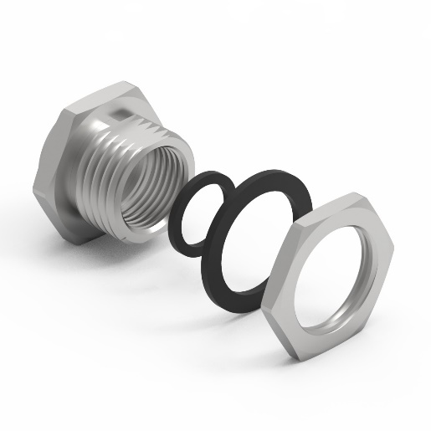  Image source: Würth Elektronik  Screw connector including seals to achieve IP67 | 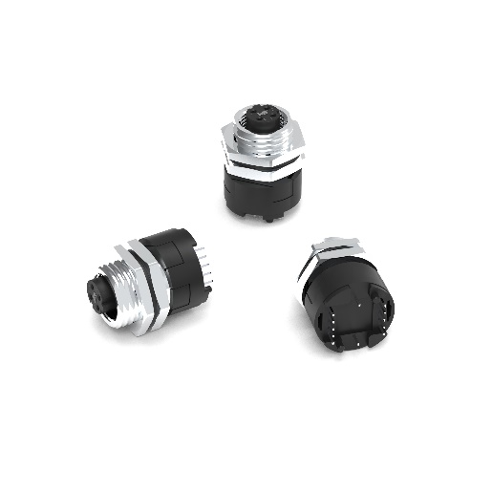  Image source: Würth Elektronik  Assembly of the socket together with the screw connector

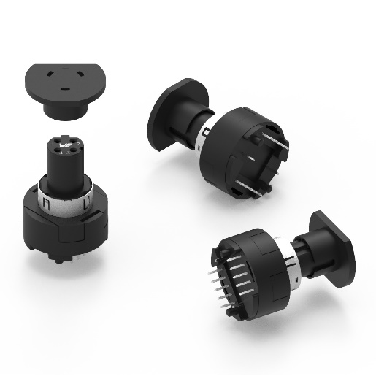
Image source: Würth Elektronik
Socket with cap for automatic assembly

About the Würth Elektronik eiSos Group
Würth Elektronik eiSos Group is a manufacturer of electronic and electromechanical components for the electronics industry and a technology company that spearheads pioneering electronic solutions. Würth Elektronik eiSos is one of the largest European manufacturers of passive components and is active in 50 countries. Production sites in Europe, Asia and North America supply a growing number of customers worldwide.

The product range includes EMC components, inductors, transformers, RF components, varistors, capacitors, resistors, quartz crystals, oscillators, power modules, Wireless Power Transfer, LEDs, sensors, connectors, power supply elements, switches, push-buttons, connection technology, fuse holders and solutions for wireless data transmission.
The unrivaled service orientation of the company is characterized by the availability of all catalog components from stock without minimum order quantity, free samples and extensive support through technical sales staff and selection tools.
Through its technology partnership with the Audi Sport ABT Schaeffler Formula E Team and its support for the Formula Student racing series, the company demonstrates its innovative strength in eMobility
(www.we-speed-up-the-future.com).
Würth Elektronik is part of the Würth Group, the world market leader for assembly and fastening technology. The company employs 7,300 staff and generated sales of 823 million euros in 2020.
Würth Elektronik: more than you expect!
Further information at www.we-online.com

Further information:  Würth Elektronik eiSos GmbH & Co. KG  Sarah Hurst  Max-Eyth-Strasse 1  74638 Waldenburg  Germany  Phone: +49 7942 945-5186  E-mail: sarah.hurst@we-online.de  www.we-online.de | Press contact:  HighTech communications GmbH  Brigitte Basilio  Brunhamstrasse 21  81249 Munich  Germany  Phone: +49 89 500778-20  Telefax: +49 89 500778-77  E-mail: b.basilio@htcm.de  www.htcm.de

