PRESS RELEASE
7-segment displays from Würth Elektronik
Fast, Economical and Robust
Waldenburg (Germany), July 8, 2021—Würth Elektronik presents two product series of 7-segment displays: The SMT-mountable WL-S7DS and the THT-variant WL-T7DS. These rugged single-digit display can perform numbers easily. The new long-term standard products are available in three sizes, each with red or green LEDs (635 nm or 570 nm). Other emitted colors can be realized on request. Compared to the other number displays, which are available on the market, Würth Elektronik's products score with the low power consumption of just a few milliamperes and with faster switching characteristics.
7-segment displays are the indispensable classic among displays for many applications. Where only numbers need to be presented, they are unbeatably fast compared to LCDs, easier to control and exceptionally robust with an operating temperature range of -35 to +85°C. WL-S7DS is available in 12 × 7.3 × 3.75 mm (0.30 inch), 15 × 9.8 × 3.75 mm (0.39 inch), and 19 × 12.4 × 3.75 mm (0.56 inch). The WL-T7DS THT variant offers a choice of 13 × 10 × 7 mm (0.39 inch), 17.5 × 12.4 × 7 mm (0.52 inch) and 19 × 12.6 × 7.9 mm (0.56 inch). The 7-segment displays are now available from stock without a minimum order quantity. Free samples are provided on request.

Available images
The following images can be downloaded from the Internet in printable quality: https://kk.htcm.de/press-releases/wuerth/

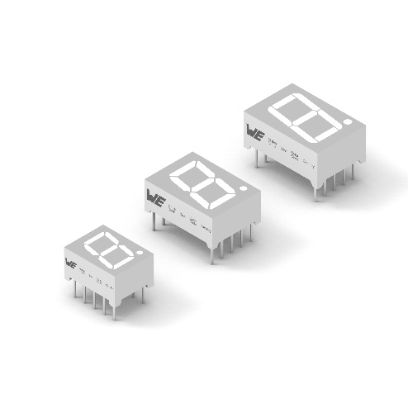  Image source: Würth Elektronik  Available from Würth Elektronik as standard products with long-term availability: economical 7-segment displays (Fig: THT variant WL-T7DS) | 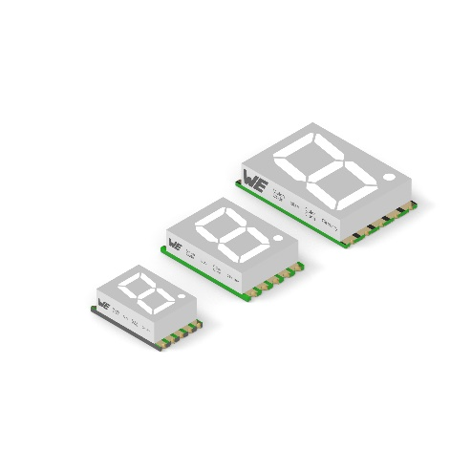  Image source: Würth Elektronik  7-segment displays: SMT-mountable WL-S7DS

About the Würth Elektronik eiSos Group
Würth Elektronik eiSos Group is a manufacturer of electronic and electromechanical components for the electronics industry and a technology company that spearheads pioneering electronic solutions. Würth Elektronik eiSos is one of the largest European manufacturers of passive components and is active in 50 countries. Production sites in Europe, Asia and North America supply a growing number of customers worldwide.
The product range includes EMC components, inductors, transformers, RF components, varistors, capacitors, resistors, quartz crystals, oscillators, power modules, Wireless Power Transfer, LEDs, sensors, connectors, power supply elements, switches, push-buttons, connection technology, fuse holders and solutions for wireless data transmission.
The unrivaled service orientation of the company is characterized by the availability of all catalog components from stock without minimum order quantity, free samples and extensive support through technical sales staff and selection tools.
Through its technology partnership with the Audi Sport ABT Schaeffler Formula E Team and its support for the Formula Student racing series, the company demonstrates its innovative strength in eMobility
(www.we-speed-up-the-future.com).
Würth Elektronik is part of the Würth Group, the world market leader for assembly and fastening technology. The company employs 7,300 staff and generated sales of 823 million euros in 2020.
Würth Elektronik: more than you expect!
Further information at www.we-online.com

Further information:  Würth Elektronik eiSos GmbH & Co. KG  Sarah Hurst  Max-Eyth-Strasse 1  74638 Waldenburg  Germany  Phone: +49 7942 945-5186  E-mail: sarah.hurst@we-online.de  www.we-online.de | Press contact:  HighTech communications GmbH  Brigitte Basilio  Brunhamstrasse 21  81249 Munich  Germany  Phone: +49 89 500778-20  Telefax: +49 89 500778-77  E-mail: b.basilio@htcm.de  www.htcm.de

