PRESS RELEASE
OPEN MIND presents CAD/CAM function hyperMILL® BEST FIT
Component Alignment at the Touch of a Button
Wessling (Germany), July 6, 2021 – OPEN MIND’s hyperMILL® BEST FIT is a new function that is revolutionizing planning in machining operations. Instead of having to align the unmachined part in the clamping to the NC program manually, the hyperMILL® CAM system aligns the NC program automatically to the component position. This method saves time and increases process reliability, especially with cast, forged, welded, and additively manufactured stocks with small or irregular allowances, when reworking heat-treated parts, and during machine changeovers. Each of these processes requires a delicate touch to calibrate it with the CAD model of the end product.
hyperMILL® BEST FIT takes full advantage of the options offered by the virtual machine in the CAM program and communication with a 5-axis machining center capable of 3D measurements to eliminate the uncertainty that comes with manual alignment.
Real-time alignment for reliable, plannable processes
Up to now, it has been standard practice to adapt the stock and the clamping in the machine to the conditions of the NC program. The component is aligned manually, using a dial gauge, control cycles, plus a great deal of sensitivity. The actual clamping operation is adapted to conform to the virtual programming. This process was time-intensive, often needed to be repeated multiple times, and involved a number of uncertainties. One way to solve this issue is to align the component in CAM in real time. The unaligned stock is probed on the machine by way of a 3D measurement, the measurement log is sent to the CAM system, and hyperMILL® BEST FIT adjusts the NC code to the actual position of the component. The virtual world (programming) is adapted to the real world (clamping), not the other way around! The adjusted NC code is then simulated in the virtual machine on the actual clamping setup, and automatically optimized.
A real game changer in many application areas
“Thanks to hyperMILL® BEST FIT, time-consuming and unsafe component alignment on the machine is a thing of the past. hyperMILL® detects the situation on the machine and aligns the component virtually,” explains Manfred Guggemos, Product Manager at OPEN MIND Technologies. “Component alignment at the touch of a button is a real game changer in many application areas. This could include reworking refurbished parts and imperfect forged parts, machining parts that are too heavy to be aligned by hand, eliminating the need for high-precision equipment, and more. What makes this unique is that unlike previous solutions available on the market, hyperMILL® BEST FIT does not change the origin on the controller and generates completely collision-checked toolpaths.”

Available images
The following images are available for download in printable format at:
https://kk.htcm.de/press-releases/open-mind/
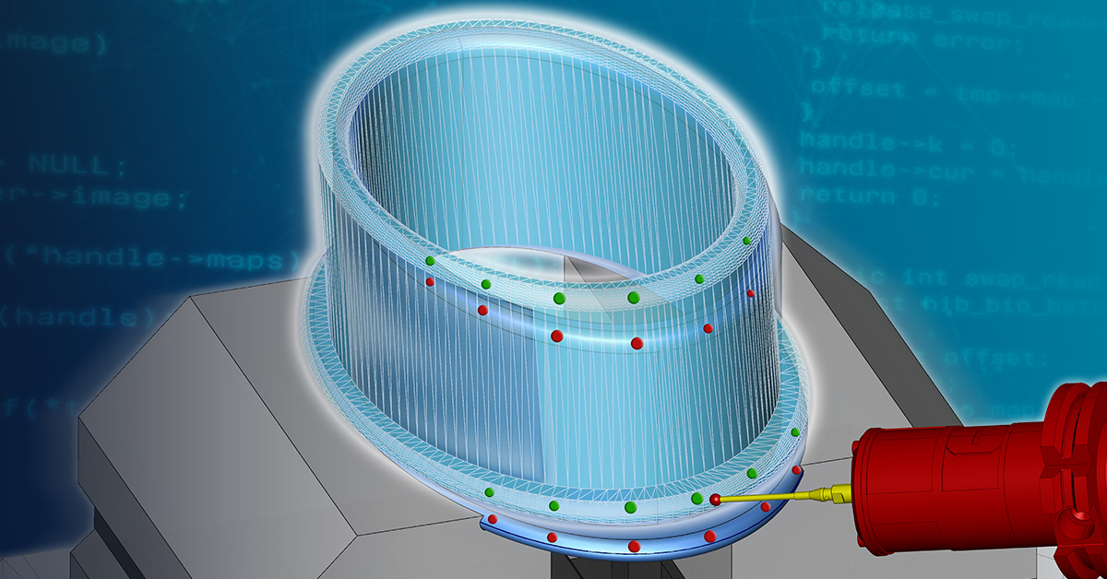  Source: OPEN MIND  Intelligent component alignment at the touch of a button | 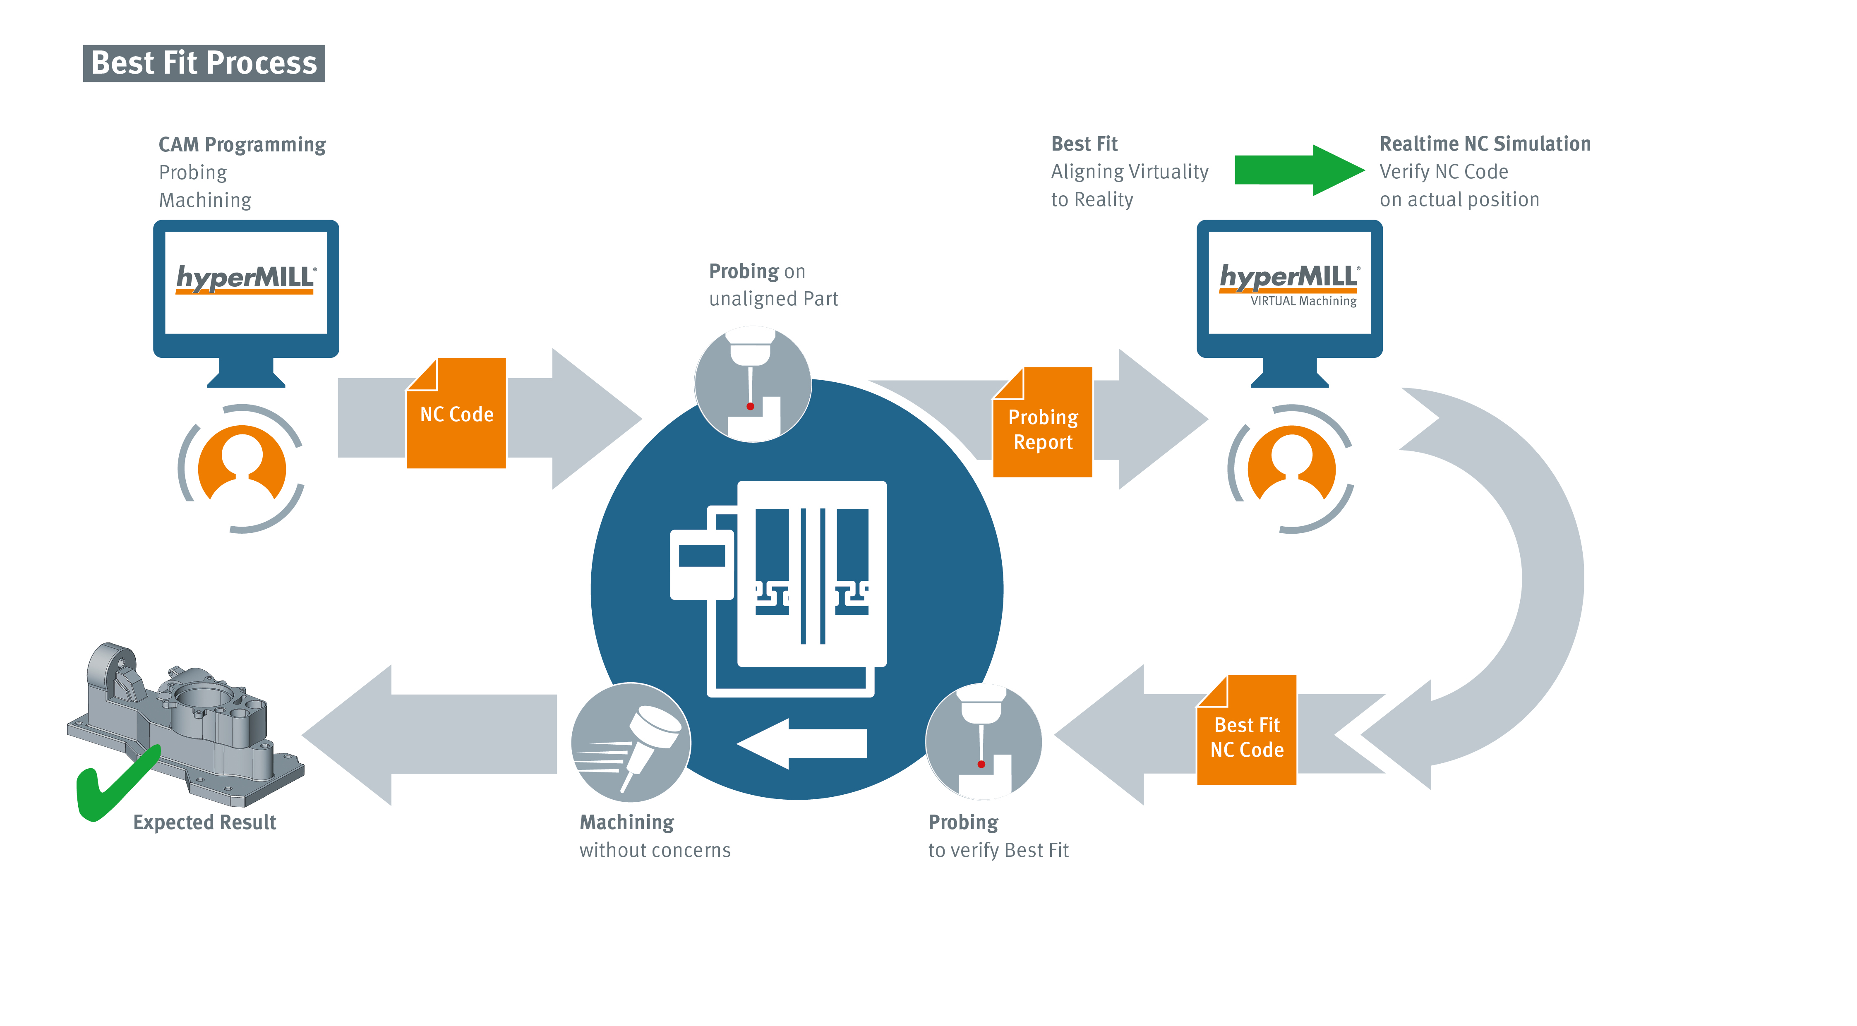  Source: OPEN MIND  With hyperMILL® BEST FIT, the process is reliable, precise, and plannable.

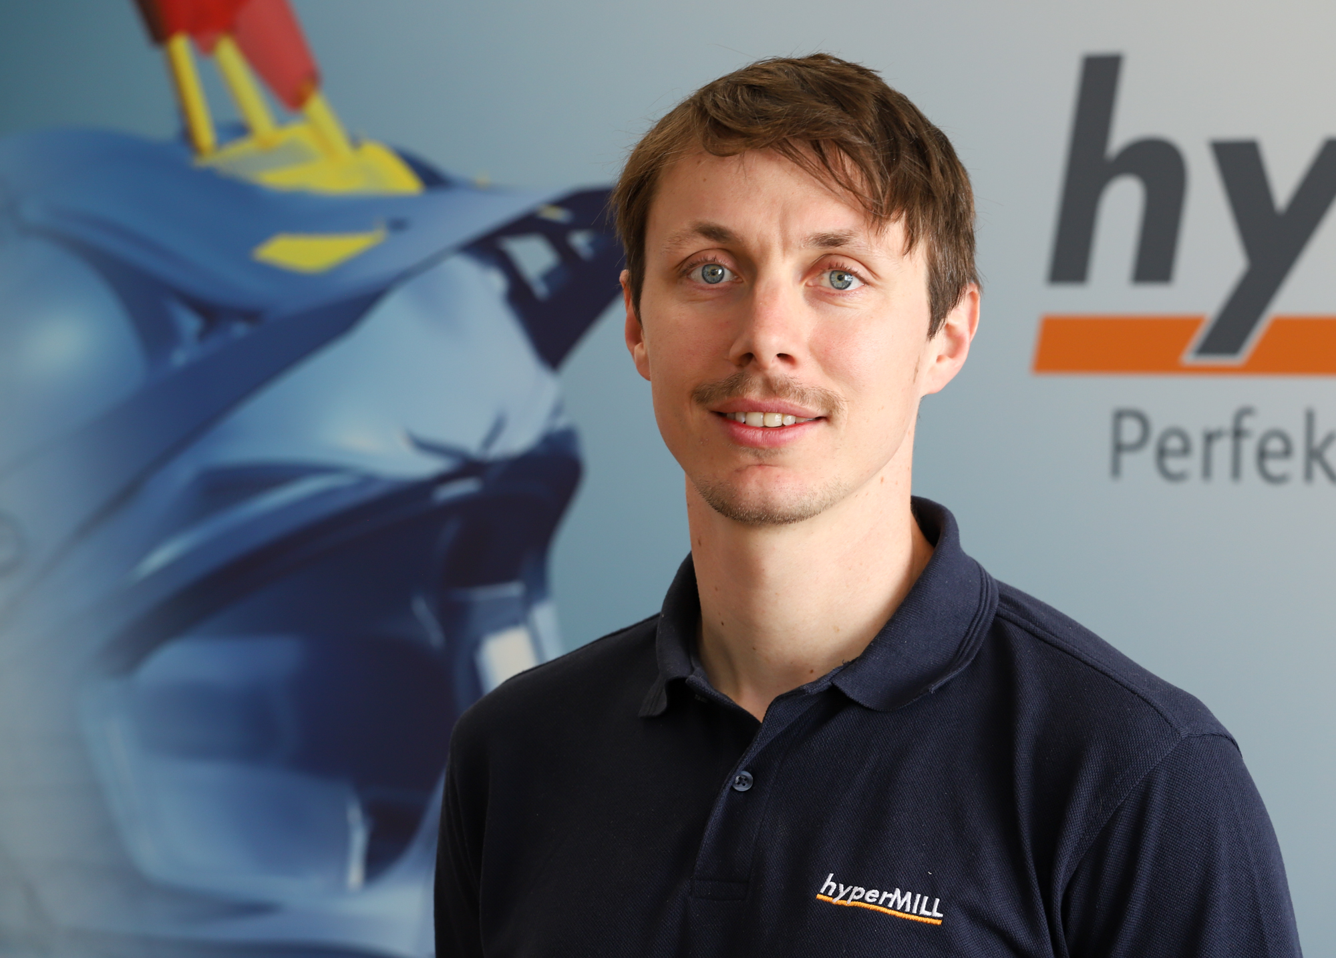
Source: OPEN MIND

Manfred Guggemos, Product Manager at OPEN MIND Technologies AG

Available videos
You can find the following videos on our YouTube channel:
https://youtu.be/lT6-fYy3h1g
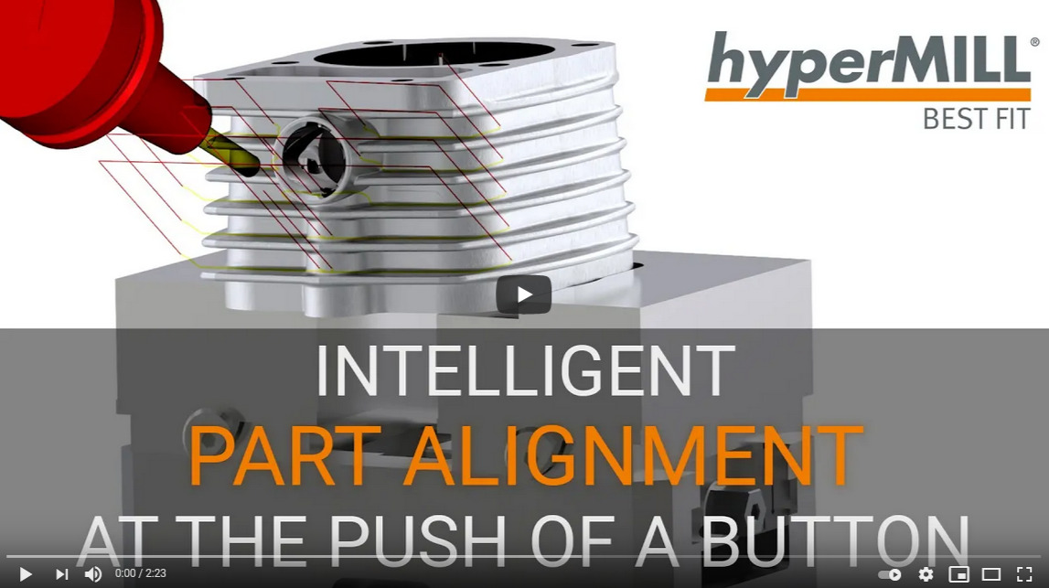
Source: OPEN MIND

Video on intelligent component alignment in CAM using hyperMILL® BEST FIT

About OPEN MIND Technologies AG
OPEN MIND is one of the world’s most sought-after developers of powerful CAM solutions for machine and controller-independent programming.
OPEN MIND develops optimized CAM solutions that include a high number of innovative features not available elsewhere to deliver significantly higher performance in both programming and machining. Strategies such as 2.5D, 3D as well as 5-axis milling/mill turning, and machining operations like HSC and HPC are efficiently built into the hyperMILL® CAM system. hyperMILL® provides the maximum possible benefits to customers thanks to its full compatibility with all current CAD solutions and extensive programming automation.
OPEN MIND strives to be the best and most innovative CAD/CAM manufacturer in the world, helping it become one of the top five in the CAM industry according to the “NC Market Analysis Report 2021” compiled by CIMdata. The CAD/ CAM solutions of OPEN MIND fulfil the highest demands in the automotive, tool and mold manufacturing, production machining, medical, job shops, energy and aerospace industries. OPEN MIND is represented in all key markets in Asia, Europe and America, and is a Mensch und Maschine company.

You can find more information at www.openmind-tech.com.

OPEN MIND Technologies UK Ltd., Oxford
Unit 3
Bicester Business Park
Telford Road
Bicester
Oxfordshire OX26 4LN
England
Fon: +44 1869 290 003
Fax: +44 1869 369 429
E-mail: Info.UK@openmind-tech.com

OPEN MIND Technologies USA, Inc.
1492 Highland Avenue, Unit 3
Needham MA 02492
USA
Phone: +1 339 225 4557 office
Phone: +1 888 516 1232 x0 toll-free
Fax: +1 270 912 5822
E-mail: Info.Americas@openmind-tech.com

Head office:
OPEN MIND Technologies AG, Argelsrieder Feld 5, 82234 Wessling, Germany
Tel.: (+49-8153) 933-500, Fax: (+49-8153) 933-501
E-mail: Info@openmind-tech.com, website: www.openmind-tech.com

Press contact:
HighTech communications GmbH
Brigitte Basilio
Brunhamstrasse 21
81249 Munich
Germany
Tel.: (+49-89) 500778-20
Fax: (+49-89) 500778-78
E-mail: b.basilio@htcm.de
Website: www.htcm.de

