PRESS RELEASE

Würth Elektronik at the DLD Summer Conference
Space-age electronics from Europe
Waldenburg (Germany), July 6, 2021 - On July 1, Munich hosted the hybrid event "DLD Summer" from the international Digital-Life-Design (DLD) event series. At the Munich Urban Colab, Alexander Gerfer, CTO of the Würth Elektronik eiSos Group, presented new activities of the component manufacturer in the session "Space: The New Frontier".
Modern communication, networking and media are hardly conceivable without the use of satellites. At the DLD in Munich, component manufacturer Würth Elektronik also showed itself to be an enabler for new solutions in this area. CTO Alexander Gerfer reported on the company's contribution to the European consortium EleGaNT. This initiative focuses on gallium nitride (GaN) semiconductors for highly efficient power transistors and integrated circuits. This technology, coupled with the optimization of inductive and capacitive passive components, is required for durable and robust electronics in space. This is where Europe wants to tap new potential in space applications. Würth Elektronik already has highly efficient GaN solutions in its portfolio and is taking on the challenge of developing radiation-insensitive and highly robust electronic components for applications outside the Earth's protective atmosphere.
"Communication and information flows are a central part of our daily digital lives. The network required for this extends into space. Geostationary satellites play an important role, and with the new networks from low-orbit satellites, the need for suitable electronic solutions is increasing - Würth Elektronik is contributing to important European research initiatives here and developing innovative components as the basis for highly efficient solutions," says Alexander Gerfer.
Further information at: https://dld-conference.com/

Available images
The following images can be downloaded from the Internet in printable quality: https://kk.htcm.de/press-releases/wuerth/

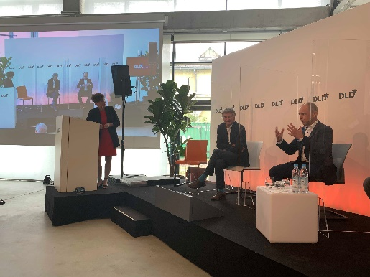  Image source: Würth Elektronik  Alexander Gerfer, CTO of the Würth Elektronik eiSos Group (right), spoke at DLD about the company's commitment to research initiatives and innovation in electronics. | 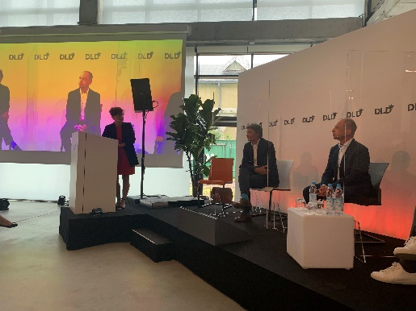  Image source: Würth Elektronik  "DLD Summer" took place as a hybrid conference at the Munich Urban Colab.

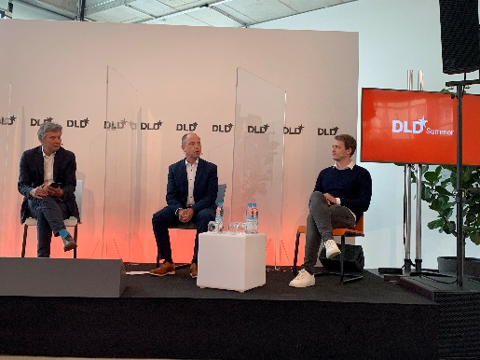
Image source: Würth Elektronik
Alexander Gerfer, CTO of the Würth Elektronik eiSos Group (center) on the podium at the session "Space: The New Frontier".

About the Würth Elektronik eiSos Group
Würth Elektronik eiSos Group is a manufacturer of electronic and electromechanical components for the electronics industry and a technology company that spearheads pioneering electronic solutions. Würth Elektronik eiSos is one of the largest European manufacturers of passive components and is active in 50 countries. Production sites in Europe, Asia and North America supply a growing number of customers worldwide.

The product range includes EMC components, inductors, transformers, RF components, varistors, capacitors, resistors, quartz crystals, oscillators, power modules, Wireless Power Transfer, LEDs, sensors, connectors, power supply elements, switches, push-buttons, connection technology, fuse holders and solutions for wireless data transmission.
The unrivaled service orientation of the company is characterized by the availability of all catalog components from stock without minimum order quantity, free samples and extensive support through technical sales staff and selection tools.
Through its technology partnership with the Audi Sport ABT Schaeffler Formula E Team and its support for the Formula Student racing series, the company demonstrates its innovative strength in eMobility
(www.we-speed-up-the-future.com).
Würth Elektronik is part of the Würth Group, the world market leader for assembly and fastening technology. The company employs 7,300 staff and generated sales of 823 million euros in 2020.
Würth Elektronik: more than you expect!
Further information at www.we-online.com

Further information:  Würth Elektronik eiSos GmbH & Co. KG  Sarah Hurst  Max-Eyth-Strasse 1  74638 Waldenburg  Germany  Phone: +49 7942 945-5186  E-mail: sarah.hurst@we-online.de  www.we-online.de | Press contact:  HighTech communications GmbH  Brigitte Basilio  Brunhamstrasse 21  81249 Munich  Germany  Phone: +49 89 500778-20  Telefax: +49 89 500778-77  E-mail: b.basilio@htcm.de  www.htcm.de

