PRESS RELEASE

Würth Elektronik Announces Expansion of Popular Transformer Series
Four new members for MID-PPTI family
Watertown (USA), 1 July 2021 – Würth Elektronik is pleased to announce the expansion of their popular MID-PPTI tiny push-pull transformer series. This series of parts can be used in a host of push-pull and pulse transformer applications, and is found on dozens of reference designs.
The four parts added to the MID-PPTI series include 750317828, 750317829, 750317830, and 750317331; all which are AEC-Q200 qualified, and include and isolation voltage of 2500VAC isolation.
Both 5 volt and 12 volt output versions are available for each of the 12 volt and 24 volt inputs. The 5 volt output versions, 750317828 and 750317830, are capable of handling 250 miliAmps of current. The 12 volt output versions, 750317829 and 750317331, are capable of handling 100miliAmps of current.
“This expands the tool set available when designing low power isolated power supplies,” said Dean Huumala, Product Manager from Würth Elektronik. “This series is so attractive in that the part count is so low, making it a very small and low cost solution.”
This low profile, surface mount series features an operating temperature of -40°C to 125°C, and are built with function, supplementary, or reinforced insulation.
The MID-PPTI transformers are best suited for isolated interface power supply for CAN, RS-485, RS-422, RSS-232, SPI, I2C, low-power LAN, industrial, process control, medical equipment, PLC analog and digital I/O modules, isolated gate driver power supplies, AC motor drives, and solar inverter applications.
To review the transformer family, visit www.we-online.com/catalog/en/MID-PPTI. Free samples are available upon request.

Available images
The following images can be downloaded from the Internet in printable quality: https://kk.htcm.de/press-releases/wuerth/
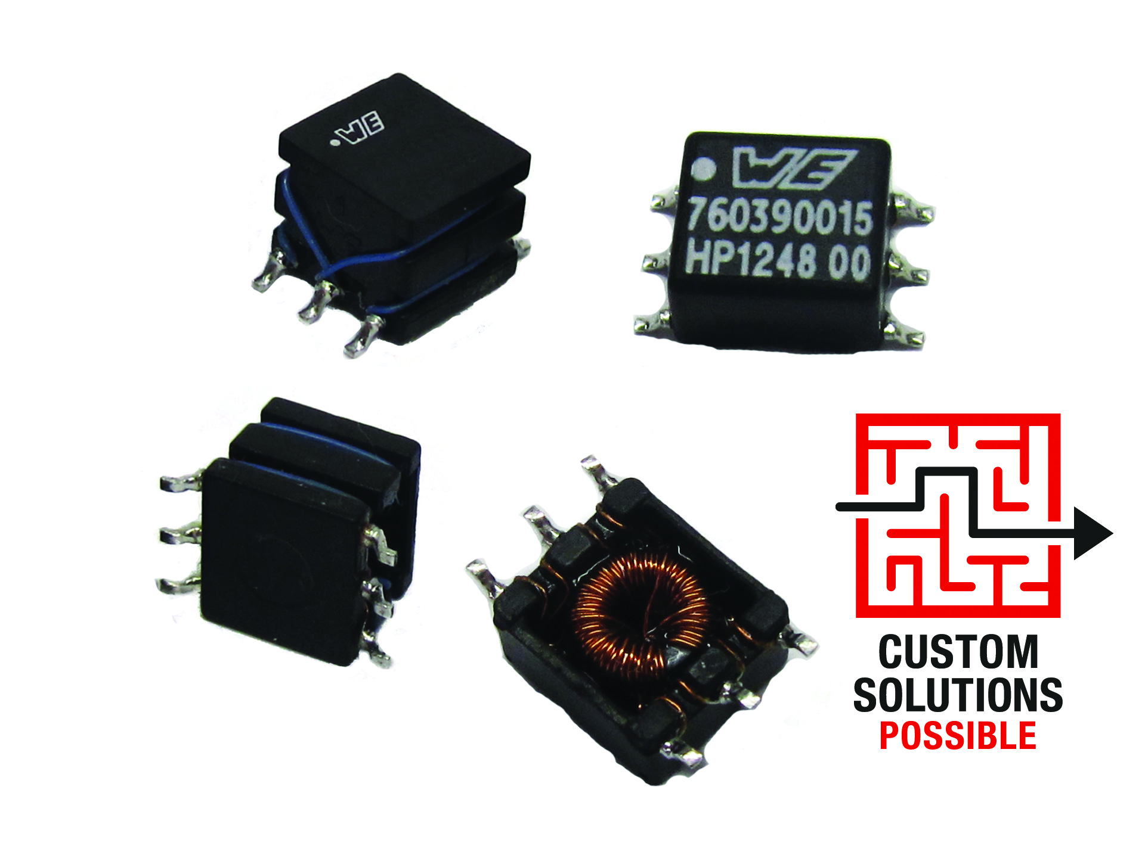
Image source: Wurth Electronics
Würth Elektronik is expanding its popular MID-PPTI transformer series with four additional components for an isolation voltage of 2500VAC and 100 or 250 milliamperes of current.

About the Würth Elektronik eiSos Group
Würth Elektronik eiSos Group is a manufacturer of electronic and electromechanical components for the electronics industry and a technology company that spearheads pioneering electronic solutions. Würth Elektronik eiSos is one of the largest European manufacturers of passive components and is active in 50 countries. Production sites in Europe, Asia and North America supply a growing number of customers worldwide.
The product range includes EMC components, inductors, transformers, RF components, varistors, capacitors, resistors, quartz crystals, oscillators, power modules, Wireless Power Transfer, LEDs, sensors, connectors, power supply elements, switches, push-buttons, connection technology, fuse holders and solutions for wireless data transmission.
The unrivaled service orientation of the company is characterized by the availability of all catalog components from stock without minimum order quantity, free samples and extensive support through technical sales staff and selection tools.
Through its technology partnership with the Audi Sport ABT Schaeffler Formula E Team and its support for the Formula Student racing series, the company demonstrates its innovative strength in eMobility
(www.we-speed-up-the-future.com).
Würth Elektronik is part of the Würth Group, the world market leader for assembly and fastening technology. The company employs 7,300 staff and generated sales of 823 million euros in 2020.
Würth Elektronik: more than you expect!
Further information at www.we-online.com

Further information:  Wurth Electronics Midcom, Inc.  Lindsey Esche  121 Airport Drive  PO Box 1330  Watertown, SD 57201 USA  Phone: +1 605 886 4385  Toll-free (in the U.S.):  Phone: +1 800 643 2661  E-mail: lindsey.esche@we-online.com  www.we-online.com | Press contact:  HighTech communications GmbH  Brigitte Basilio  Brunhamstrasse 21  81249 Munich  Germany  Phone: +49 89 500778-20  Fax: +49 89 500778-77  E-mail: b.basilio@htcm.de  www.htcm.de

