PRESS RELEASE
Würth Elektronik extends its MID-POE series of PoE transformers
More Power, More Possibilities
Watertown (USA), 16 June 2021—Würth Elektronik expands its MID-POE Power over Ethernet transformer series to include PoE++. These SMT transformers are suitable for Flyback or Active Clamp Forward power supplies that comply with the IEEE 802.3bt (four pair power over Ethernet, 4PPoE, also known as PoE++) standard. The ten new transformers can provide an output power of up to 95 W.
Demand for more power in Power-over-Ethernet (PoE) devices has risen due to the advancements in smart and IoT (Internet of Things) applications. In response to this demand, Würth Elektronik expanded its MID-POE series for IEEE 802.3bt Type 3 (60 W) and Type 4 (90 W) devices. These transformers utilize the low-profile EFD20 and EFD25 packages and offer high power densities over a wide range of common PoE output voltages.
The new series is suitable for devices such as video conferencing systems, automation control systems, smart IP cameras and much more. Customer-specific versions are possible on request. All MID-POE transformers are available from stock without a minimum order quantity.

Available images
The following images can be downloaded from the Internet in printable quality: http://www.htcm.de/kk/wuerth
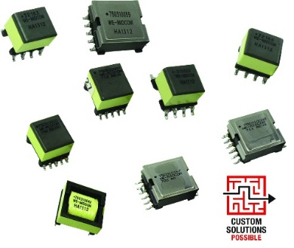
Image source: Wurth Electronics
Now also for IEEE 802.3bt standard Power over Ethernet: Würth Elektronik MID-POE

About the Würth Elektronik eiSos Group
Würth Elektronik eiSos Group is a manufacturer of electronic and electromechanical components for the electronics industry and a technology company that spearheads pioneering electronic solutions. Würth Elektronik eiSos is one of the largest European manufacturers of passive components and is active in 50 countries. Production sites in Europe, Asia and North America supply a growing number of customers worldwide.
The product range includes EMC components, inductors, transformers, RF components, varistors, capacitors, resistors, quartz crystals, oscillators, power modules, Wireless Power Transfer, LEDs, sensors, connectors, power supply elements, switches, push-buttons, connection technology, fuse holders and solutions for wireless data transmission.
The unrivaled service orientation of the company is characterized by the availability of all catalog components from stock without minimum order quantity, free samples and extensive support through technical sales staff and selection tools.
Through its technology partnership with the Audi Sport ABT Schaeffler Formula E Team and its support for the Formula Student racing series, the company demonstrates its innovative strength in eMobility
(www.we-speed-up-the-future.com).
Würth Elektronik is part of the Würth Group, the world market leader for assembly and fastening technology. The company employs 7,300 staff and generated sales of 823 million euros in 2020.
Würth Elektronik: more than you expect!
Further information at www.we-online.com

Further information:  Wurth Electronics Midcom, Inc.  Lindsey Esche  121 Airport Drive  PO Box 1330  Watertown, SD 57201 USA  Phone: +1 605 886 4385  Toll-free (in the U.S.):  Phone: +1 800 643 2661  E-mail: lindsey.esche@we-online.com  www.we-online.com | Press contact:  HighTech communications GmbH  Brigitte Basilio  Brunhamstrasse 21  81249 Munich  Germany  Phone: +49 89 500778-20  Fax: +49 89 500778-77  E-mail: b.basilio@htcm.de  www.htcm.de

