

NEWS RELEASE

For Release: IMMEDIATELY With Art: Two Digital Images

Editorial Michael McCue OPEN MIND Alan Levine
Contact: McCue & Associates LLC Contact: OPEN MIND Technologies USA, Inc.
978-733-1353 339-225-4557 mmccue@mccueassociates.com alan.levine@openmind-tech.com

OPEN MIND Introduces hyperMILL® 2021.2 CAD/CAM Software Suite

New Capabilities, Enhancements Offered for Virtual Machining,
Additive Manufacturing, hyperCAD-S, 3D Finishing and More

NEEDHAM, MA U.S.A. (June 21, 2021) – OPEN MIND Technologies AG, a leading developer of CAD/CAM software solutions worldwide, has introduced its latest hyperMILL® 2021.2 CAD/CAM software suite which offers users innovative and enhanced features for efficient, user friendly machining in applications ranging from 2.5D to 5-axis. “With our continued focus on providing a rich, simplified user experience, the latest version of hyperMILL® offers enhanced machining strategies, increased options for data feedback, as well as more convenience,” said Mr. Alan Levine, Managing Director of OPEN MIND Technologies USA, Inc.
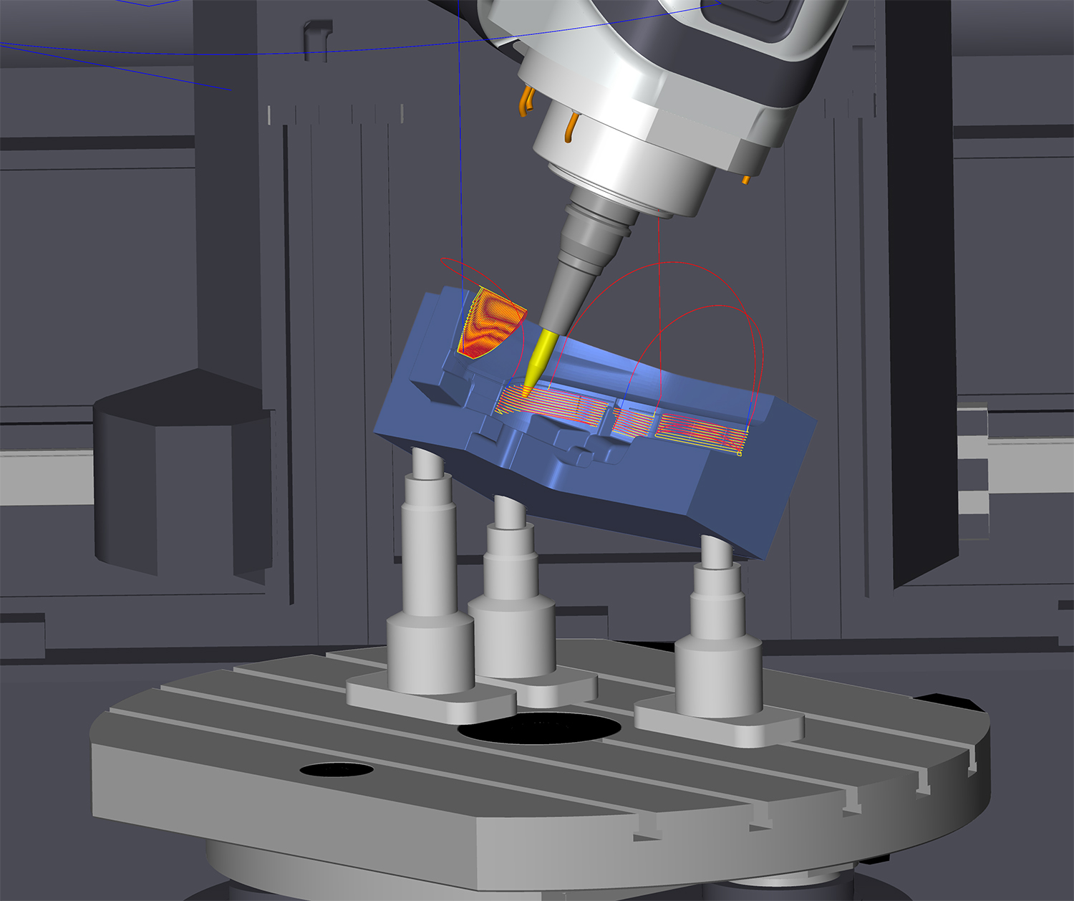
Resulting in simplified programming and increased process reliability, hyperMILL® VIRTUAL Machining NC code-based machine simulation has also been enhanced. Within the VIRTUAL Machining Optimizer module which links individual part programs with smooth and safe connections, the cutter is able to remain close to the workpiece, violations of the axis limitations are now detected and movement sequences are optimized accordingly. There is also a new option in VIRTUAL Machining to apply a special approach and retract strategy to machines where the cutting tool can be retracted into a tunnel.
hyperMILL® VIRTUAL Machining Optimizer now detects violations of the axis limitations and optimizes movement sequences accordingly.

A forerunner in CAM Additive Manufacturing, OPEN MIND has introduced more capabilities in hyperMILL® 2021.2 ADDITIVE Manufacturing including a Weave Mode. This new mode generates a toolpath in a wave-shaped or zigzag movement, to apply material to contours or to fill areas, allowing the application area to be widened and the thickness to be increased for the individual movement. This continuous application also improves the metallurgical properties of the applied material.
- more -

In the integrated hyperCAD®-S CAD module, additional file formats for import and export have been added including SAT as standard ACIS text, and OBJ and 3MF for importing mesh data. Also, electrode creation has been improved via the optimized selection of the raw material. To support EDM machining, the hyperCAD®-S Electrode Converter can now be used to create import files for several EDM machines such as Exeron, Zimmer & Kreim and OPS-INGERSOLL.
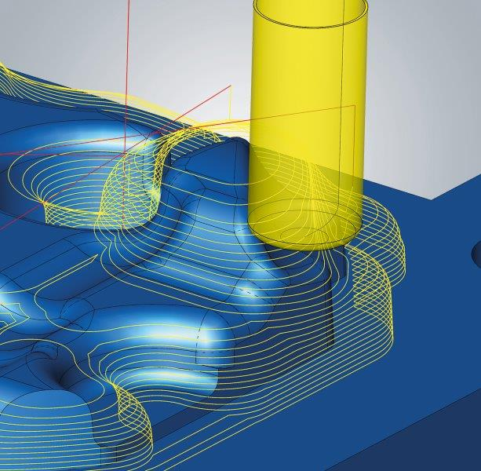
For increased quality and ease of use, enhancements to some CAM cycles are offered in hyperMILL® 2021.2 such as 3D and 5-axis Equidistant Finishing capabilities that define the milling area by selecting bounding curves so that individual areas on a surface model can be targeted. With 3D ISO Machining, multiple bounding curves can now be used to allow different areas to be machined in one job. In addition, 3D Z-level Shape Finishing includes several innovative features to improve machining quality, including optimized sorting of toolpath, smooth overlap at boundary, free tool geometry and trim toolpath to stock.
3D Z-Level Finishing enables machining with free tool geometry.

For improved clarity, hyperMILL® 2021.2 also has new functions that provide better feedback during CAM programming. Automatic Stock Display displays stock automatically for any machining job. Also, there is a new Preview of Selected Entities feature that highlights entities such as curves, faces or points when a job is selected. And for component alignment at a touch of a button, a new BEST FIT feature aligns the NC program automatically to the component position, eliminating manual alignment and optimizing the options offered by VIRTUAL Machining.

More Information about hyperMILL® 2021.2

About OPEN MIND Technologies AG
Headquartered in Wessling, Germany, OPEN MIND is one of the world's leading developers of powerful CAM solutions for machine and controller-independent programming. The company develops optimized CAM solutions that include many innovative features unavailable elsewhere, to deliver significantly higher performance in both programming and machining. Strategies such as 2.5D, 3D, as well as 5-axis milling, mill/ turning, and machining operations like HSC and HPC, are efficiently designed into the hyperMILL® CAM system, providing maximum user benefit and compatibility with all current CAD solutions and extensive programming automation. OPEN MIND strives to be the best, most innovative CAD/ CAM developer in the world, and has earned the top five ranking in the CAD/ CAM industry according to the 2021 NC Market Analysis Report by CIMdata. OPEN MIND CAD/ CAM solutions meet and exceed the requirements of the most demanding industries such as automotive, tool and mold manufacturing, production machining, medical, job shops, energy and aerospace industries, and is represented in all key markets of Asia, Europe and the Americas. OPEN MIND is a Mensch und Maschine Company. http://www.mum.de/ For more information visit https://www.openmind-tech.com/en.html.
# # # # #

