PRESS RELEASE
Würth Elektronik ICS High Current Contacts Webinar
Valuable practical knowledge for developers in power electronics
Niedernhall (Germany), 20 May 2021 – On June 2nd 2021, Würth Elektronik ICS will be hosting a free online seminar on the topic of "high current contacts in power electronics". The speaker Günter Behlau, project engineer in the components department at Würth Elektronik ICS, will present various high-current contacts, processing guidelines for them and recommended design rules for their use. You can register under Webinar "High current contacts in power electronics"
The field of power electronics is currently experiencing strong growth and is being increasingly used in more and more applications. E-mobility being the most prominent example. Power electronics applications include electrical drive technology or converters requiring the safe handling of high currents. Cable connections, busbar contacts, board-to-board connections or component connections all require correspondingly robust contacting solutions. In addition, contacts and PCB must be optimally matched to each other.
In the webinar, Günter Behlau will explain various aspects that are important in high-current contacting. Special attention will be paid to mounting methods to the PCB, including soldering and press-fit technology. The fixing of the contacts to the application, for example by means of plugging or screws is also relevant. In order to guarantee the reliability of the overall system, certain design rules must be observed with the design of the overall system influencing both the current-carrying capacity and mechanical stability.
Tips from the inventor of Powerelements
With Powerelements, Würth Elektronik ICS has performed important pioneering work in the field of high-current contacts for PCBs - and is now doing so again with a lead-free product line "LF Powerelements". Using these, developers can reduce the documentation effort (REACH, SCIP) and make designs free of the uncertainty surrounding the future of the RoHS Exemption Directive 6c. As such there is no risk of a possible re-design at a later point in time. The lead-free high-current contacts, available as standard or customised solutions, can be used in not only in the automotive sector, but in many fields including medical technology and household appliances. By working closely with their customers, the experts at Würth Elektronik ICS have experience with many practical applications - and thus with the practical strengths and weaknesses of various designs. "In the webinar, we provide an insight into our technologies and pragmatically describe the design guidelines for high-current contacts in conjunction with the PCB. We provide information on the reliability of the systems and show various interesting practical solutions. I am already looking forward to the feedback from the webinar participants," says Würth Elektronik ICS expert Günter Behlau.
Registration under Webinar "High current contacts in power electronics"

Verfügbares Bildmaterial
Folgendes Bildmaterial steht druckfähig im Internet zum Download bereit: http://www.htcm.de/kk/wuerth_ics
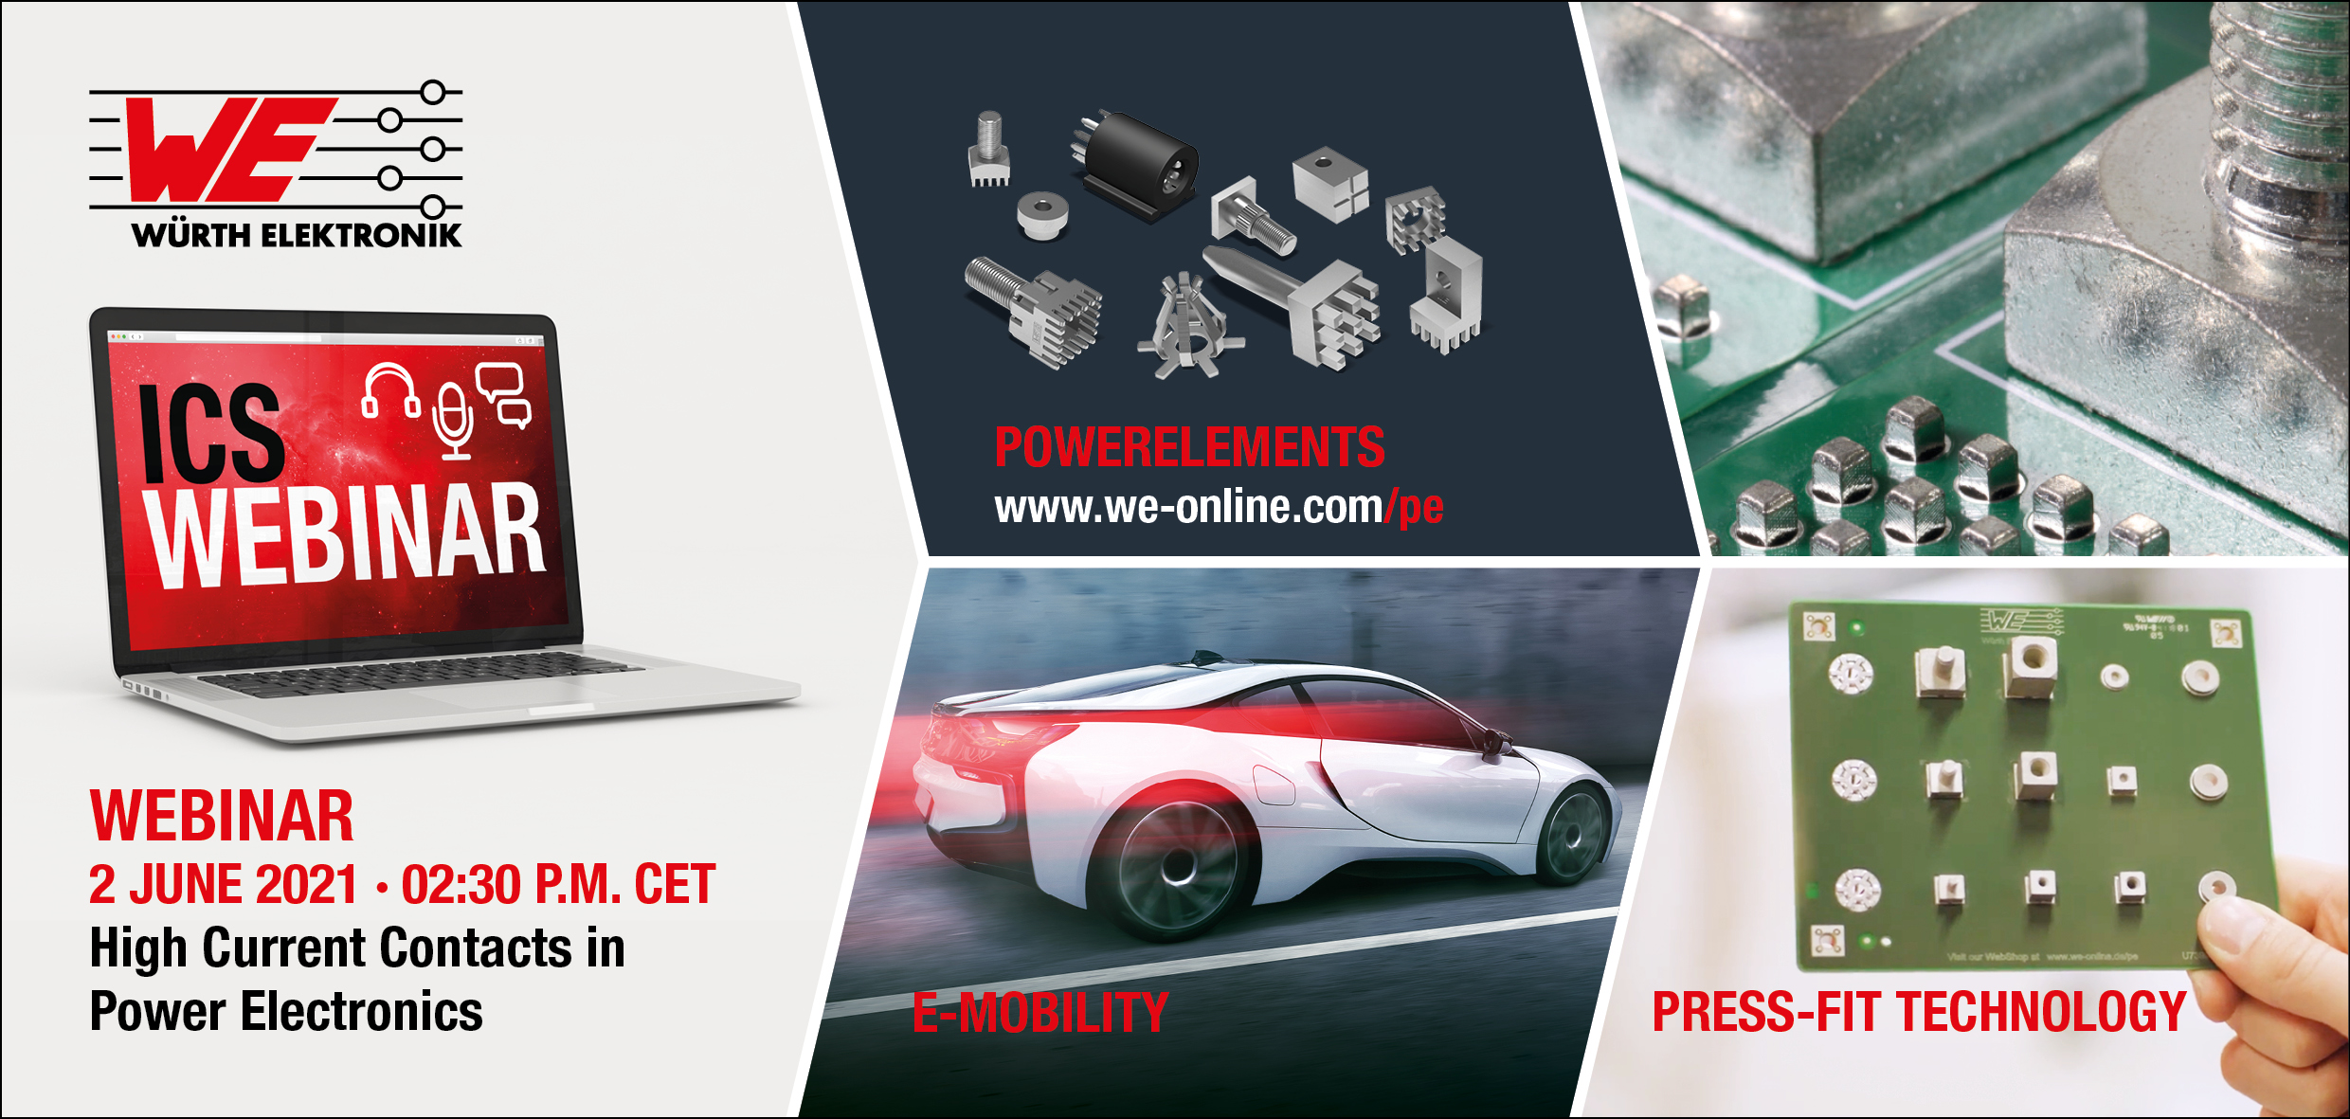
Image source: Würth Elektronik
On June 2nd 2021, Würth Elektronik ICS will be hosting a free online seminar on the topic of "high current contacts in power electronics".

About Würth Elektronik ICS GmbH & Co. KG
Würth Elektronik ICS is a system supplier for electromechanical and electronic solutions for signal and power distribution, control, and display and operating solutions. ICS has been on the market as a member of the Würth Elektronik Group since 1984, and currently has about 400 employees, who generate an annual turnover of over €75 million. Its company headquarters are located in Niedernhall, Germany. There are subsidiaries of the company in France, the U.S., and India. Its main customers include well-known manufacturers of construction and agricultural machinery, as well as commercial vehicles. Sectors such as industrial technology or renewable energies also benefit from products and services provided by ICS.
Würth Elektronik: more than you expect!
Further info at www.we-online.com/ics

More information:  Würth Elektronik ICS GmbH & Co. KG  Sandra Herter  Gewerbepark Waldzimmern  Würthstrasse 1  74676 Niedernhall  Germany  Phone: +49 7940 9810-1503  E-mail: sandra.herter@we-online.de  www.we-online.com/ics | Press contact:  HighTech communications GmbH  Brigitte Basilio  Brunhamstrasse 21  81249 Munich  Germany  Phone: +49 89 500778-20  Telefax: +49 89 500778-77  E-mail: b.basilio@htcm.de  www.htcm.de

