PRESS RELEASE
Würth Elektronik presents its new common mode chokes
Chokes with Top Specs
Waldenburg (Germany), 19 May 2021 - Würth Elektronik is expanding its portfolio of common mode chokes with two new models. The THT-mountable WE-FCLP for common-mode and differential-mode suppression, and the SMT data line and low-voltage common mode choke WE-CMDC. Both are available from stock without a minimum order quantity.
The WE-FCLP has a compact design with a maximum height of 14.5 mm, yet achieves an inductance up to 100 mH. It can suppress common-mode interference up to 85 dB and, thanks to its high leakage inductance, it can be used not only for common-mode suppression but also for differential-mode suppression. WE-FCLP is suitable for applications like mains-powered LED drivers, electronic ballasts, switch mode power supplies and mains filters.
WE-CMDC is an AEC-Q200 Grade 1 qualified data line common mode choke. Measuring 11 × 12 × 6 mm, it is also very compact. The choke has a current-carrying capacity up to 8 A and is available with high impedances of 700, 1000 and 1500 ohms. In addition to data and signal lines, applications include low-voltage DC power supplies and DC/DC converters.

Available images
The following images can be downloaded from the Internet in printable quality: http://www.htcm.de/kk/wuerth

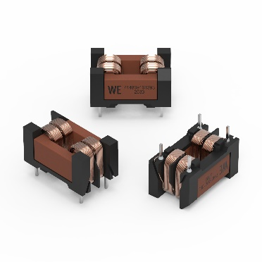  Image source: Würth Elektronik  WE-FCLP current-compensated power line chokes | 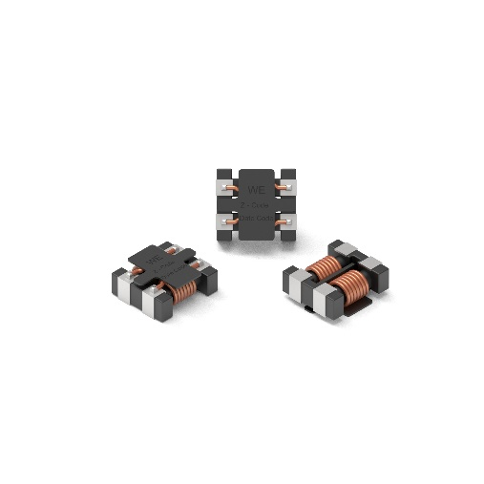  Image source: Würth Elektronik  WE-CMDC common mode data line filters

About the Würth Elektronik eiSos Group
Würth Elektronik eiSos Group is a manufacturer of electronic and electromechanical components for the electronics industry and a technology company that spearheads pioneering electronic solutions. Würth Elektronik eiSos is one of the largest European manufacturers of passive components and is active in 50 countries. Production sites in Europe, Asia and North America supply a growing number of customers worldwide.
The product range includes EMC components, inductors, transformers, RF components, varistors, capacitors, resistors, quartz crystals, oscillators, power modules, Wireless Power Transfer, LEDs, sensors, connectors, power supply elements, switches, push-buttons, connection technology, fuse holders and solutions for wireless data transmission.
The unrivaled service orientation of the company is characterized by the availability of all catalog components from stock without minimum order quantity, free samples and extensive support through technical sales staff and selection tools.
Through its technology partnership with the Audi Sport ABT Schaeffler Formula E Team and its support for the Formula Student racing series, the company demonstrates its innovative strength in eMobility
(www.we-speed-up-the-future.com).
Würth Elektronik is part of the Würth Group, the world market leader for assembly and fastening technology. The company employs 7,300 staff and generated sales of 823 million euros in 2020.
Würth Elektronik: more than you expect!
Further information at www.we-online.com

Further information:  Würth Elektronik eiSos GmbH & Co. KG  Sarah Hurst  Max-Eyth-Strasse 1  74638 Waldenburg  Germany  Phone: +49 7942 945-5186  E-mail: sarah.hurst@we-online.de  www.we-online.de | Press contact:  HighTech communications GmbH  Brigitte Basilio  Brunhamstrasse 21  81249 Munich  Germany  Phone: +49 89 500778-20  Telefax: +49 89 500778-77  E-mail: b.basilio@htcm.de  www.htcm.de

