PRESS RELEASE

IQXO-691: low voltage clock oscillators available from IQD
Low voltage clock oscillators
Waldenburg (Germany), 10 May 2021 – Today, billions of electronic devices are developed to suit consumer needs. As technology evolves, devices need to run at lower and lower voltages and this means that systems may need to have multiple supply rails. Because of this IQD, a subsidiary of the Würth Elektronik eiSos Group, have produced a range of frequency products that run at these low voltages, giving a system designer the opportunity to develop systems that have a common supply rail. This approach produces reliable PCBAs that support PCB downsizing by reducing component count whilst realising design goals.
IQD’s low voltage CMOS clock oscillators are available at JEDEC standard voltage levels for CMOS devices of 0.9 V, 1.2 V and 1.5 V. The IQXO-691 series oscillators are ideal for use in designs where improved battery life is critical, including body cameras for security services, digital cameras, personal navigation devices (PND), portable audio players, portable test equipment as well as USB Interface, WLAN and wearable applications.
The clock oscillators are available in four industry standard packages: 2.5 x 2.0 mm, 3.2 x 2.5 mm, 5.0 x 3.2 mm and 7.0 x 5.0 mm. Furthermore, the IQXO-691 series is available with a frequency stability down to either ±20 ppm over an operating temperature range of -20 to 70 °C or ±25 ppm over -40 to 85 °C.
Full details on the IQXO-691 series are available at www.iqdfrequencyproducts.com or for further advice, speak to a member of IQD’s Sales team or Application Support team.

Available images
The following images can be downloaded from the Internet in printable quality: http://www.htcm.de/kk/wuerth

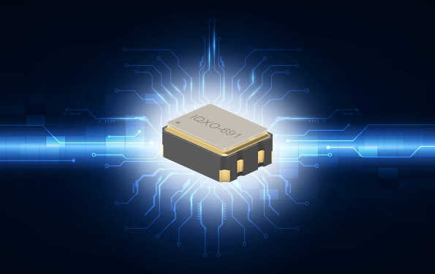
Image source: IQD
IQXO-691, IQD’s low voltage clock oscillator

About IQD
Backed by over 40 years’ experience in the manufacture of frequency products, IQD is a recognised market leader in the frequency control market and part of the Würth Elektronik eiSos Group, one of the leading European manufacturers of passive components. With active customers in over 80 countries, IQD offers one of the most comprehensive frequency product ranges available, from low cost commercial grade product to that used in high reliability industrial and automotive applications including: Quartz Crystals, Clock Oscillators, AEC-Q200 Crystals & Oscillators, VCXOs, TCXOs, OCVCSOs & OCXOs, GPS Disciplined OCXOs, and Rubidium Oscillators.
Further info at www.iqdfrequencyproducts.com

About the Würth Elektronik eiSos Group
Würth Elektronik eiSos Group is a manufacturer of electronic and electromechanical components for the electronics industry and a technology company that spearheads pioneering electronic solutions. Würth Elektronik eiSos is one of the largest European manufacturers of passive components and is active in 50 countries. Production sites in Europe, Asia and North America supply a growing number of customers worldwide.
The product range includes EMC components, inductors, transformers, RF components, varistors, capacitors, resistors, quartz crystals, oscillators, power modules, Wireless Power Transfer, LEDs, sensors, connectors, power supply elements, switches, push-buttons, connection technology, fuse holders and solutions for wireless data transmission.
The unrivaled service orientation of the company is characterized by the availability of all catalog components from stock without minimum order quantity, free samples and extensive support through technical sales staff and selection tools.

Through its technology partnership with the Audi Sport ABT Schaeffler Formula E Team and its support for the Formula Student racing series, the company demonstrates its innovative strength in eMobility
(www.we-speed-up-the-future.com).
Würth Elektronik is part of the Würth Group, the world market leader for assembly and fastening technology. The company employs 7,300 staff and generated sales of 823 million euros in 2020.
Würth Elektronik: more than you expect!
Further information at www.we-online.com

Further information:  IQD Frequency Products Ltd  Rebecca Long  Station Road  Crewkerne  Somerset  TA18 8AR  United Kingdom  Phone: +44 1460 270270  E-mail: rebecca.long@iqdfrequencyproducts.com  www.we-online.com  www.iqdfrequencyproducts.com | Press contact:  HighTech communications GmbH  Brigitte Basilio  Brunhamstrasse 21  81249 Munich  Germany  Phone: +49 89 500778-20  Telefax: +49 89 500778-77  E-mail:  b.basilio@htcm.de  www.htcm.de

