PRESS RELEASE

Würth Elektronik publishes Web Application Guide
From the application to the right component
Waldenburg (Germany), 27 April 2021 – To facilitate component selection, Würth Elektronik provides the new Web Application Guide at https://www.we-online.de/applicationguide/en. The easy-to-use tool offers the most common switching regulator and interface topologies - for example buck converters, CAN or Ethernet interfaces - and an overview of which components are required for them. From here, there is a direct link to ordering free component samples.
With the help of clear and deliberately simple schematic representations, the user quickly gets an overview of the structure of the application and the suitable product range from Würth Elektronik. Helpful hints, for example on the selection of active components as well as EMC tips, also facilitate the layout of the PCB design where it goes beyond the Würth Elektronik range. For the exact specification of the component requirements according to electrical and mechanical parameters (e. g. current, voltage, inductance and design), the user can either use the filter function on the product page or the full functionality of the simulation tool REDEXPERT. In both cases, the user can then place the desired item in the shopping cart, select additional components of the application and order free samples or enter inquiries.
Mathias Kalmbach, Head of Marketing at Würth Elektronik eiSos, is pleased about the innovation: "We see the Web Application Guide as a very helpful tool for our customers to find the right component for the design without a long search. In addition, the tool provides an application-related overview of all components that Würth Elektronik can supply. This fully pays off our "More than you expect!" customer promise."

Available images
The following images can be downloaded from the Internet in printable quality: http://www.htcm.de/kk/wuerth

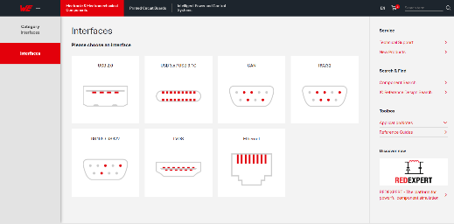Image source: Würth Elektronik  Web Application Guide - simple tool for component selection. The picture shows the interface selection | 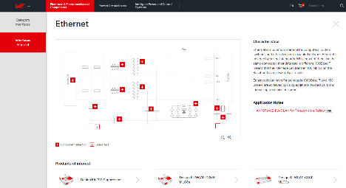Image source: Würth Elektronik  Ethernet interface in the Web Application Guide

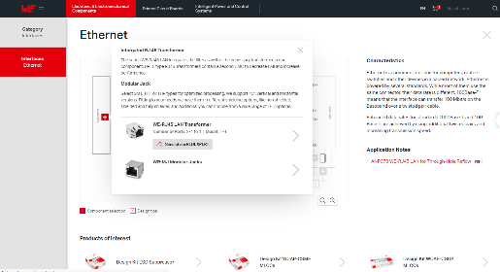Image source: Würth Elektronik
Selection in the category Interfaces: Ethernet, integrated RJ 45 transformer

About the Würth Elektronik eiSos Group
Würth Elektronik eiSos Group is a manufacturer of electronic and electromechanical components for the electronics industry and a technology company that spearheads pioneering electronic solutions. Würth Elektronik eiSos is one of the largest European manufacturers of passive components and is active in 50 countries. Production sites in Europe, Asia and North America supply a growing number of customers worldwide.
The product range includes EMC components, inductors, transformers, RF components, varistors, capacitors, resistors, quartz crystals, oscillators, power modules, Wireless Power Transfer, LEDs, sensors, connectors, power supply elements, switches, push-buttons, connection technology, fuse holders and solutions for wireless data transmission.
The unrivaled service orientation of the company is characterized by the availability of all catalog components from stock without minimum order quantity, free samples and extensive support through technical sales staff and selection tools.
Through its technology partnership with the Audi Sport ABT Schaeffler Formula E Team and its support for the Formula Student racing series, the company demonstrates its innovative strength in eMobility
(www.we-speed-up-the-future.com).
Würth Elektronik is part of the Würth Group, the world market leader for assembly and fastening technology. The company employs 7,300 staff and generated sales of 823 million euros in 2020.
Würth Elektronik: more than you expect!
Further information at www.we-online.com

Further information:  Würth Elektronik eiSos GmbH & Co. KG  Sarah Hurst  Max-Eyth-Strasse 1  74638 Waldenburg  Germany  Phone: +49 7942 945-5186  E-mail: sarah.hurst@we-online.de  www.we-online.de | Press contact:  HighTech communications GmbH  Brigitte Basilio  Brunhamstrasse 21  81249 Munich  Germany  Phone: +49 89 500778-20  Telefax: +49 89 500778-77  E-mail: b.basilio@htcm.de  www.htcm.de

