PRESS RELEASE

Würth Elektronik presents innovative WE-HCF-2010 high-current inductor
Best features in the smallest space
Waldenburg (Germany), 22 April 2021 – With innovative improvements in its internal design, the latest model of WE-HCF-SMT high-current inductors from Würth Elektronik sets new standards in its class. WE-HCF in the 2010 design offers significantly better characteristics than previously available inductors in this size: inductance values up to 2 μH and saturation currents up to 25% higher than comparable products in the market.
The magnetically shielded flat wire coil with MnZn core impresses with a low resistance of 0.84 mΩ and low core losses. The recommended 3-pin contacting ensures mechanical stability of the WE-HCF, which is designed for an operating temperature of -40 to +125 °C. Potential applications include POL regulators for FPGA, ASIC and GPU, high-efficiency DC/DC converters, high-current switching power supplies, forward converters, half-bridge and full-bridge converters, as well as battery chargers and solar inverters.
WE-HCF 2010 is available immediately from stock with no minimum order quantity. Würth Elektronik will provide free samples to developers upon request.

Available images
The following images can be downloaded from the Internet in printable quality: http://www.htcm.de/kk/wuerth
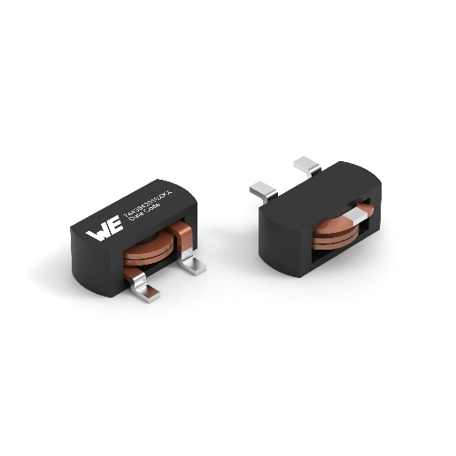
Image source: Würth Elektronik
WE-HCF-2010 high-current inductor

About the Würth Elektronik eiSos Group
Würth Elektronik eiSos Group is a manufacturer of electronic and electromechanical components for the electronics industry and a technology company that spearheads pioneering electronic solutions. Würth Elektronik eiSos is one of the largest European manufacturers of passive components and is active in 50 countries. Production sites in Europe, Asia and North America supply a growing number of customers worldwide.
The product range includes EMC components, inductors, transformers, RF components, varistors, capacitors, resistors, quartz crystals, oscillators, power modules, Wireless Power Transfer, LEDs, sensors, connectors, power supply elements, switches, push-buttons, connection technology, fuse holders and solutions for wireless data transmission.
The unrivaled service orientation of the company is characterized by the availability of all catalog components from stock without minimum order quantity, free samples and extensive support through technical sales staff and selection tools.
Through its technology partnership with the Audi Sport ABT Schaeffler Formula E Team and its support for the Formula Student racing series, the company demonstrates its innovative strength in eMobility
(www.we-speed-up-the-future.com).
Würth Elektronik is part of the Würth Group, the world market leader for assembly and fastening technology. The company employs 7,300 staff and generated sales of 823 million euros in 2020.
Würth Elektronik: more than you expect!
Further information at www.we-online.com

Further information:  Würth Elektronik eiSos GmbH & Co. KG  Sarah Hurst  Max-Eyth-Strasse 1  74638 Waldenburg  Germany  Phone: +49 7942 945-5186  E-mail: sarah.hurst@we-online.de  www.we-online.de | Press contact:  HighTech communications GmbH  Brigitte Basilio  Brunhamstrasse 21  81249 Munich  Germany  Phone: +49 89 500778-20  Telefax: +49 89 500778-77  E-mail: b.basilio@htcm.de  www.htcm.de

