March 31, 2021

ASM Solutions Provide Agility, Quality, Ease-of-Use and Remote Access
Lighting Innovator CantoUSA Selects ASM’s E by DEK and E by SIPLACE Platforms for In-house SMT Operation

The SMT Solutions Segment of ASM Pacific Technology continues to expand market share, and today announced its most recent partnership with Marietta, GA-based CantoUSA. The theatrical, entertainment and commercial lighting leader selected ASM’s E by DEK stencil printer and E by SIPLACE pick and place system for its inaugural in-house SMT assembly line. Previously, CantoUSA outsourced PCB assembly, but the requirement for more control of its production schedules and new product development initiatives compelled the lighting innovator to invest in a vertically integrated solution.

“The contract manufacturing model simply did not align with our business agility requirements,” shares John Luhrs, CantoUSA Founding Partner. “We need to be able to build superior quality product on demand, quickly develop and test new lighting technology and have seamless production schedule oversight. Ease-of-use, scalability for future growth and error-reducing safeguards were essential elements for our platform selection.”

Tapping the expertise of Canadian-based SMT Operations Management Consultant Shawn Vike of SSFE, Incorporated to spearhead the equipment analysis and integration project, the CantoUSA team identified manufacturing requirements and began system evaluations in February 2020. Currently a low-volume, low-mix operation, CantoUSA’s product line dictated a placement solution with a wide component range, easy-to-use programming software, scalability for future growth, accuracy and reliability, as well as proven remote system access and digital training tools. Robust performance with limited operator supervision, precision, flexibility and intuitive software control were also prerequisites for the printer platform.

“The E by SIPLACE machine ticked all the boxes and delivers broad capability at an affordable price-point,” says SSFE’s Vike. “The CP12/PP placement head’s wide component range – from 01005 up to 45.0 mm x 87.5 mm -- gives us unlimited growth potential, SIPLACE Pro software is incredibly easy to use and ASM Setup Center’s barcode scanner prevents incorrect parts loading. E by DEK’s paste roll height monitor and GridLok automatic reconfigurable board support reduce both operator interaction and manual errors. Honestly, though, it was ASM Remote Smart Factory that was the difference-maker, as we were conducting our equipment analysis in the midst of the COVID pandemic and with the understanding that I would be assisting operations from Canada. Remote connectivity and hotline support were game-changers and have been integral to our production success since machine installation last September. I can securely program jobs offline, watch production happening from my desktop and receive responsive support for any issues.”

Quality is a hallmark of CantoUSA lighting products, which are well-known for their ability to provide true LED lighting that emulates the dimming quality of a traditional incandescent fixture. Maintaining high product standards and expanding its reach into new markets like commercial lighting could not have been achieved without the manufacturing control the company now enjoys, according to Luhrs.

“This decision has secured our company’s successful future,” says Luhrs in conclusion. “The ASM E systems are impressive, very easy to use and have performed exactly as promised. Our product lead times have been cut in half, quality is excellent, cost savings are significant and, with remote capability, any required assistance happens very quickly. The entire team – CantoUSA, SSFE, ASM and ASM’s local representative Process Automation & Tool – delivered, and we are very satisfied.”

To learn more about ASM’s E-Solutions line or Remote Smart Factory visit www.asm-smt.com. Details about CantoUSA can be found at www.cantousa.com.

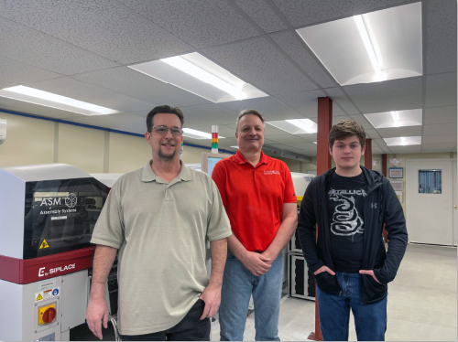
Source: CantoUSA

“Impressive performance, excellent quality and easy to use – the decision for ASM’s E-Solutions has secured our company’s successful future”, says CantoUSA General Manager John Lurs (in the middle of the picture, surrounded by Process Manager Jeffey Mitchell, left, and Warehouse Technician Peyton White, right).

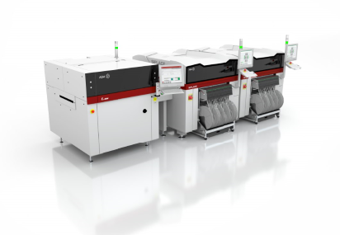
Source: ASM

Whether in R&D, prototyping, production of smaller lots or EMS – ASM E-Solutions are setting new benchmarks regarding quality, speed, efficiency and flexibility in the midspeed world.

About the SMT Solutions segment within the ASM Pacific Technology Group
The mission of the SMT Solutions segment within the ASM Pacific Technology Group (ASMPT) is to implement and support the smart SMT factory at electronics manufacturers worldwide.
ASM solutions such as SIPLACE placement systems and DEK printing systems support the networking, automation and optimization of central workflows with hardware, software and services that enable electronics manufacturers to transition to the smart SMT factory in stages and enjoy dramatic improvements in productivity, flexibility and quality.

Since maintaining close relationships with customers and partners is a central component of ASM’s strategy, the company has established the SMT Smart Network as a global forum for the active exchange of information between and with smart champions. In addition to being a founding member of the ADAMOS joint venture for the development of an IIoT platform for manufacturing companies, ASM is establishing together with other SMT manufacturers the open HERMES standard as a successor to the SMEMA standard for M2M communication in SMT lines.

ASM Pacific Technology Limited
Headquartered in Singapore, ASMPT (HKEX stock code: 0522) is a global technology and market leader in leading-edge solutions and materials for the semiconductor assembly and packaging industries. Its surface mount technology solutions are deployed in a wide range of end-user markets including electronics, mobile communications, automotive, industrial, and LED. The company’s continuous investments in research and development help to provide its customers with innovative and cost-efficient solutions and systems that enable them to achieve higher productivity, greater reliability and enhanced quality.

For more information about ASMPT, visit www.asmpacific.com.

About CantoUSA
Located in Marietta, GA and founded in 2013, CantoUSA is a manufacturer of LED houselight retrofits and followspots. The company offers a wide range of products and services designed to our mission: “Our customers come first. In order to do this, we continuously train our team on the latest trends and needs of the industry, while at the same time becoming a trendsetter in the development of new products and technology that no other company has available.”

Press inquiries:
Americas Press Office
ASM Assembly Systems, LLC
Mark Ogden, Senior Manager, Regional Marketing Americas
E-mail: ogden.mark@asmpt.com
Tel.: +1 (770) 797 3189

