PRESS RELEASE
OPEN MIND sees high demand for standardized CAM programming
Automation with hyperMILL® Is a Strong Trend
Wessling (Germany), April 7, 2021 –CAD/CAM specialist OPEN MIND has identified a strong trend towards automated program generation. In fact, the industry innovators estimate that the number of automation projects among users of the hyperMILL® CAD/CAM suite has tripled in 2020. At the same time, demand for hyperMILL® AUTOMATION Center Advanced has significantly increased. This version offers a comprehensive automation toolbox.
“The more powerful the machining centers and tools become, the more often CAM programming becomes a bottleneck,” explains Rico Müller, Project Manager for CAD/CAM Automation at OPEN MIND Technologies AG. “Companies are looking for solutions that allow them to make their CAM programming more efficient by automating processes. Even the most complex and diverse workpieces are created based on a large number of similar operations that can be standardized. In hyperMILL®, tool databases, feature recognition, and macros for standardization have been available for some time. These are now being used more and more across the manufacturing industry to automate CAM program creation.”
From Programming Standards to Process Automation
Even the basic version of hyperMILL® AUTOMATION Center allows users to automate the job list creation process as well as the selection and positioning of clamping devices. In addition, a uniform process can be defined for all programmers. The Advanced version makes it possible to define and standardize even complex processes. The solution primarily focuses on the individual elements of a CAD model. The steps for data preparation and programming, right up to simulation and NC program generation, can all be defined. Once a manufacturing process has been defined, it can be applied to any new components and executed automatically. If there are any decisions that cannot be made with complete certainty within the automated process, the user is prompted to make the relevant choices during the program run. The user is interactively guided through the individual process steps, making it possible to program the machining job in a very short time.
Added CAM Competence
“The possibility to create their own automation solutions effectively, increases the programming know-how of our customers,” assures Rico Müller. “On the one hand, we see that hyperMILL® users who address the topic of automation are gaining a whole new perspective on their own processes. Users revisit their processes with the goal of optimizing them. Another aspect is that automation covers many simple tasks, it has the facility to insert clamping devices or programming holes, right from the start. This gives users more time to optimize complex tasks.”
Service or Internal Projects
The availability of hyperMILL® AUTOMATION Center Advanced has now opened up CAM automation to companies that are not permitted to use external programming services due to strict internal design protection requirements. Companies across all industries that manufacture their own products can now be well prepared for CAM automation if they already work with design rules. Things are somewhat more difficult for contract manufacturers. However, they benefit even more from accelerated processes. “In one project, we were able to establish automated processes for a contract manufacturer, this is now being used to process orders via a web portal with CAD data upload,” says Rico Müller.
More information about the project with contract manufacturer BAM GmbH can be found here: https://www.openmind-tech.com/en/industries/mold-die/bam.html

Available images
The following images are available for download in printable format at:
http://www.htcm.de/kk/openmind

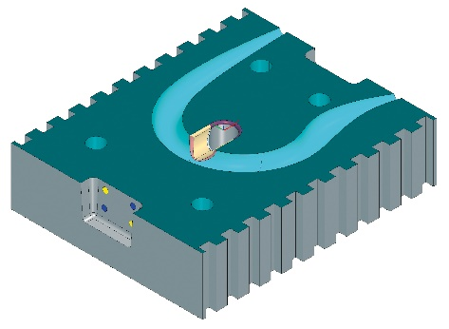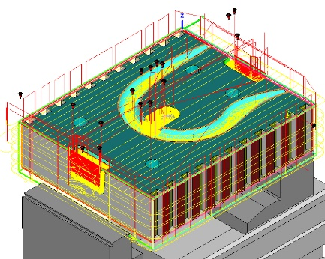
Source: OPEN MIND

hyperMILL® Automation Center Advanced: Automating the step from CAD to the final NC program


Source: OPEN MIND

Rico Müller, Project Manager for CAD/CAM Automation at OPEN MIND Technologies AG.

Available videos
You can find the following videos on our YouTube channel:
https://youtu.be/5dtmYFaGjzQ
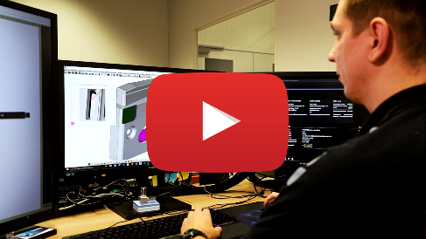
Source: OPEN MIND

Standardize, automate, optimize – BAM uses hyperMILL® Automation Center to improve process times

About OPEN MIND Technologies AG
OPEN MIND is one of the world’s most sought-after developers of powerful CAM solutions for machine and controller-independent programming.
OPEN MIND develops optimized CAM solutions that include a high number of innovative features not available elsewhere to deliver significantly higher performance in both programming and machining. Strategies such as 2.5D, 3D as well as 5-axis milling/mill turning, and machining operations like HSC and HPC are efficiently built into the hyperMILL® CAM system. hyperMILL® provides the maximum possible benefits to customers thanks to its full compatibility with all current CAD solutions and extensive programming automation.
OPEN MIND strives to be the best and most innovative CAD/CAM manufacturer in the world, helping it become one of the top five in the CAM industry according to the “NC Market Analysis Report 2020” compiled by CIMdata. The CAD/ CAM solutions of OPEN MIND fulfil the highest demands in the automotive, tool and mold manufacturing, production machining, medical, job shops, energy and aerospace industries. OPEN MIND is represented in all key markets in Asia, Europe and America, and is a Mensch und Maschine company.

You can find more information at www.openmind-tech.com.

OPEN MIND Technologies UK Ltd., Oxford
Unit 3
Bicester Business Park
Telford Road
Bicester
Oxfordshire OX26 4LN
England
Fon: +44 1869 290 003
Fax: +44 1869 369 429
E-mail: Info.UK@openmind-tech.com

OPEN MIND Technologies USA, Inc.
1492 Highland Avenue, Unit 3
Needham MA 02492
USA
Phone: +1 339 225 4557 office
Phone: +1 888 516 1232 x0 toll-free
Fax: +1 270 912 5822
E-mail: Info.Americas@openmind-tech.com

Head office:
OPEN MIND Technologies AG, Argelsrieder Feld 5, 82234 Wessling, Germany
Tel.: (+49-8153) 933-500, Fax: (+49-8153) 933-501
E-mail: Info@openmind-tech.com, website: www.openmind-tech.com

Press contact:
HighTech communications GmbH
Brigitte Basilio
Brunhamstrasse 21
81249 Munich
Germany
Tel.: (+49-89) 500778-20
Fax: (+49-89) 500778-78
E-mail: b.basilio@htcm.de
Website: www.htcm.de

