PRESS RELEASE

Hufschmied Virtual Masterclass on Composite Materials
Achieving ideal machining results with carbon fiber-reinforced thermoplastics
Bobingen (Germany), 23 February 2021 - On March 4, 2021 at 5:00 p.m., Hufschmied Zerspanungssysteme invites machining professionals to another online technical seminar. The title is "Effective machining of high-performance carbon fiber reinforced thermoplastic composite materials". Specifically, the seminar will focus on the high-performance composite material Toray Cetex® TC1225 from the manufacturer Toray Advanced Composites. The material will be machined on a milling center from the Italian machine manufacturer Cms. Participation in the Virtual Masterclass is free of charge, the presentation language is English.
Thermoplastic composites such as Toray-Cetex® materials have great advantages, but also place particular demands on the machining process. Only the perfect interaction of tool, machine and machining program ensures machining can be achieved without the need for additional reworking. The Hufschmied Virtual Masterclass at the beginning of March will focus on the settings and tools used to achieve burr- and delamination-free cuts and surfaces, and will then document this with videos of the machining process. The presentation by Hufschmied shows the 5-axis machining of Toray Cetex® TC1225 with the Hufschmied 065SMCS and details the unique geometry and diamond coating of the tool.
Interested parties can register at https://register.gotowebinar.com/register/1704152176180022799.

Available images
The following images can be downloaded from the Internet in printable quality:
http://www.htcm.de/kk/hufschmied
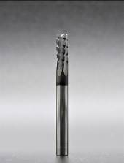  Image source:  Hufschmied Zerspanungssysteme  Hufschmieds SMC program for more efficiency in plastic milling. | 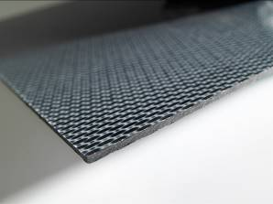 Image source:  Hufschmied Zerspanungssysteme  The proven choice for high-volume manufacturing: The Toray-Cetex® family of thermoplastic composites is available in a variety of fiber/resin combinations and product formats.

About Hufschmied Zerspanungssysteme GmbH
Established in 1991 and headquartered in Bobingen near Augsburg, Hufschmied Zerspanungssysteme GmbH is a manufacturer of high-quality tools for machinable production. By specializing at an early stage in the machining of plastics, fiberglass materials and carbon fiber, Hufschmied has become a leader in Europe in the development of solutions for new materials. The company is an established system supplier to renowned machine tool manufacturers. Tools and manufacturing process consulting from Hufschmied are particularly valued in the automotive and aerospace industries as well as in medical technology. The company is involved in numerous organizations, including Composites United Deutschland e. V. Hufschmied's manufacturing operations are located in Winterlingen in the Swabian Alb.
For more information: www.hufschmied.net

Additional information:  Hufschmied Zerspanungssysteme GmbH  Sybille Schuller  Edisonstrasse 11d  86399 Bobingen  Germany  Phone: +49 8234 9664-0  Telefax: +49 8234 9664-99  E-Mail: info@hufschmied.net  www.hufschmied.net | Press contact:  HighTech communications GmbH  Brigitte Basilio  Brunhamstrasse 21  81249 Munich  Germany  Phone: +49 89 500778-20  Telefax: +49 89 500778-77  E-Mail: b.basilio@htcm.de  www.htcm.de

