PRESS RELEASE

Material from the Virtual Masterclass with Hufschmied, Ensinger and Fehlmann
Post-processing-free composite machining
Bobingen (Germany), March 11, 2021 - Hufschmied Zerspanungssysteme GmbH held the Virtual Masterclass "Machining Thermoplastic Carbon Winglet" on February 23, 2021. Now the video of the machining example carried out with CNC machine manufacturer Fehlmann AG Maschinenfabrik and Ensinger Composites Schweiz GmbH is available in English at https://youtu.be/K3QFSelQMqs.
In order to efficiently manufacture demanding components from high-performance materials, the machine, machining strategy and tool must be coordinated. In the Virtual Masterclass on February 23, Hufschmied, Ensinger and Fehlmann focused on the endless carbon fiber-reinforced polyphenylene sulfide TECATEC PPS CW50 PL natural. The exemplary workpiece was a winglet with complex free-form contours, which was machined with Hufschmied's Graftor® tools, 065SMC drill milling cutter and FB162 drill on Fehlmann's VERSA 645 linear 5-axis high-performance milling center.
The Virtual Masterclasses, which Hufschmied hosts regularly with partners, offer manufacturing and process managers, machining technicians and machine operators concrete assistance for practical work in machining production. Dates and topics of the Virtual Masterclasses can be viewed at https://www.hufschmied-tools.com/en/events/.

Available images
The following images can be downloaded from the Internet in printable quality:
http://www.htcm.de/kk/hufschmied

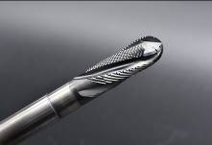  Source: Hufschmied Zerspanungssysteme  The Graftor®, a roughing/finishing tool with a unique cutting-edge geometry | 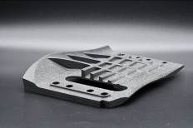Source: Hufschmied Zerspanungssysteme  In cooperation with Ensinger and Fehlmann, Hufschmied machined the carbon winglet, which is made of the material PPS CFRP.

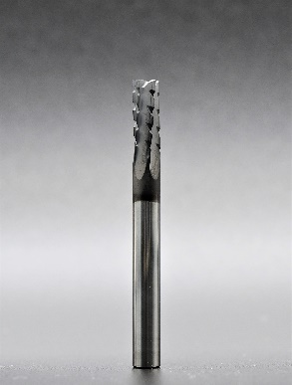  Source: Hufschmied Zerspanungssysteme  More efficiency when machining "thermoplastics" with the 065SMC milling cutter | 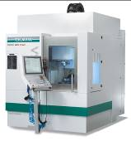  Source: Hufschmied Zerspanungssysteme  The 5-axis high-performance machining center FEHLMANN VERSA 645 linear

About Hufschmied Zerspanungssysteme GmbH
Established in 1991 and headquartered in Bobingen near Augsburg, Hufschmied Zerspanungssysteme GmbH is a manufacturer of high-quality tools for machinable production. By specializing at an early stage in the machining of plastics, fiberglass materials and carbon fiber, Hufschmied has become a leader in Europe in the development of solutions for new materials. The company is an established system supplier to renowned machine tool manufacturers. Tools and manufacturing process consulting from Hufschmied are particularly valued in the automotive and aerospace industries as well as in medical technology. The company is involved in numerous organizations, including Composites United Deutschland e. V. Hufschmied's manufacturing operations are located in Winterlingen in the Swabian Alb.
For more information: www.hufschmied.net

Additional information:  Hufschmied Zerspanungssysteme GmbH  Sybille Schuller  Edisonstrasse 11d  86399 Bobingen  Germany  Phone: +49 8234 9664-0  Telefax: +49 8234 9664-99  E-Mail: info@hufschmied.net  www.hufschmied.net | Press contact:  HighTech communications GmbH  Brigitte Basilio  Brunhamstrasse 21  81249 Munich  Germany  Phone: +49 89 500778-20  Telefax: +49 89 500778-77  E-Mail: b.basilio@htcm.de  www.htcm.de

