PRESS RELEASE

Würth Elektronik WEbinars Receive Exclusive Sponsorship from Digi-Key Electronics
Content to help educate customers
Watertown (USA), 26 February 2021 – For the third year in a row, Würth Elektronik in the United States is pleased to announce Digi-Key Electronics as the exclusive sponsor of their 2021 technical WEbinars.
In 2021, Würth Elektronik expects to triple the number of presented webinars; including topics in English, Spanish, and Portuguese. Brand new topics include custom transformer design, coupled inductors, optocouplers, and more. Amelia Thompson, Marketing & Communications Coordinator with Würth Elektronik, is hoping the continued partnership with Digi-Key Electronics helps to not only grow the base attendance rate, but also reach universities and students as a free educational tool, as topics range from basic to advanced subjects.
“Over the last several years, our educational webinars have become increasingly popular. Our continued goal is to educate any person willing to learn about electronics. Online presence continues to the best way to do so, especially after everything we have seen in 2020,” says Amelia Thompson. “Our strong partnership and exclusive sponsorship with Digi-Key Electronics ensures the webinars remain free for our attendees.”
“Digi-Key is proud to be the exclusive sponsor for Würth Elektronik’s webinar series once again in 2021,” said David Stein, vice president, global supplier management for Digi-Key. “These webinars provide great content to help educate our mutual customers on their entire portfolio from capacitors to wireless modules. Our partnership with Würth Elektronik on the webinars illustrates our commitment to providing our customers with knowledge and resources related to electronic and electromechanical components.”
Registration for all 2021 WEbinars is available at www.we-online.com/webinars.

Available images
The following images can be downloaded from the Internet in printable quality: http://www.htcm.de/kk/wuerth
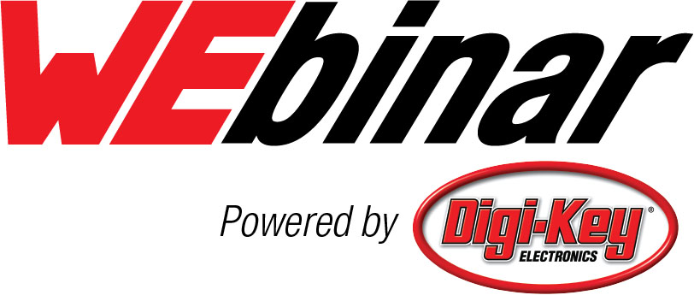
Image source: Wurth Electronics
Digi-Key Electronics is the exclusive sponsor of Würth Elektronik‘s 2021 technical WEbinars.

About the Würth Elektronik eiSos Group
Würth Elektronik eiSos Group is a manufacturer of electronic and electromechanical components for the electronics industry and a technology company that spearheads pioneering electronic solutions. Würth Elektronik eiSos is one of the largest European manufacturers of passive components and is active in 50 countries. Production sites in Europe, Asia and North America supply a growing number of customers worldwide.
The product range includes EMC components, inductors, transformers, RF components, varistors, capacitors, resistors, quartz crystals, oscillators, power modules, Wireless Power Transfer, LEDs, sensors, connectors, power supply elements, switches, push-buttons, connection technology, fuse holders and solutions for wireless data transmission.
The unrivaled service orientation of the company is characterized by the availability of all catalog components from stock without minimum order quantity, free samples and extensive support through technical sales staff and selection tools.
Through its technology partnership with the Audi Sport ABT Schaeffler Formula E Team and its support for the Formula Student racing series, the company demonstrates its innovative strength in eMobility
(www.we-speed-up-the-future.com).
Würth Elektronik is part of the Würth Group, the world market leader for assembly and fastening technology. The company employs 7,300 staff and generated sales of 822 million euros in 2019.
Würth Elektronik: more than you expect!
Further information at www.we-online.com

Further information:  Wurth Electronics Midcom, Inc.  Lindsey Esche  121 Airport Drive  PO Box 1330  Watertown, SD 57201 USA  Phone: +1 605 886 4385  Toll-free (in the U.S.):  Phone: +1 800 643 2661  E-mail: lindsey.esche@we-online.com  www.we-online.com | Press contact:  HighTech communications GmbH  Brigitte Basilio  Brunhamstrasse 21  81249 Munich  Germany  Phone: +49 89 500778-20  Fax: +49 89 500778-77  E-mail: b.basilio@htcm.de  www.htcm.de

