PRESS RELEASE
IQD presents ultra-miniature LVDS / LVPECL oscillators
One of the World’s Smallest LVDS / LVPECL Oscillators
Waldenburg (Germany), 15 March 2021—IQD, a subsidiary of the Würth Elektronik eiSos Group, introduces its latest LVDS / LVPECL oscillators, IQXO-406 and IQXO-439, in a small 2.0 x 1.6 mm package. Available in a frequency range from 50 MHz to 250 MHz, the new oscillators offer both miniaturization and higher clock frequencies for end applications. Common applications include 5G, Ethernet (10G/100G/1000G), Fibre Channel, IoT, SONET/SDH and wearables.
The demand for smaller, more powerful and more reliable electronic components is growing. This leads to manufacturers of frequency products developing even smaller products with higher frequencies. This aims at achieving the design goals while allowing miniaturization of the circuit. IQD's IQXO-406 and IQXO-439 are the right choice here.
The LVPECL and LVDS outputs provide a differential signal with reduced phase noise at higher frequencies compared with CMOS logic signals.
The new oscillators are available either as 2.5 V or 3.3 V versions and with a phase jitter of less than 0.5 ps RMS (over 12 kHz to 20 MHz), regardless of which output is specified. Components in a 2.5 x 2.0 mm package are also available, as required.
Detailed information on IQXO-406 and IQXO-439 is available at www.iqdfrequencyproducts.com.

Available images
The following images can be downloaded from the Internet in printable quality: http://www.htcm.de/kk/wuerth
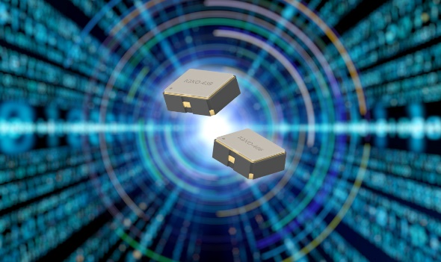
Image source: IQD
IQD’s LVDS / LVPEC oscillators

About IQD
Backed by over 40 years’ experience in the manufacture of frequency products, IQD is a recognised market leader in the frequency control market and part of the Würth Elektronik eiSos Group, one of the leading European manufacturers of passive components. With active customers in over 80 countries, IQD offers one of the most comprehensive frequency product ranges available, from low cost commercial grade product to that used in high reliability industrial and automotive applications including: Quartz Crystals, Clock Oscillators, AEC-Q200 Crystals & Oscillators, VCXOs, TCXOs, OCVCSOs & OCXOs, GPS Disciplined OCXOs, and Rubidium Oscillators.
Further info at www.iqdfrequencyproducts.com

About the Würth Elektronik eiSos Group
Würth Elektronik eiSos Group is a manufacturer of electronic and electromechanical components for the electronics industry and a technology company that spearheads pioneering electronic solutions. Würth Elektronik eiSos is one of the largest European manufacturers of passive components and is active in 50 countries. Production sites in Europe, Asia and North America supply a growing number of customers worldwide.
The product range includes EMC components, inductors, transformers, RF components, varistors, capacitors, resistors, quartz crystals, oscillators, power modules, Wireless Power Transfer, LEDs, sensors, connectors, power supply elements, switches, push-buttons, connection technology, fuse holders and solutions for wireless data transmission.
The unrivaled service orientation of the company is characterized by the availability of all catalog components from stock without minimum order quantity, free samples and extensive support through technical sales staff and selection tools.
Through its technology partnership with the Audi Sport ABT Schaeffler Formula E Team and its support for the Formula Student racing series, the company demonstrates its innovative strength in eMobility
(www.we-speed-up-the-future.com).
Würth Elektronik is part of the Würth Group, the world market leader for assembly and fastening technology. The company employs 7,300 staff and generated sales of 823 million euros in 2020.
Würth Elektronik: more than you expect!
Further information at www.we-online.com

Further information:  IQD Frequency Products Ltd  Rebecca Long  Station Road  Crewkerne  Somerset  TA18 8AR  United Kingdom  Phone: +44 1460 270270  E-mail: rebecca.long@iqdfrequencyproducts.com  www.we-online.com  www.iqdfrequencyproducts.com | Press contact:  HighTech communications GmbH  Brigitte Basilio  Brunhamstrasse 21  81249 Munich  Germany  Phone: +49 89 500778-20  Telefax: +49 89 500778-77  E-mail:  b.basilio@htcm.de  www.htcm.de

