PRESS RELEASE
Würth Elektronik Technology Partnerships for eMobility
Exclusive technology seminars for developers in student racing teams
Waldenburg (Germany), 22 January 2021 – Würth Elektronik is pleased to announce the addition of technology partnerships, including three Exclusive Formula Student teams and Team Sonnenwagen Aachen e. V. Intensive virtual seminars were held for 2 days for the individual development teams. The content of the exclusive seminars was specially adapted to the needs and requests of the respective teams. Through these seminars, the student developers received support from proven experts from Würth Elektronik to help with selected technology areas.
"True to our motto "WE speed up the future", we promote technology partnerships, which also include our three exclusive teams in Formula Student - Greenteam Uni Stuttgart e. V., KA RaceIng e. V., HHN Racing e. V. - and Team Sonnenwagen Aachen e.V.. Our primary aim here is to support the racing teams with our services in their developments in the field of eMobility from the very beginning and to familiarize them with our product portfolio at an early stage," explains Marion Wagner, Strategy & Coordination Manager for Group Technology Partnerships eMotorsports of the Würth Elektronik Group. "Intensive support in the development phase is important here, so that errors, for example in the area of electromagnetic compatibility, can be avoided in advance. Our specialists are available to the teams at all times with advice and support to drive the project forward together."
Virtual in the Innovation Center
Ingenuity is required during these times, so the first intensive seminar, initially planned as a face-to-face event for the end of October 2020, was moved to a virtual space. Spontaneously, the Research & Innovation Center of the Reinhold-Würth-Hochschule in Künzelsau was used to meet with the developers of the Sonnenwagen Aachen team via video conference. Sonnenwagen Aachen has already developed two solar-powered vehicles and participates annually in international competitions such as the European Solar Challenge in Belgium, and the World Solar Challenge in Australia. Twelve developers received exclusive training on surge, burst and ESD protection, EMC with design tips and filter circuits, SMD ferrites, EMC and efficiency optimization of high-power DC/DC converters, common mode chokes and industrial radio standards. In this way, the latest technology trends are incorporated into the development or challenges in the electronics design of the Sonnenwagen Aachen and can be discussed directly with the experts from Würth Elektronik.
Individual program
In mid-December, Würth Elektronik then held an intensive seminar for the Formula Student team Greenteam Uni Stuttgart, and another one for the KA-RaceIng team of KIT Karlsruhe. The topics ranged from EMC-compliant design of AC/DC converters, to Bluetooth Low Energy and LAN transceivers. The technical contents were supplemented by a module on the topic of new product development in the field of New Mobility - from the original idea to market maturity. The career tips section of the program gave the audience an understanding of the process and content of a successful job interview, as well as entry-level opportunities in the company. After positive feedback, the University Marketing Team of Würth Elektronik eiSos then organized another seminar, in which all other Formula Student teams supported by Würth Elektronik in Germany could participate. Here, the number of participants was larger and the audience had the opportunity to choose between topics presented simultaneously in various virtual rooms. The seminar series was a complete success and has aroused interest for further joint seminars.

Available images
The following images can be downloaded from the Internet in printable quality: http://www.htcm.de/kk/wuerth

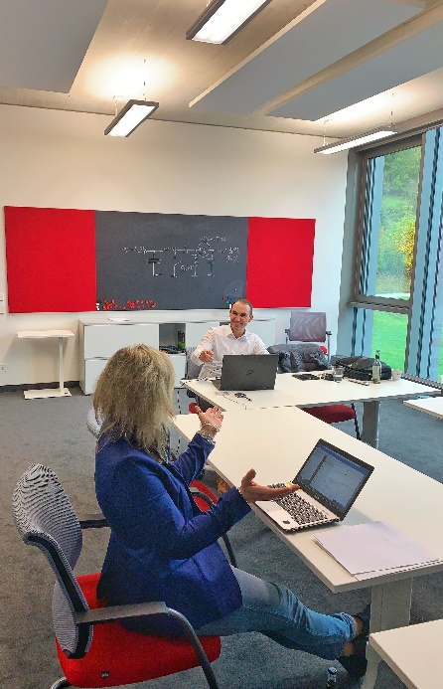  Image source: Würth Elektronik  Marion Wagner, Strategy & Coordinaton Manager Group Technology Partnerships eMotorsports, and Andreas Nadler, Field Application Engineer (both Würth Elektronik eiSos), sit virtually with the developers of Sonnenwagen Aachen e. V. in the seminar room. | 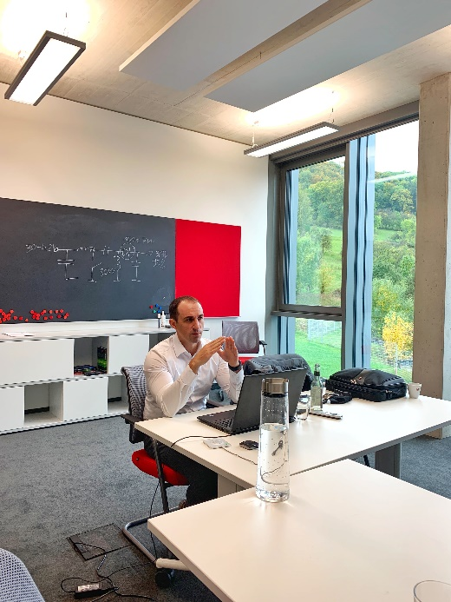  Image source: Würth Elektronik  Andreas Nadler, Field Application Engineer at Würth Elektronik eiSos, held a virtual training session on EMC topics.

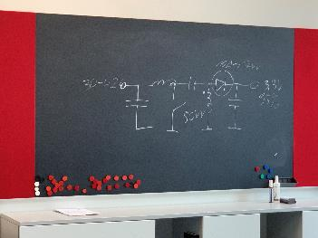  Image source: Würth Elektronik  With the camera pointed at the board, you can also quickly sketch a circuit. | 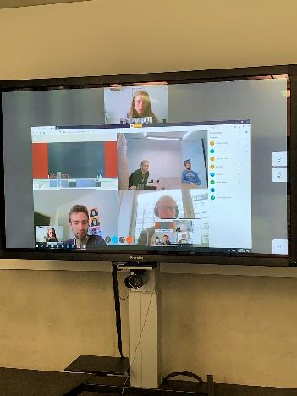  Image source: Würth Elektronik  A seminar as a video conference - the student eMobility developers and their technology partner Würth Elektronik have had good experiences.

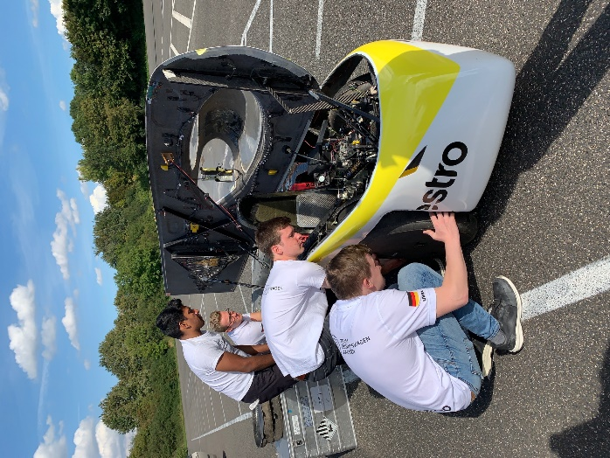
Image source: Würth Elektronik
Team Sonnenwagen Aachen e. V. and its solar vehicle: Würth Elektronik helps with components and training - even under corona conditions.

About the Würth Elektronik eiSos Group
Würth Elektronik eiSos Group is a manufacturer of electronic and electromechanical components for the electronics industry and a technology company that spearheads pioneering electronic solutions. Würth Elektronik eiSos is one of the largest European manufacturers of passive components and is active in 50 countries. Production sites in Europe, Asia and North America supply a growing number of customers worldwide.
The product range includes EMC components, inductors, transformers, RF components, varistors, capacitors, resistors, quartz crystals, oscillators, power modules, Wireless Power Transfer, LEDs, sensors, connectors, power supply elements, switches, push-buttons, connection technology, fuse holders and solutions for wireless data transmission.
The unrivaled service orientation of the company is characterized by the availability of all catalog components from stock without minimum order quantity, free samples and extensive support through technical sales staff and selection tools.
Through its technology partnership with the Audi Sport ABT Schaeffler Formula E Team and its support for the Formula Student racing series, the company demonstrates its innovative strength in eMobility
(www.we-speed-up-the-future.com).
Würth Elektronik is part of the Würth Group, the world market leader for assembly and fastening technology. The company employs 7,300 staff and generated sales of 822 million euros in 2019.
Würth Elektronik: more than you expect!
Further information at www.we-online.com

Further information:  Würth Elektronik eiSos GmbH & Co. KG  Sarah Hurst  Max-Eyth-Strasse 1  74638 Waldenburg  Germany  Phone: +49 7942 945-5186  E-mail: sarah.hurst@we-online.de  www.we-online.de | Press contact:  HighTech communications GmbH  Brigitte Basilio  Brunhamstrasse 21  81249 Munich  Germany  Phone: +49 89 500778-20  Telefax: +49 89 500778-77  E-mail: b.basilio@htcm.de  www.htcm.de

