PRESS RELEASE

Würth Elektronik extends its product family of WE-SHC shielding cabinets
Shielding Cabinets for High Frequency Applications
Waldenburg (Germany), 25 February 2021—Würth Elektronik has added further WE-SHC series shielding cabinets to its product range: WE-SHC Seamless are the first cabinets of their kind for automated population, optimized for high frequency applications. They are completely enclosed with seamless corners making them particularly effective. The tin-plated steel plate cabinets are available in over 100 different dimensions. Customized or application-specific cabinet developments are also possible.
WE-SHC Seamless serves to protect sensitive components, such as RF stages, oscillators, signal generators and sensitive ICs, from electromagnetic radiation. Würth Elektronik has developed the cabinets specifically geared toward 5G, IoT, IO-Link radio and GNSS applications. All versions are available from stock without a minimum order quantity; free samples are available. Würth Elektronik also accepts orders for customized and application-specific cabinet solutions, which often opens up decisive design advantages in modern, highly miniaturized assemblies for communication applications.

Available images
The following images can be downloaded from the Internet in printable quality: http://www.htcm.de/kk/wuerth

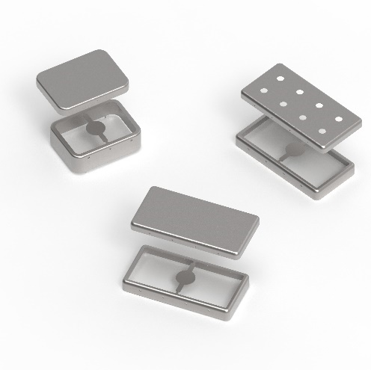
Image source: Würth Elektronik
WE-SHC Seamless shielding cabinets

About the Würth Elektronik eiSos Group
Würth Elektronik eiSos Group is a manufacturer of electronic and electromechanical components for the electronics industry and a technology company that spearheads pioneering electronic solutions. Würth Elektronik eiSos is one of the largest European manufacturers of passive components and is active in 50 countries. Production sites in Europe, Asia and North America supply a growing number of customers worldwide.
The product range includes EMC components, inductors, transformers, RF components, varistors, capacitors, resistors, quartz crystals, oscillators, power modules, Wireless Power Transfer, LEDs, sensors, connectors, power supply elements, switches, push-buttons, connection technology, fuse holders and solutions for wireless data transmission.
The unrivaled service orientation of the company is characterized by the availability of all catalog components from stock without minimum order quantity, free samples and extensive support through technical sales staff and selection tools.
Through its technology partnership with the Audi Sport ABT Schaeffler Formula E Team and its support for the Formula Student racing series, the company demonstrates its innovative strength in eMobility
(www.we-speed-up-the-future.com).
Würth Elektronik is part of the Würth Group, the world market leader for assembly and fastening technology. The company employs 7,300 staff and generated sales of 822 million euros in 2019.
Würth Elektronik: more than you expect!
Further information at www.we-online.com

Further information:  Würth Elektronik eiSos GmbH & Co. KG  Sarah Hurst  Max-Eyth-Strasse 1  74638 Waldenburg  Germany  Phone: +49 7942 945-5186  E-mail: sarah.hurst@we-online.de  www.we-online.de | Press contact:  HighTech communications GmbH  Brigitte Basilio  Brunhamstrasse 21  81249 Munich  Germany  Phone: +49 89 500778-20  Telefax: +49 89 500778-77  E-mail: b.basilio@htcm.de  www.htcm.de

